**Practical-1(a)**

**Working with basic C# and ASP.NET**

1. **Create an application that obtains four int values from the users and display the product.**

**Solution:**

**Source code :**

**WebForm1.aspx.cs:**

using System;

using System.Collections.Generic;

using System.Linq;

using System.Web;

using System.Web.UI;

using System.Web.UI.WebControls;

namespace practical_1

{

public partial class WebForm1 : System.Web.UI.Page

{

protected void Page_Load(object sender, EventArgs e)

{

}

protected void Button1_Click(object sender, EventArgs e)

{

int a, b, c, d, s;

a = int.Parse(TextBox1.Text);

b = int.Parse(TextBox2.Text);

c = int.Parse(TextBox3.Text);

d = int.Parse(TextBox4.Text);

s = a * b * c * d;

TextBox5.Text = s.ToString();

}

}

}

Design :

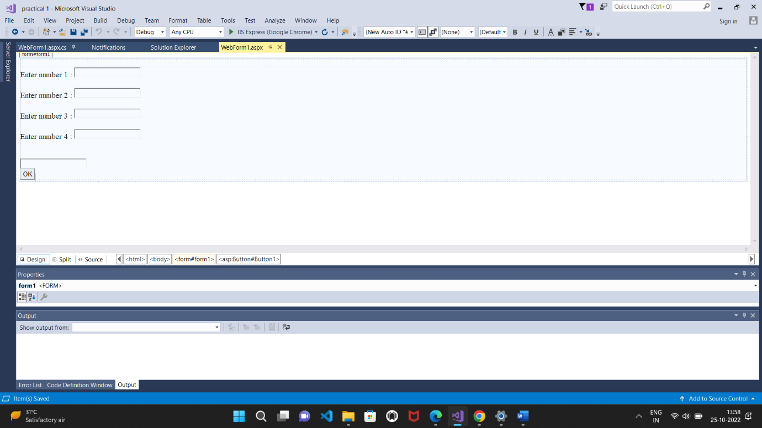

Output :

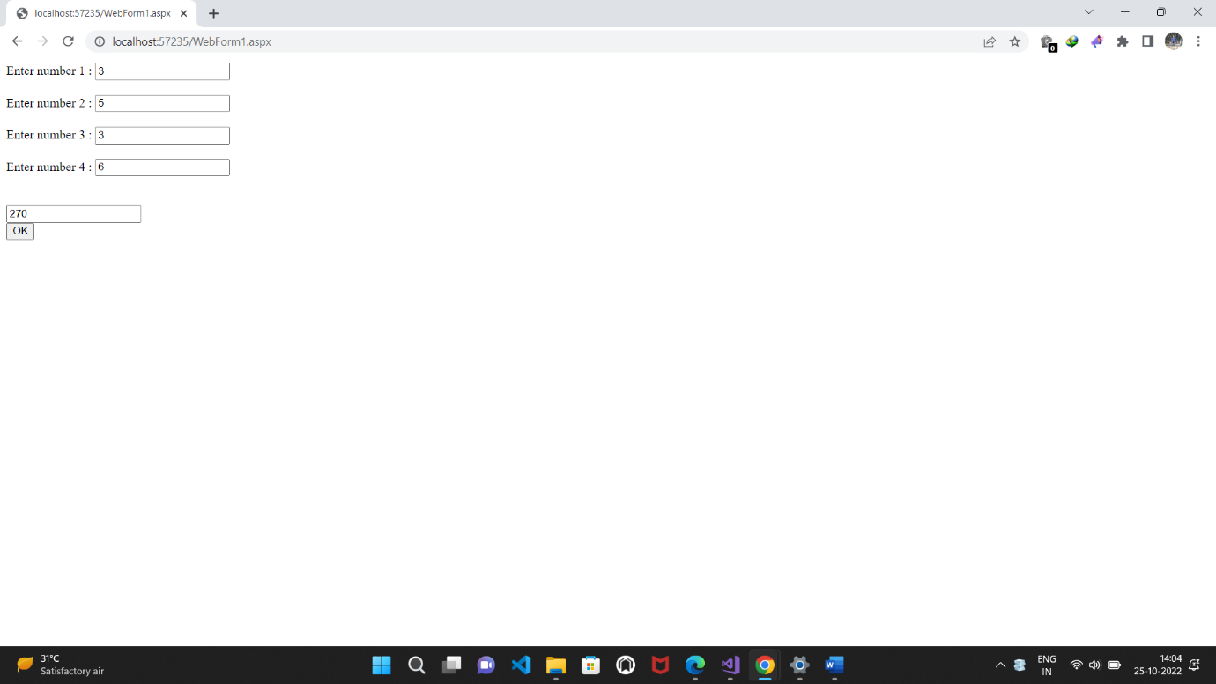

**b)Create an application to demonstrate string operations.**

**Source code:**

**WebForm1.aspx.cs:**

using System;

using System.Collections.Generic;

using System.Linq;

using System.Web;

using System.Web.UI;

using System.Web.UI.WebControls;

namespace practical_1b

{

public partial class WebForm1 : System.Web.UI.Page

{

protected void Page_Load(object sender, EventArgs e)

{

}

protected void Button1_Click(object sender, EventArgs e)

{

string str1;

str1 = TextBox1.Text;

String[] words = str1.Split(' ');

for (int i = 0; i < words.Length; i++)

{

TextBox2.Text = TextBox2.Text + words[i] + "\r\n";

}

}

}

}

**Design:**

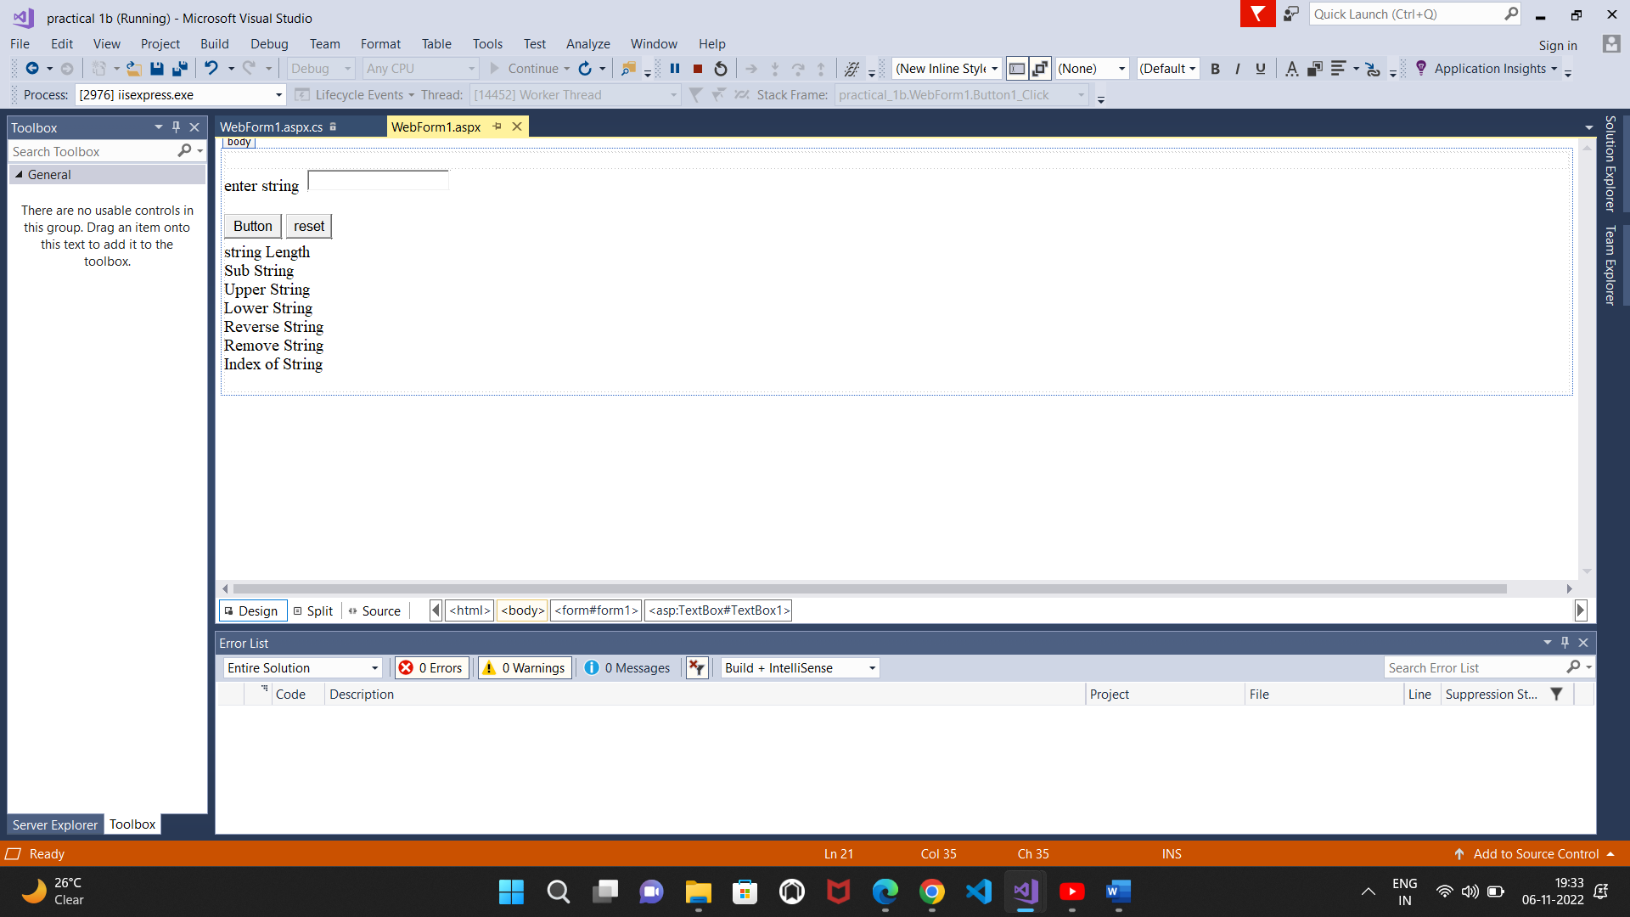

**Output:**

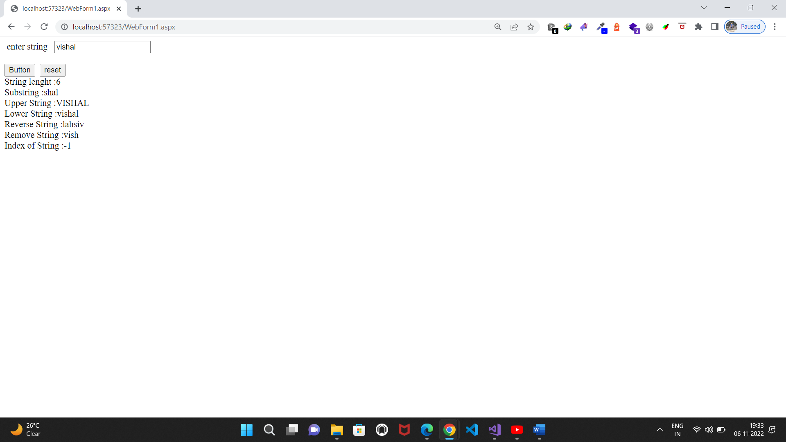

**c) Create an application that receives the (Student ID, Student Name, Course Name, Date of Birth) information from the set of student. The application should also display the information of all the student once the data entered.**

**Source code:**

**WebForm1.aspx.cs:**

using System;

using System.Collections.Generic;

using System.Linq;

using System.Web;

using System.Web.UI;

using System.Web.UI.WebControls;

namespace Practical_1_c

{

struct student

{

public string name, id, cname, dob;

}

;

public partial class WebForm1 : System.Web.UI.Page

{

static student[] s = new student[2];

static int i;

protected void Page_Load(object sender, EventArgs e)

{

}

protected void Button2_Click(object sender, EventArgs e)

{

Response.Write("i=" + i);

s[i].id = TextBox1.Text;

s[i].name = TextBox2.Text;

s[i].cname = TextBox3.Text;

s[i].dob = TextBox4.Text;

i++;

}

protected void Button1_Click(object sender, EventArgs e)

{

for (int y = 0; y < i; y++)

{

Response.Write("i="+ y +"<br>");

Response.Write("student id :" +s[y].id+ "<br>");

Response.Write("Name: "+ s[y].name + "<br>");

Response.Write("course name:" + s[y].cname+"<br>");

Response.Write("Date of Birth:" +s[y].dob+"<br>");

}

}

}

}

**Design:**

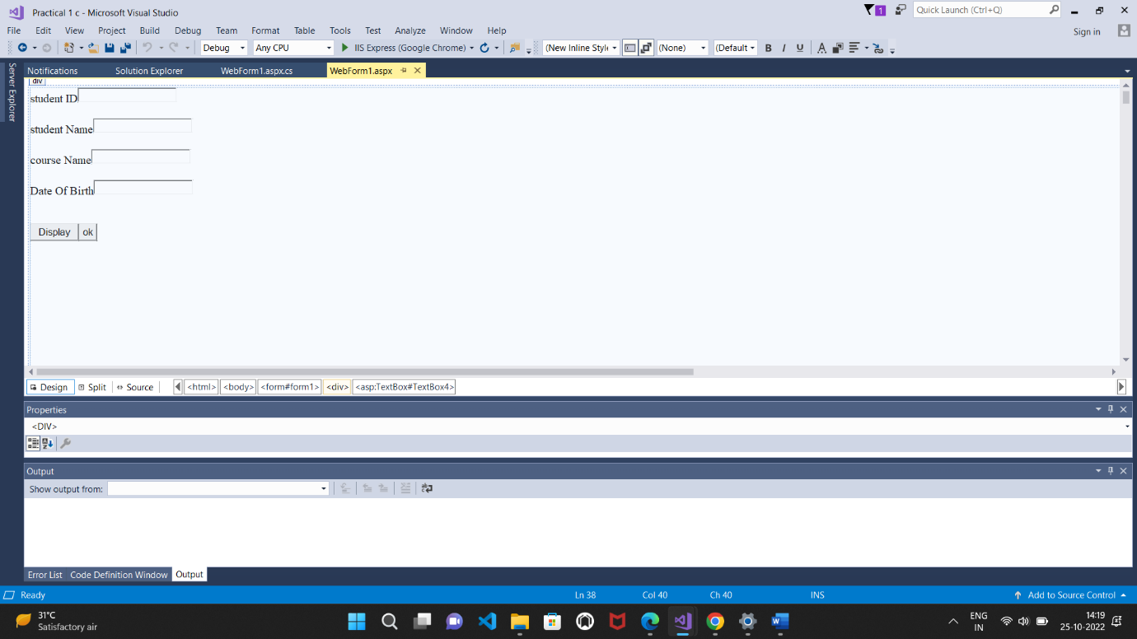

**Output:**

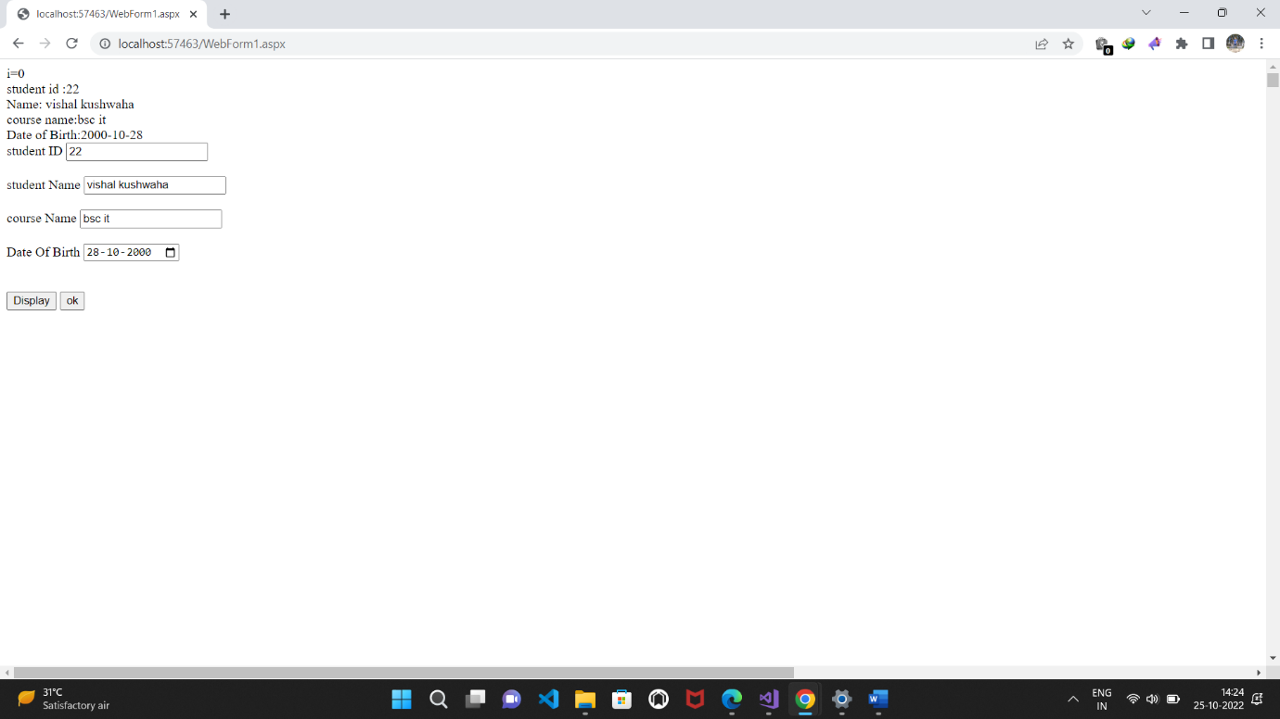

**d) Create an application to demonstrate following operation. I) Generate Fibonacci series ii) Test for prime numbers iii) Test for vowels IV) Use of foreach loop with array v) Reverse a number and find sum of digit of a number.**

**Source code:**

**WebForm1.aspx.cs:**

using System;

using System.Collections.Generic;

using System.Linq;

using System.Web;

using System.Web.UI;

using System.Web.UI.WebControls;

namespace practicale_1_D

{

public partial class WebForm1 : System.Web.UI.Page

{

protected void Page_Load(object sender, EventArgs e)

{

}

protected void Button1_Click(object sender, EventArgs e)

{

int i = 0, j = 1, n, sum = 0;

Label11.Text = sum.ToString();

n = Convert.ToInt32(TextBox1.Text);

do

{

sum = i + j;

i = j;

j = sum;

Label11.Text = Label11.Text + sum.ToString();

} while (sum <= n);

}

protected void Button2_Click(object sender, EventArgs e)

{

int i, c = 0, j, n;

n = Convert.ToInt32(TextBox2.Text);

for (j = 1; j <= n; j++)

{

i = n % j;

if (i == 0)

{

c = c + 1;

}

}

if (c == 2)

Label12.Text = "The given number is prime";

else

Label12.Text = "the given number is not prime";

}

protected void Button3_Click(object sender, EventArgs e)

{

long n, i, sum = 0;

n = Convert.ToInt32(TextBox3.Text);

while (n > 0)

{

i = n % 10;

sum = i + sum * 10;

n = n / 10;

}

Label13.Text = sum.ToString();

}

protected void Button4_Click(object sender, EventArgs e)

{

long n, i, sum = 0;

n = Convert.ToInt32(TextBox4.Text);

while (n > 0)

{

i = n % 10;

sum = i + sum;

n = n / 10;

}

Label14.Text = sum.ToString();

}

protected void Button5_Click(object sender, EventArgs e)

{

char c = Convert.ToChar(TextBox5.Text);

switch(c)

{

case 'a':

Label15.Text = "a is vowel";

break;

case 'e':

Label15.Text = "e is vowel";

break;

case 'i':

Label15.Text = "i is vowel";

break;

case 'o':

Label15.Text = "0 is vowel";

break;

case 'u':

Label15.Text = "u is vowel";

break;

default:

Label15.Text = "its not vowel";

break;

}

}

}

}

**Design:**

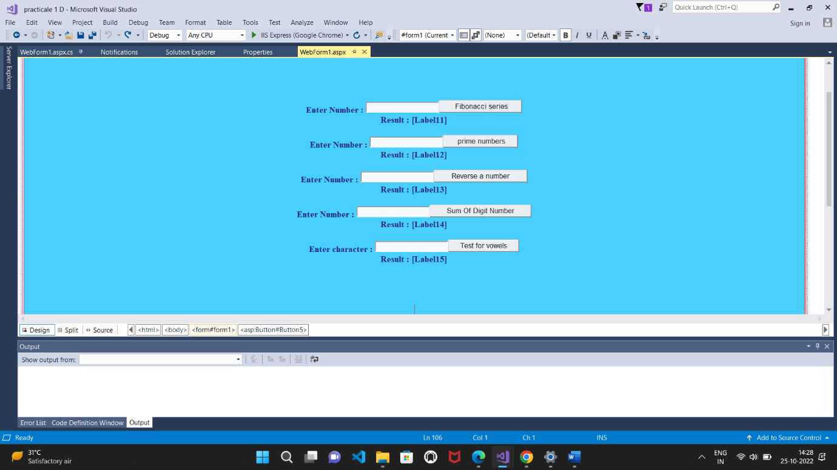

Output:

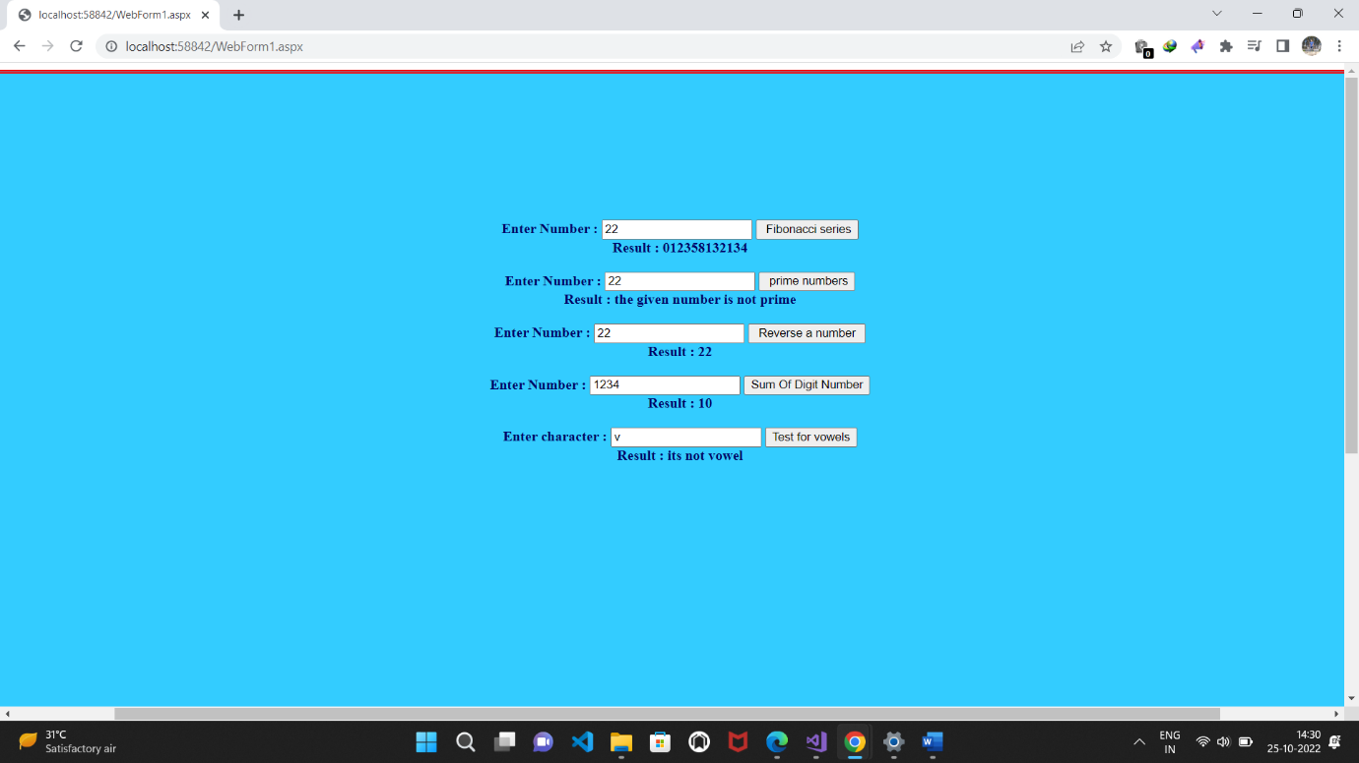

**Practical-2(a)**

**Working with Object Oriented C# and ASP.NET**

**a)Create simple application to perform following operations:**

**i) Finding factorial Value ii) Money Conversion**

**iii) Quadratic Equation iv) Temperature Conversion**

**Solution: i) Source Code (Factorial Value):**

**Source code:**

**WebForm1.aspx.cs:**

using System;

using System.Collections.Generic;

using System.Linq;

using System.Web;

using System.Web.UI;

using System.Web.UI.WebControls;

namespace Practical_2_a__Factorial_Value

{

public partial class WebForm1 : System.Web.UI.Page

{

protected void Page_Load(object sender, EventArgs e)

{

}

protected void Button1_Click(object sender, EventArgs e)

{

int i, n, f;

n = Convert.ToInt32(TextBox1.Text);

f = 1;

for (i = 1; i <= n; i++)

{

f = f * i;

}

Label2.Text = "Result:" + f;

}

}

}

**Design:**

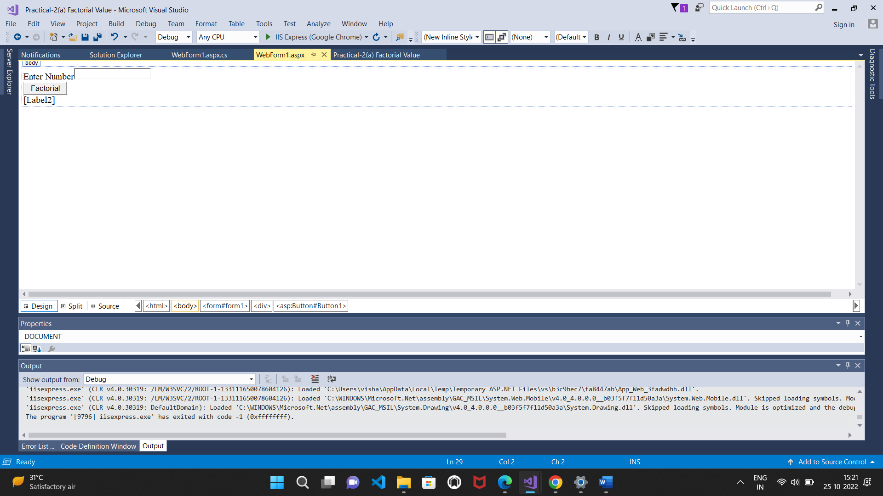

**Output:**

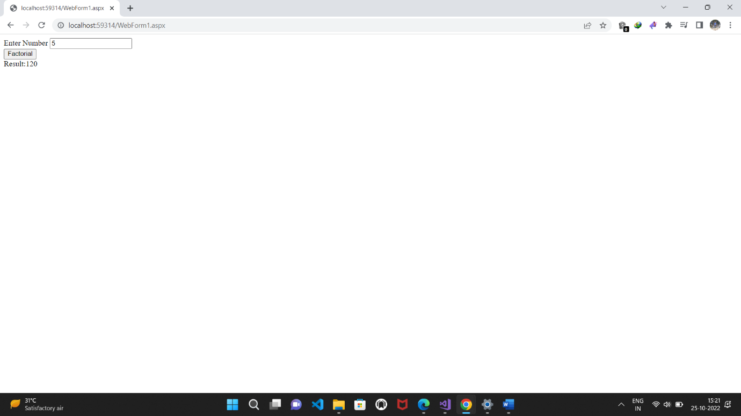

**ii) Money Conversion**

**Source code:**

**WebForm1.aspx.cs:**

using System;

using System.Collections.Generic;

using System.Linq;

using System.Web;

using System.Web.UI;

using System.Web.UI.WebControls;

namespace Money_Conversion

{

public partial class WebForm1 : System.Web.UI.Page

{

protected void Page_Load(object sender, EventArgs e)

{

}

protected void TextBox1_TextChanged(object sender, EventArgs e)

{

}

protected void Button1_Click(object sender, EventArgs e)

{

cons s = new cons();

Double r = Convert.ToDouble(TextBox1.Text);

Double rate = s.Dollar(r);

Label2.Text = rate.ToString();

}

protected void Button2_Click(object sender, EventArgs e)

{

cons s = new cons();

Double r = Convert.ToDouble(TextBox1.Text);

Double rate = s.Euro(r);

Label3.Text = rate.ToString();

}

protected void Button3_Click(object sender, EventArgs e)

{

cons s = new cons();

Double r = Convert.ToDouble(TextBox1.Text);

Double rate = s.Pound(r);

Label4.Text = rate.ToString();

}

protected void Button4_Click(object sender, EventArgs e)

{

cons s = new cons();

Double r = Convert.ToDouble(TextBox1.Text);

Double rate = s.Yen(r);

Label5.Text = rate.ToString();

}

public class cons

{

public double Dollar(double r)

{

r = r * 0.013;

return r;

}

public double Euro(double r)

{

r = r * 0.011;

return r;

}

public double Pound(double r)

{

r = r * 0.0098;

return r;

}

public double Yen(double r)

{

r = r * 1.48;

return r;

}

}

}

}

**Design:**

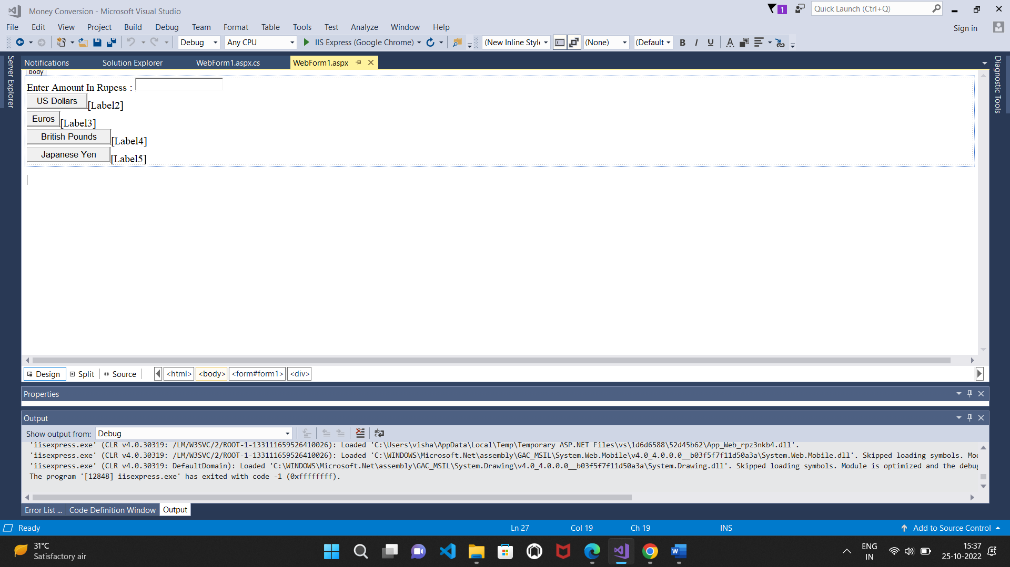

**output:**

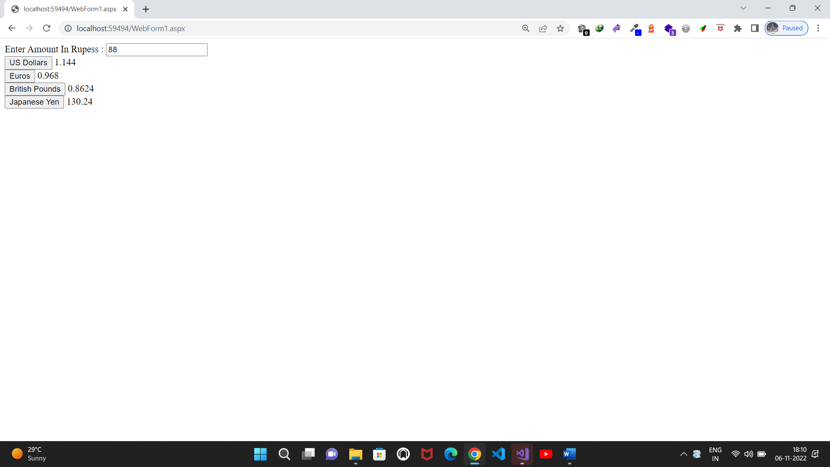

**iii) Quadratic Equation**

using System;

using System.Collections.Generic;

using System.Linq;

using System.Web;

using System.Web.UI;

using System.Web.UI.WebControls;

namespace Quadratic_Equation

{

public partial class WebForm1 : System.Web.UI.Page

{

protected void Page_Load(object sender, EventArgs e)

{

}

public void demo()

{

double a, b, c, r1, r2, x;

double det;

a = Convert.ToInt32(TextBox1.Text);

b = Convert.ToInt32(TextBox2.Text);

c = Convert.ToInt32(TextBox3.Text);

det = (b * b) - 4 * a * c;

if (det > 0)

{

x = Math.Sqrt(det);

r1 = (-b + x) / (2 * a);

r2 = (-b - x) / (2 * a);

Label4.Text = "There are two root";

Label5.Text = r1.ToString();

Label6.Text = r2.ToString();

}

else if (det == 0)

{

x = Math.Sqrt(det);

r1 = (-b + x) / 2 * a;

Label4.Text = "There is only one root";

Label6.Text = r1.ToString();

}

else

{

Label4.Text = "There is no root";

}

}

protected void Button1_Click(object sender, EventArgs e)

{

demo();

}

}

}

**Design:**

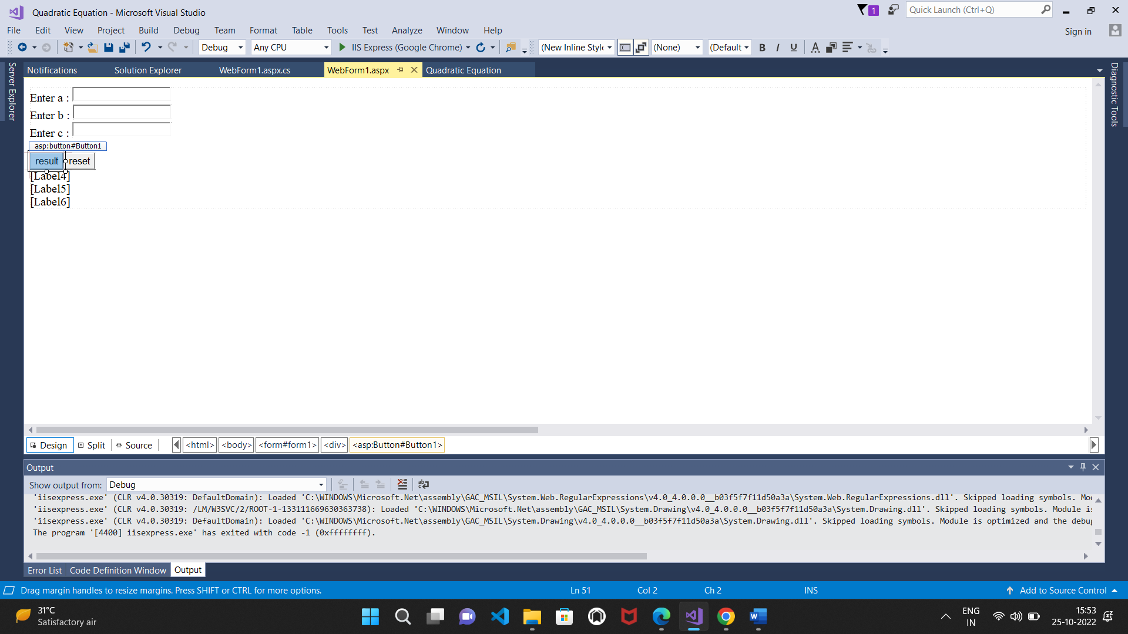

**Output:**

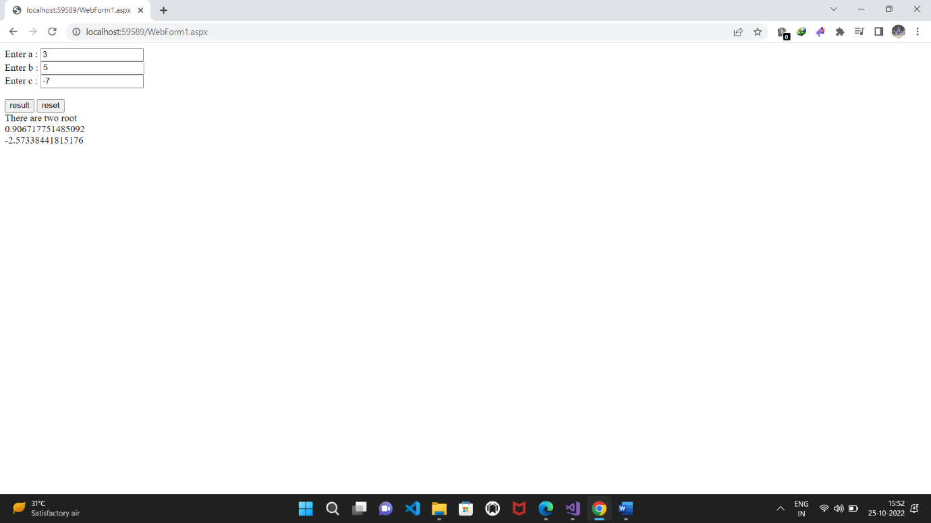

**iv) Temperature Conversion**

**Source code:**

**WebForm1.aspx.cs:**

using System;

using System.Collections.Generic;

using System.Linq;

using System.Web;

using System.Web.UI;

using System.Web.UI.WebControls;

namespace Temperature_Conversion

{

public class tempConv

{

public double ctof(double temp)

{

temp = 9.0 / 5.0 * temp + 32;

return temp;

}

public double ftoc(double temp)

{

temp = (temp - 32) * 5 / 9;

return temp;

}

}

public partial class WebForm1 : System.Web.UI.Page

{

protected void Page_Load(object sender, EventArgs e)

{

}

protected void Button1_Click(object sender, EventArgs e)

{

tempConv s = new tempConv();

double n = Convert.ToDouble(TextBox1.Text);

double x = s.ctof(n);

Label2.Text = x.ToString();

}

protected void Button2_Click(object sender, EventArgs e)

{

tempConv s = new tempConv();

double n = Convert.ToDouble(TextBox2.Text);

double x = s.ftoc(n);

Label4.Text = x.ToString();

}

}

}

**Design:**

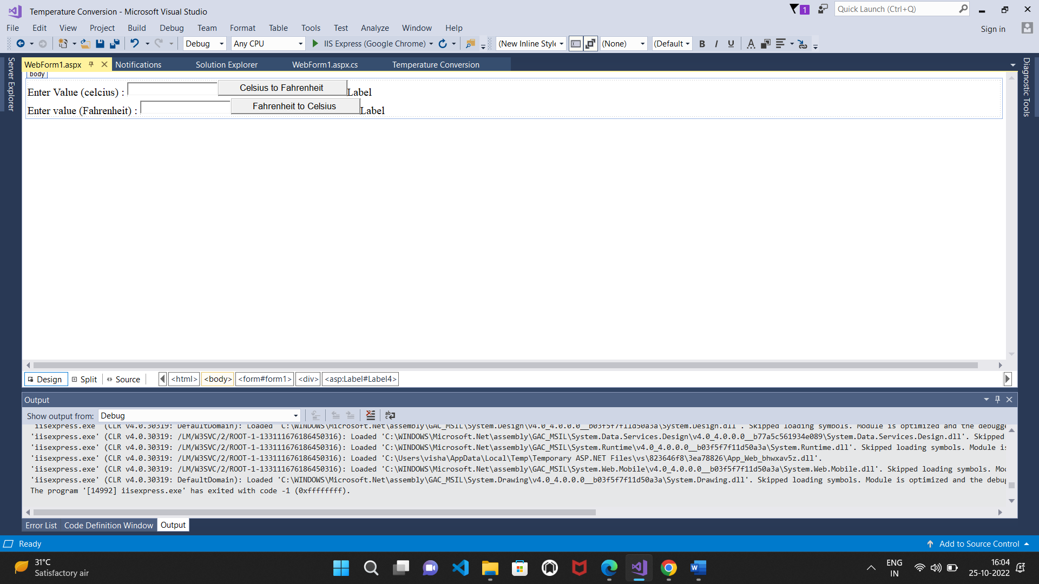

**Output:**

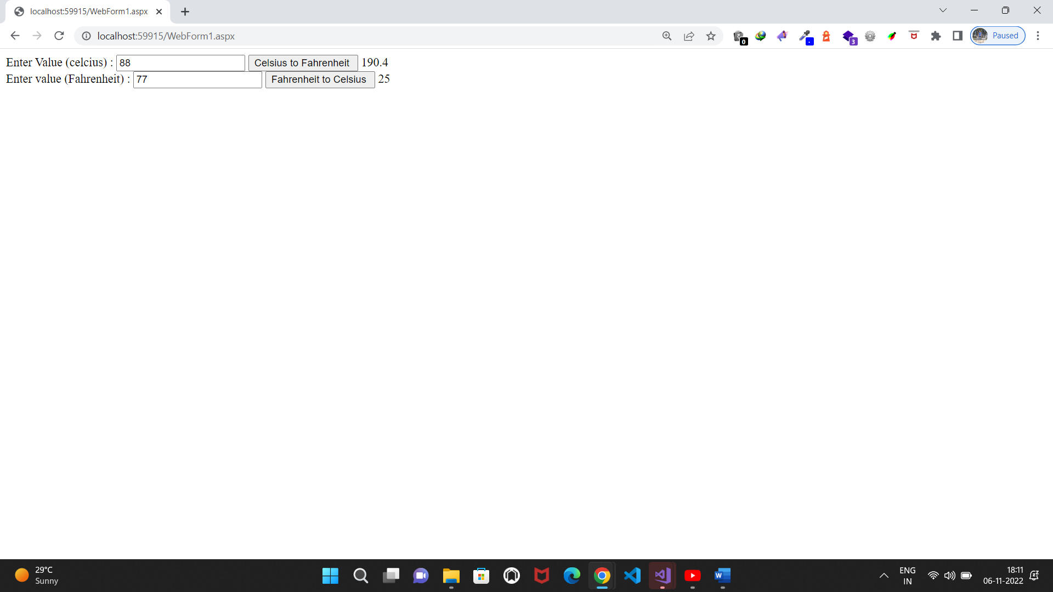

**Practical-2(b)**

**Working with Object Oriented C# and ASP.NET**

**b)Create simple application to demonstrate use of following concepts.**

**i)Function Overloading ii)Inheritance(all types)**

**iii)Constructor Overloading iv)Interfaces**

**i)Function Overloading**

**Source code:**

**WebForm1.aspx.cs:**

using System;

using System.Collections.Generic;

using System.Linq;

using System.Web;

using System.Web.UI;

using System.Web.UI.WebControls;

namespace Function_Overloading

{

public partial class WebForm1 : System.Web.UI.Page

{

public int add(int a)

{

return a + a;

}

public int add(int a, int b)

{

return a + b;

}

public int add(int a, int b, int c)

{

return a + b + c;

}

protected void Page_Load(object sender, EventArgs e)

{

int x, y, z;

x = add(2);

y = add(2, 3);

z = add(2, 3, 4);

Label2.Text = x.ToString();

Label3.Text = y.ToString();

Label4.Text = z.ToString();

}

}

}

**Design:**

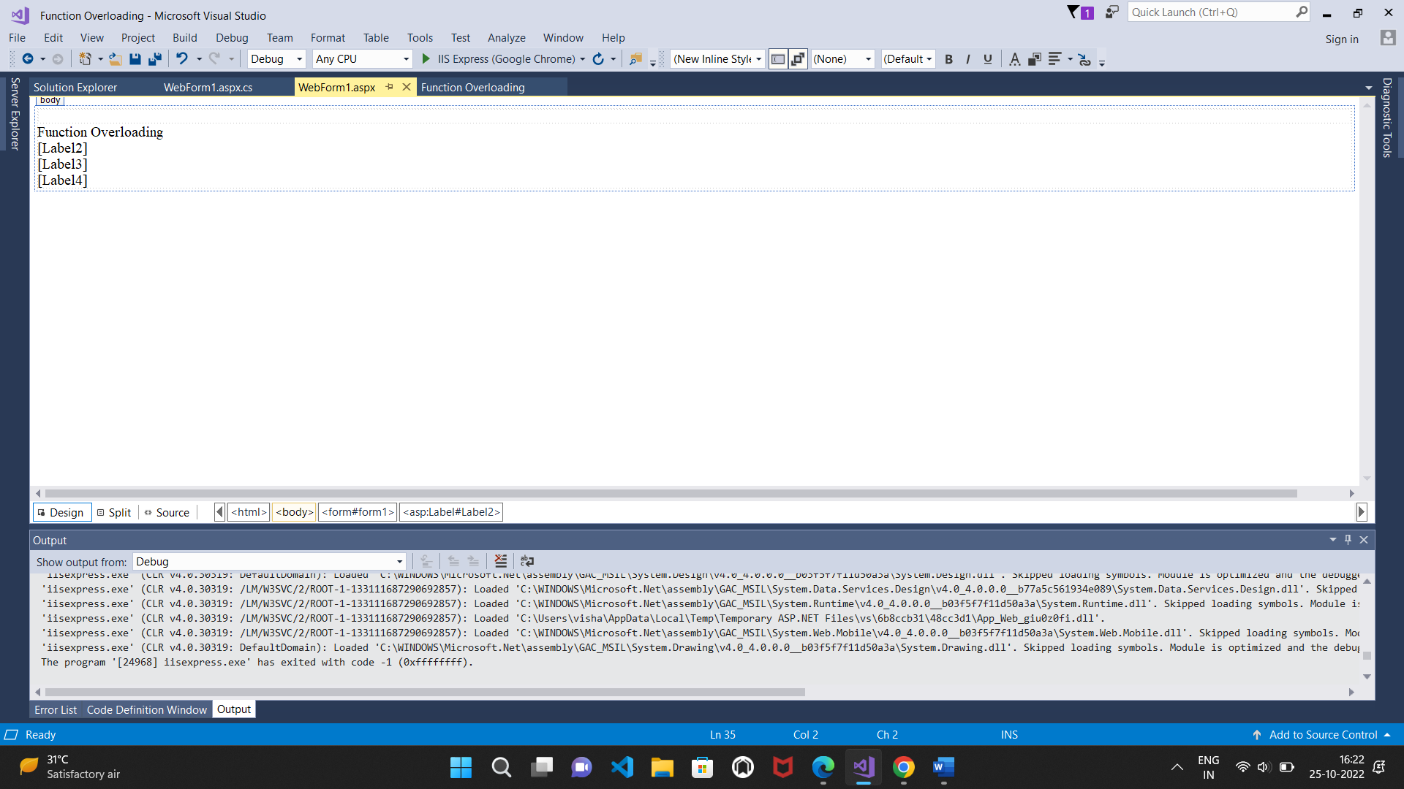

**Output:**

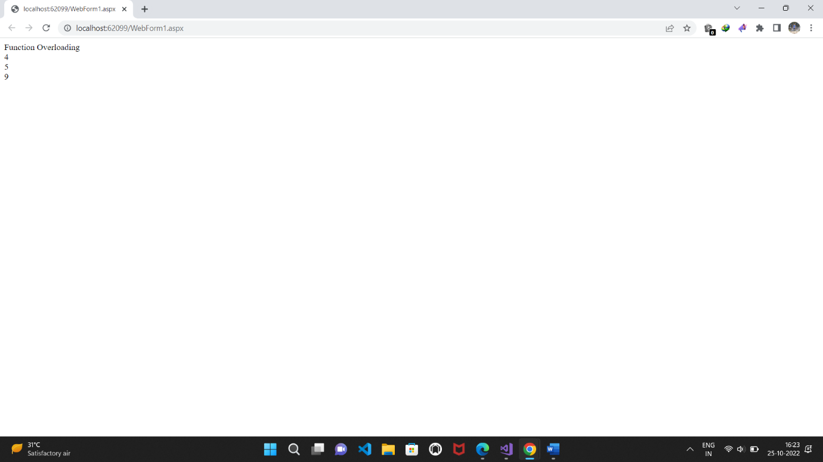

**ii)Inheritance(all types)**

**a)Single Inheritance**

**Source code:**

**WebForm1.aspx.cs:**

using System;

using System.Collections.Generic;

using System.Linq;

using System.Web;

using System.Web.UI;

using System.Web.UI.WebControls;

namespace Single_Inheritance

{

public partial class WebForm1 : System.Web.UI.Page

{

protected void Page_Load(object sender, EventArgs e)

{

}

protected void Button1_Click(object sender, EventArgs e)

{

B s = new B();

int n = Convert.ToInt32(TextBox1.Text);

int x = s.sqrt(n);

int y = s.cube(n);

Label4.Text = x.ToString();

Label5.Text = y.ToString();

}

}

public class A

{

public int sqrt(int val1)

{

return val1 * val1;

}

}

public class B : A

{

public int cube(int val1)

{

int v1 = sqrt(val1);

return v1 * val1;

}

}

}

**Design:**

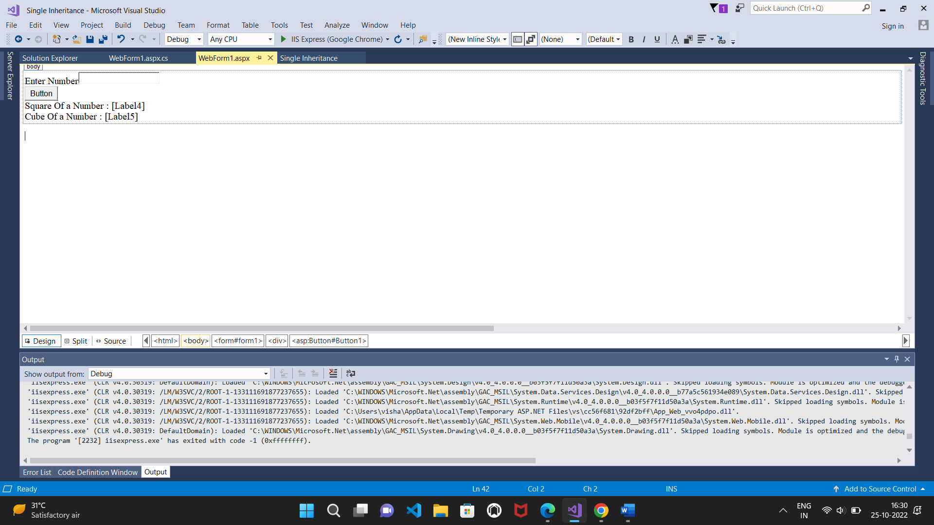

**Output:**

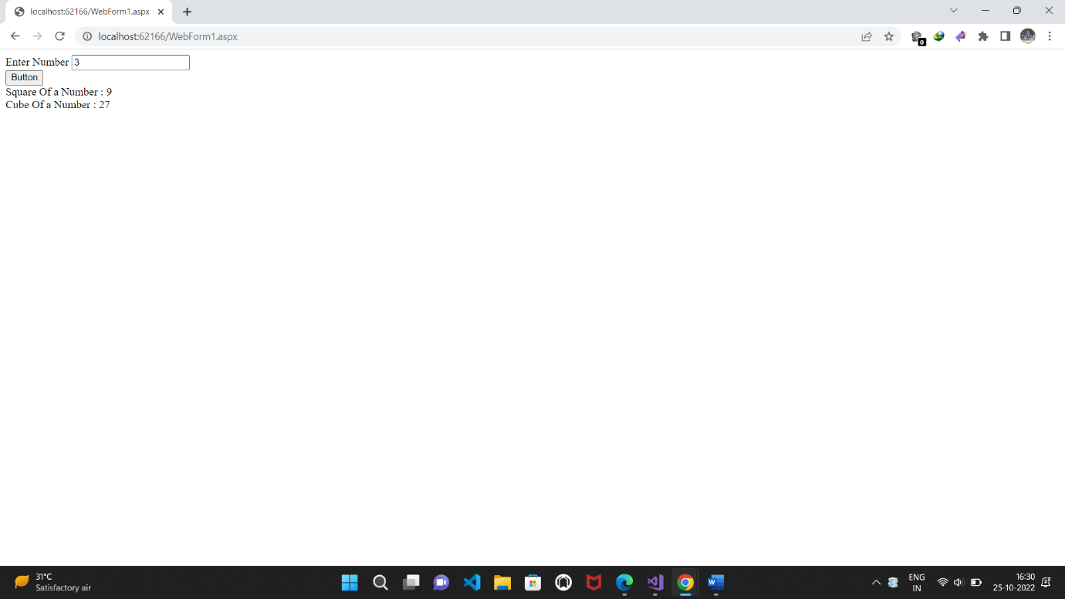

**B)Multilevel Inheritance**

**Source code:**

**WebForm1.aspx.cs:**

using System;

using System.Collections.Generic;

using System.Linq;

using System.Web;

using System.Web.UI;

using System.Web.UI.WebControls;

namespace Multilevel_Inheritance

{

public partial class WebForm1 : System.Web.UI.Page

{

protected void Page_Load(object sender, EventArgs e)

{

}

protected void Button1_Click(object sender, EventArgs e)

{

C s = new C();

int n = Convert.ToInt32(TextBox1.Text);

int x = s.pow2(n);

int y = s.pow3(n);

int z = s.pow4(n);

Label5.Text = x.ToString();

Label6.Text = y.ToString();

Label7.Text = z.ToString();

}

}

public class A

{

public int pow2(int val1)

{

return val1 * val1;

}

}

public class B : A

{

public int pow3(int val1)

{

int v1 = pow2(val1);

return v1 * val1;

}

}

public class C : B

{

public int pow4(int val1)

{

int v1 = pow3(val1);

return v1 * val1;

}

}

}

**Design:**

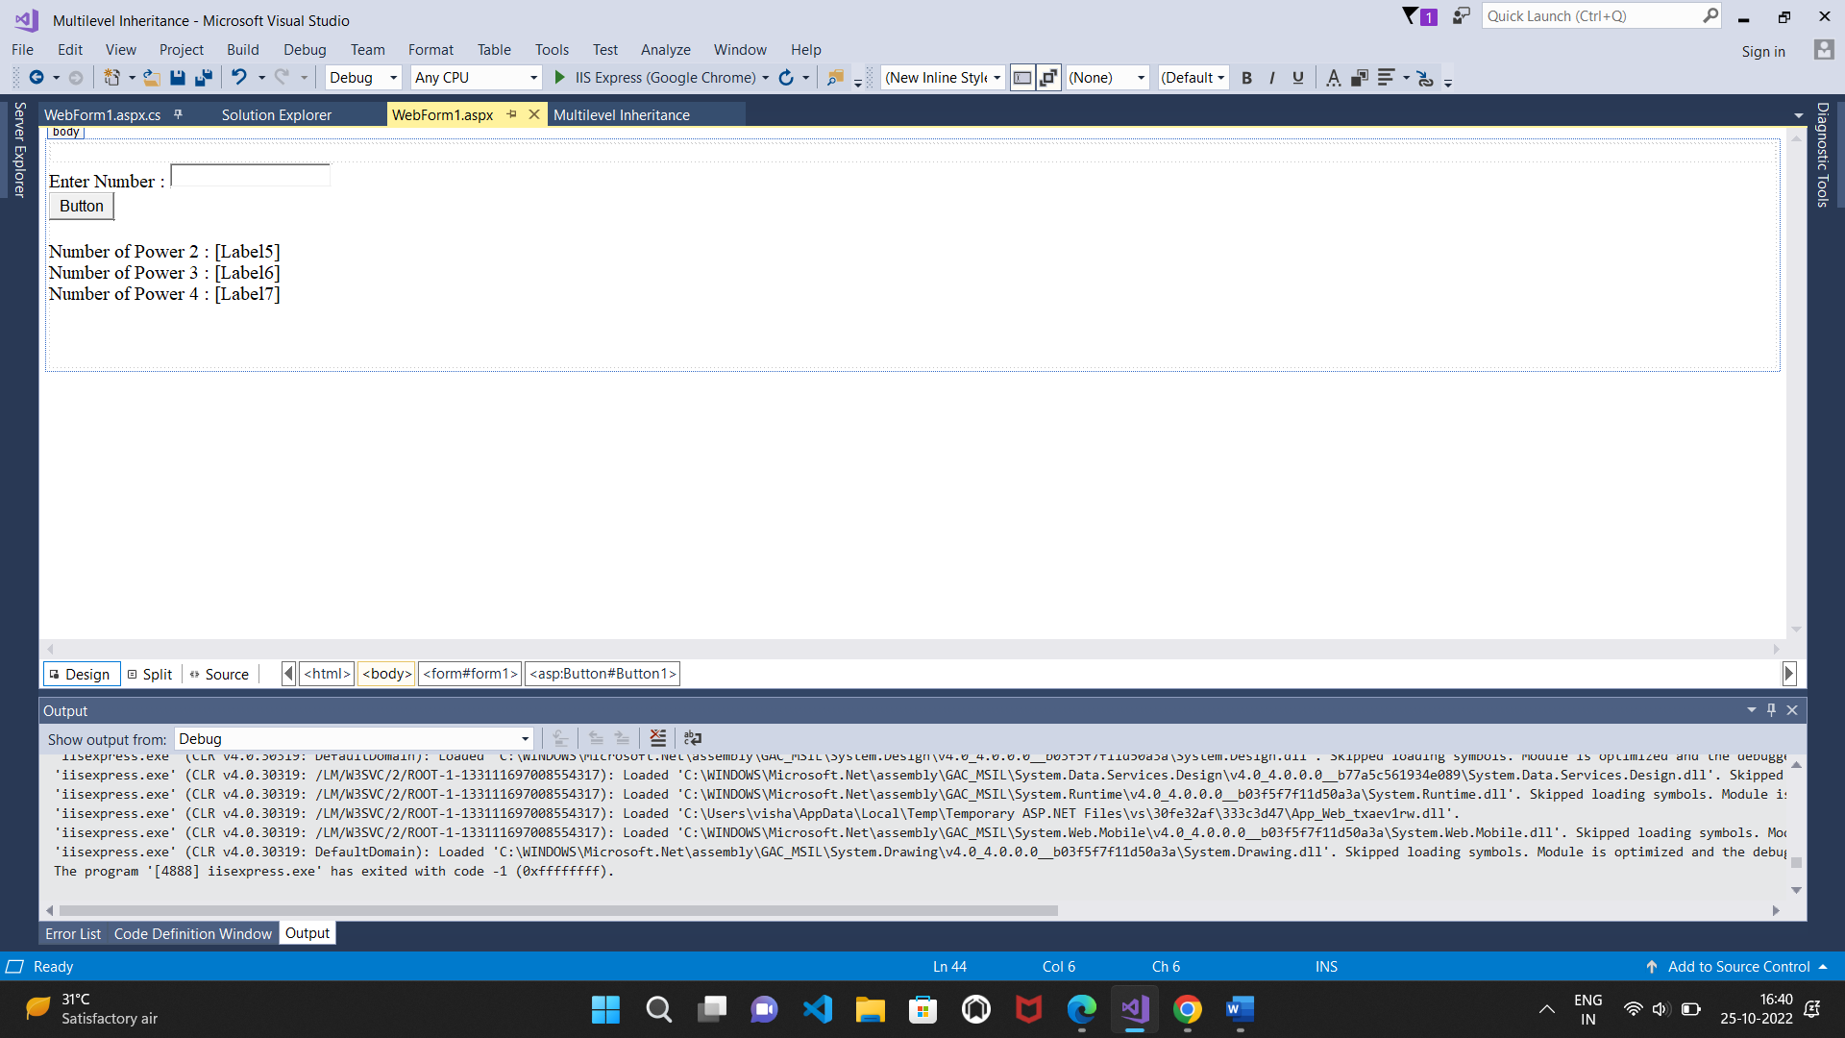

**Output:**

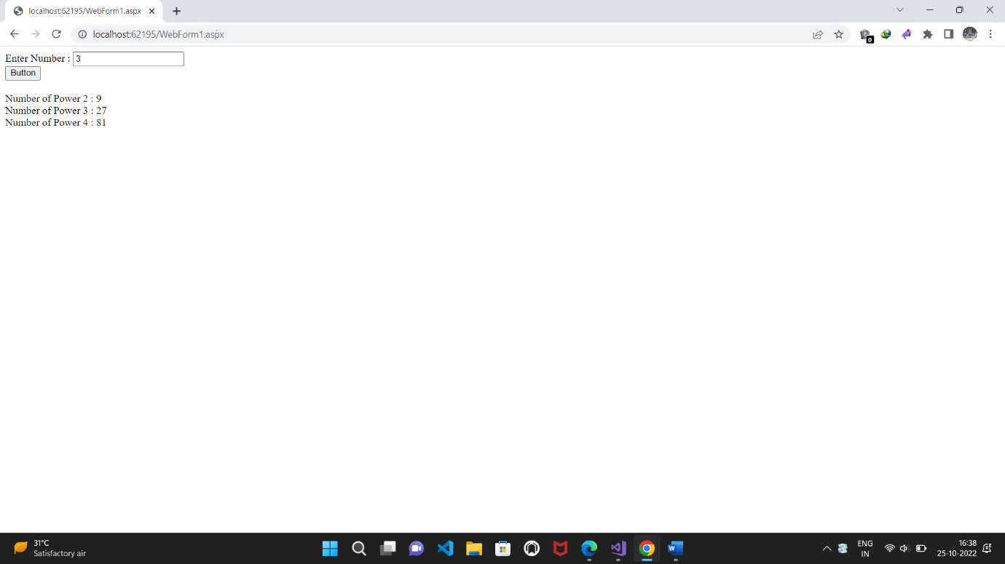

**c)Hierarchical Inheritance**

**Source code:**

**WebForm1.aspx.cs:**

using System;

using System.Collections.Generic;

using System.Linq;

using System.Web;

using System.Web.UI;

using System.Web.UI.WebControls;

namespace Hierarchical_Inheritance

{

public partial class WebForm1 : System.Web.UI.Page

{

public class A

{

public int a;

public int b;

}

public class B : A

{

public int add(int val1, int val2)

{

a = val1;

b = val2;

return a + b;

}

}

public class C : A

{

public int sub(int val1, int val2)

{

a = val1;

b = val2;

return a - b;

}

}

protected void Page_Load(object sender, EventArgs e)

{

}

protected void TextBox1_TextChanged(object sender, EventArgs e)

{

}

protected void Button1_Click(object sender, EventArgs e)

{

B s1 = new B();

C s2 = new C();

int m = Convert.ToInt32(TextBox1.Text);

int n = Convert.ToInt32(TextBox2.Text);

int x = s1.add(m, n);

int y = s2.sub(m, n);

Label4.Text = x.ToString();

Label6.Text = y.ToString();

}

}

}

**Design:**

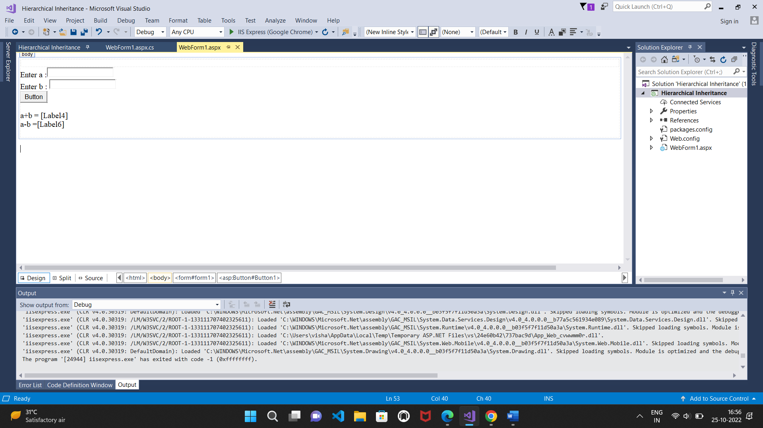

**Output:**

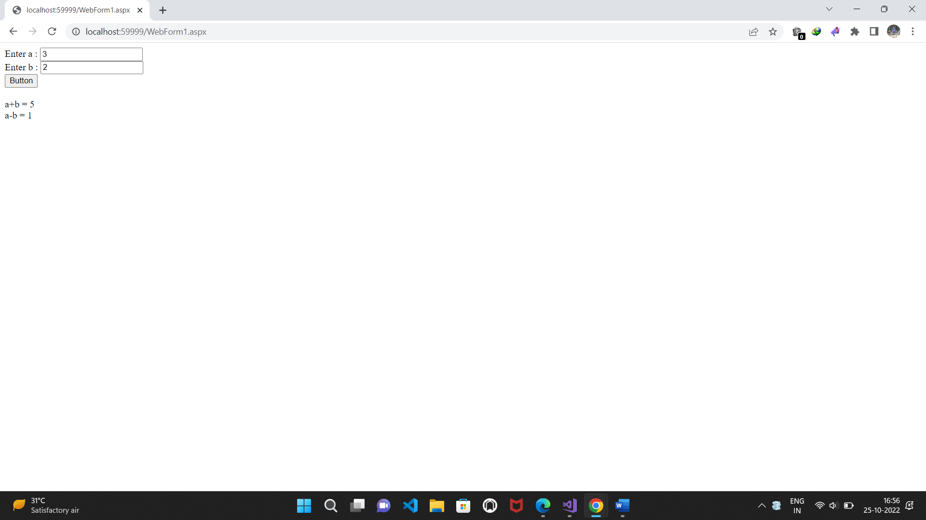

**iii)Constructor Overloading**

**Source code:**

**WebForm1.aspx.cs:**

using System;

using System.Collections.Generic;

using System.Linq;

using System.Web;

using System.Web.UI;

using System.Web.UI.WebControls;

namespace Constructor_Overloading

{

public partial class WebForm1 : System.Web.UI.Page

{

protected void Page_Load(object sender, EventArgs e)

{

add obj1 = new add(2);

add obj2 = new add(2, 3);

add obj3 = new add(2, 3, 4);

Label4.Text = obj1.r.ToString();

Label2.Text = obj2.r.ToString();

Label3.Text = obj3.r.ToString();

}

public class add

{

public int r;

public add(int a)

{

r = a + a;

}

public add(int a, int b)

{

r = a + b;

}

public add(int a, int b, int c)

{

r = a + b + c;

}

}

}

}

**Design:**

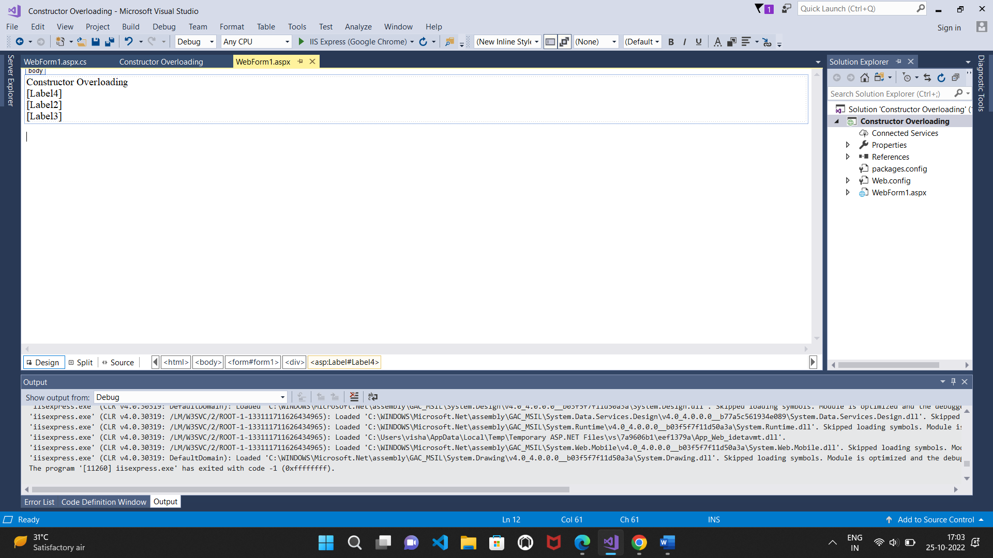

**Output:**

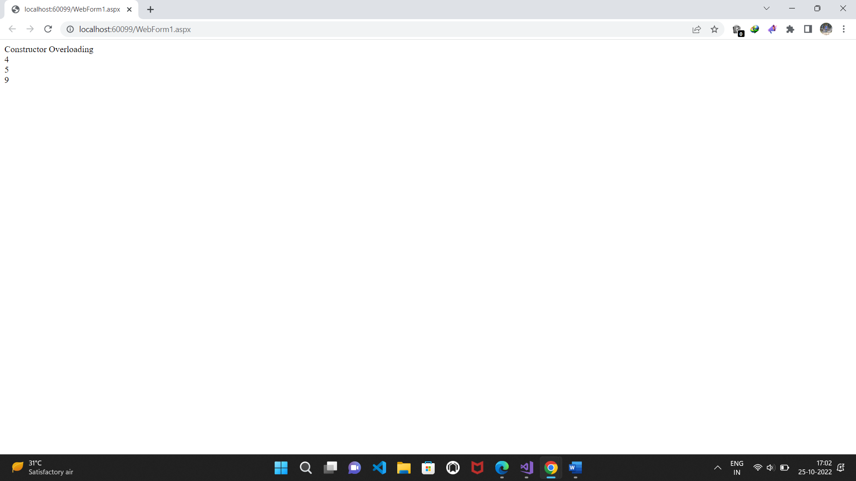

**iv)Interfaces**

**Source code:**

**WebForm1.aspx.cs:**

using System;

using System.Collections.Generic;

using System.Linq;

using System.Web;

using System.Web.UI;

using System.Web.UI.WebControls;

namespace Interfaces

{

interface Area

{

double show(double s, double t);

}

class rect : Area

{

public double show(double s, double t)

{

return s * t;

}

}

class Circle : Area

{

public double show(double s, double t)

{

return (3.14 * s * s);

}

}

public partial class WebForm1 : System.Web.UI.Page

{

protected void Page_Load(object sender, EventArgs e)

{

rect r1 = new rect();

double x = r1.show(3, 4);

Circle r2 = new Circle();

double y = r2.show(3, 4);

Label3.Text = x.ToString();

Label5.Text = y.ToString();

}

}

}

**Design:**

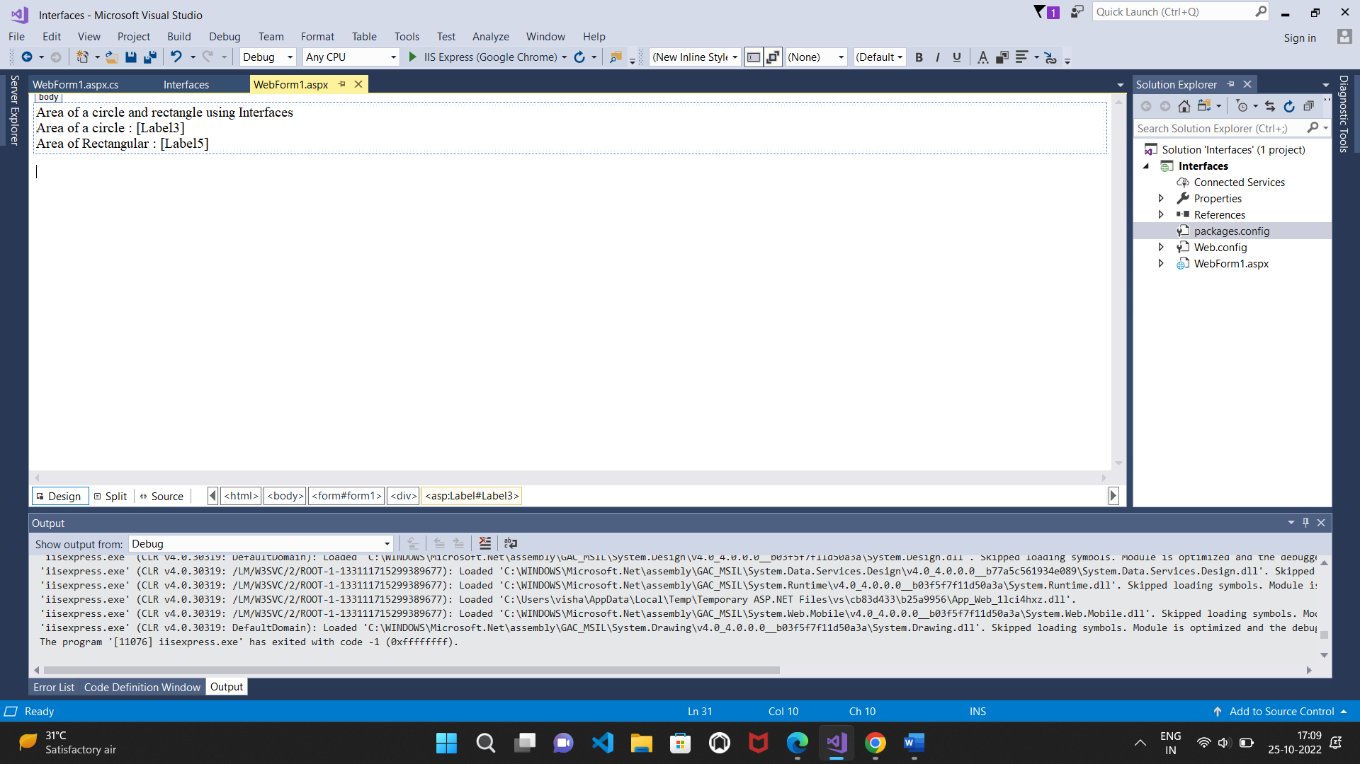

**Output:**

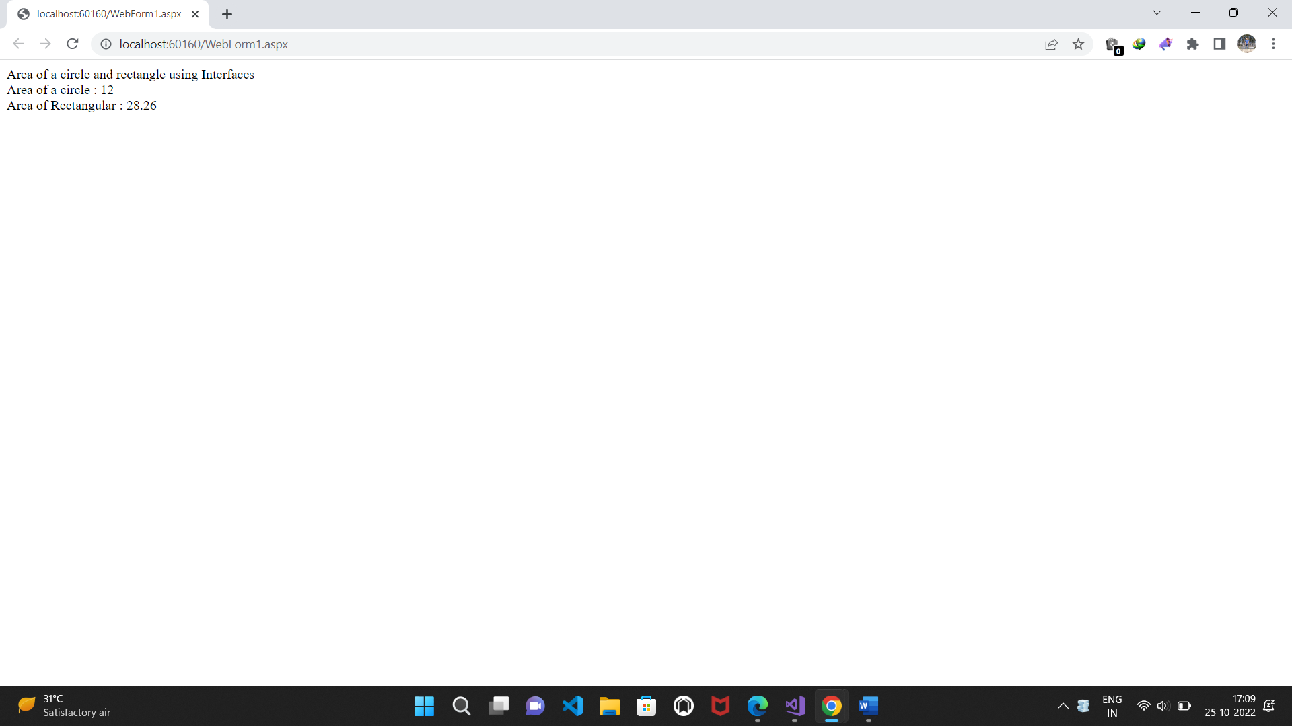

**Practical-2(c)**

**Working with Object Oriented C# and ASP.NET**

**c)Create simple application to demonstrate use of following concepts:**

**i)Using delegates and events ii)Exception handling Solution:**

**i)Using delegates and events**

**Source code:**

**WebForm1.aspx.cs:**

using System;

using System.Collections.Generic;

using System.Linq;

using System.Web;

using System.Web.UI;

using System.Web.UI.WebControls;

namespace Using_delegates_and_events

{

public partial class WebForm1 : System.Web.UI.Page

{

public delegate string dele();

public static string display()

{

string s1 = "Vishal kushwaha";

return s1;

}

public static string dis()

{

string s2 = "vishalkumar kushwaha";

return s2;

}

protected void Page_Load(object sender, EventArgs e)

{

dele d1 = new dele(display);

d1();

dele d2 = new dele(dis);

d2();

Label1.Text = d1();

Label2.Text = d2();

}

}

}

**Design:**

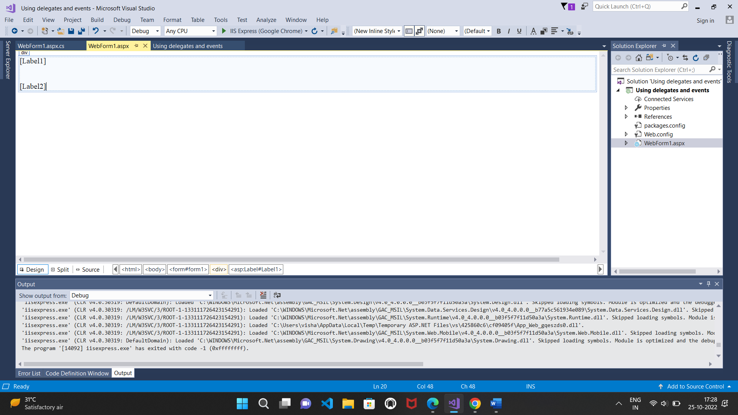

**Output:**

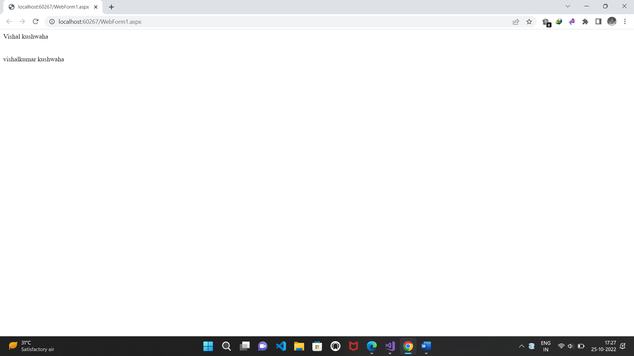

**ii)Exception Handling**

**Source code:**

**WebForm1.aspx.cs:**

using System;

using System.Collections.Generic;

using System.Linq;

using System.Web;

using System.Web.UI;

using System.Web.UI.WebControls;

class NegativeException : Exception

{

public NegativeException(string msg):base(msg)

{

}

}

namespace _Exception_Handling

{

public partial class WebForm1 : System.Web.UI.Page

{

protected void Page_Load(object sender, EventArgs e)

{

}

protected void Button1_Click(object sender, EventArgs e)

{

int num;

try

{

num = int.Parse(TextBox1.Text);

if (num < 0)

throw new NegativeException("negative number");

else;

Response.Write("positive Number");

}

catch (NegativeException en)

{

Response.Write(en.Message);

}

}

}

}

**Design:**

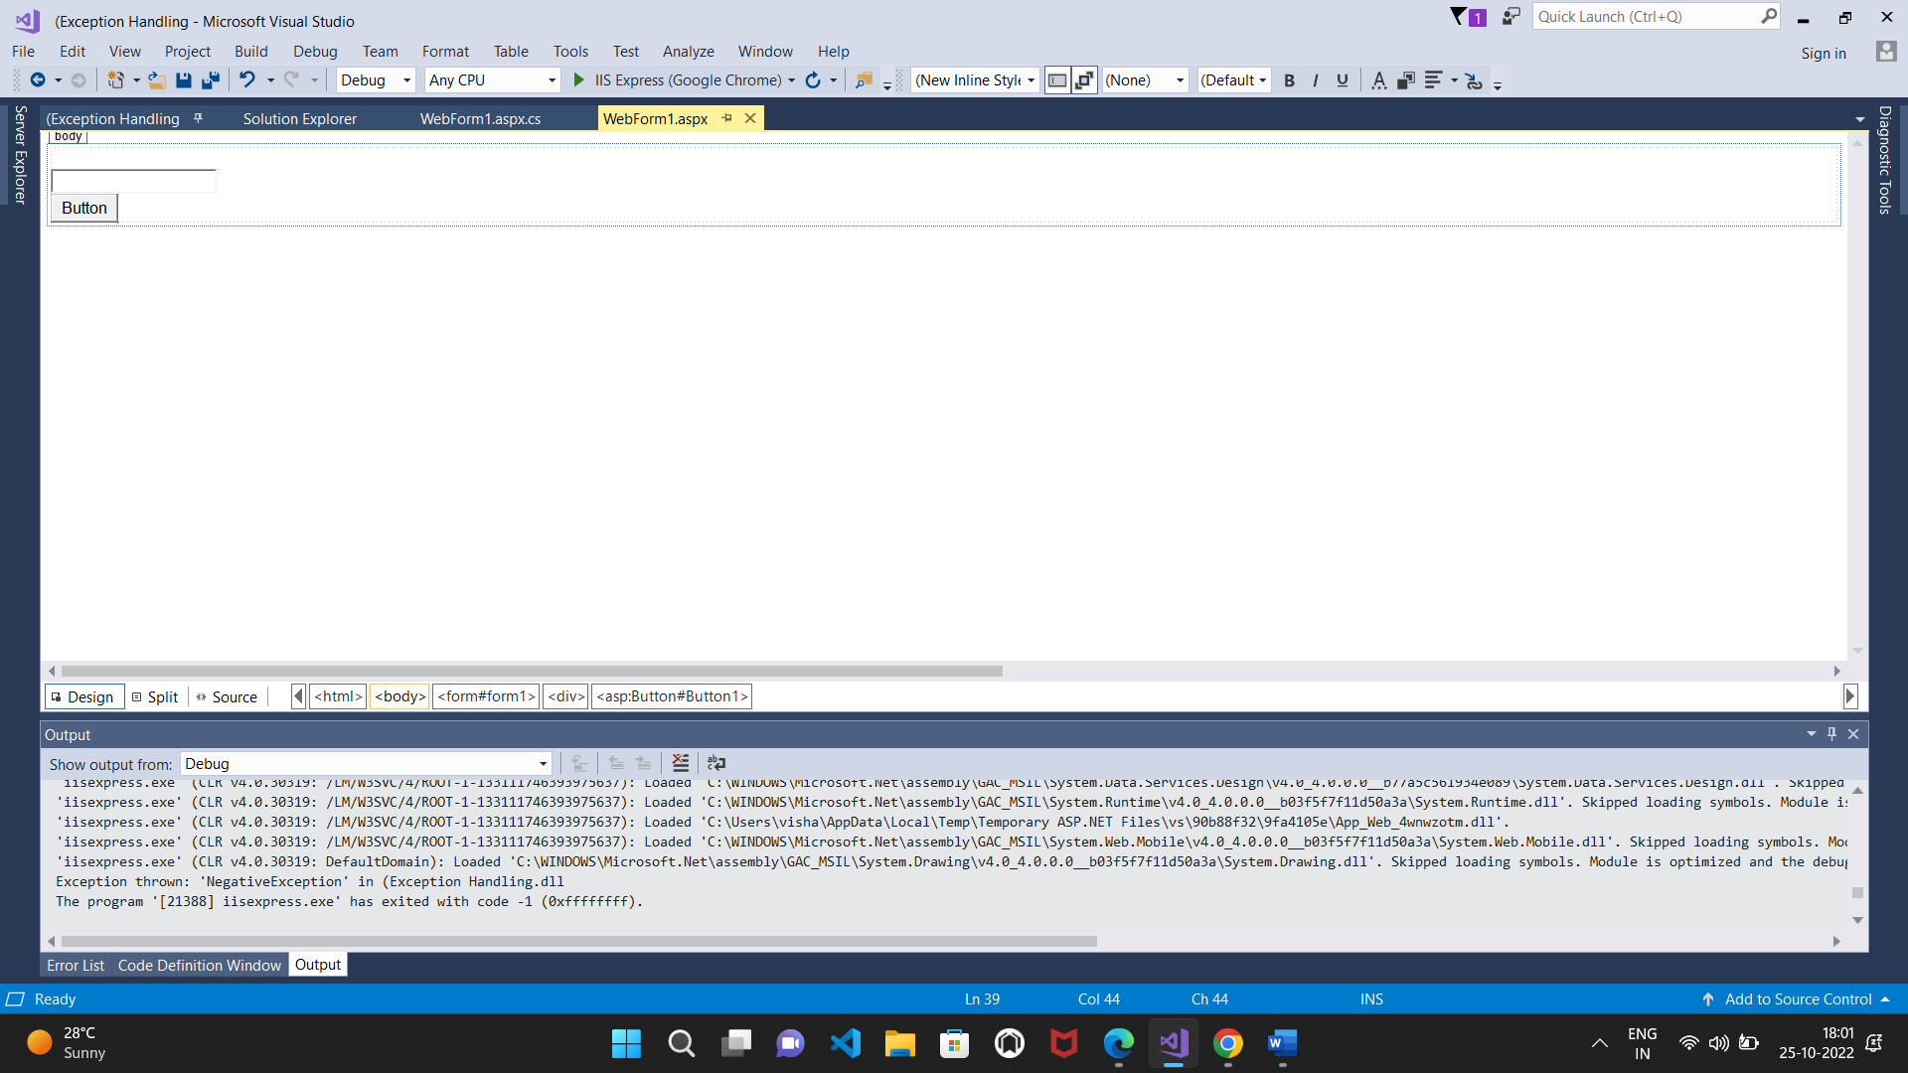

**Output:**

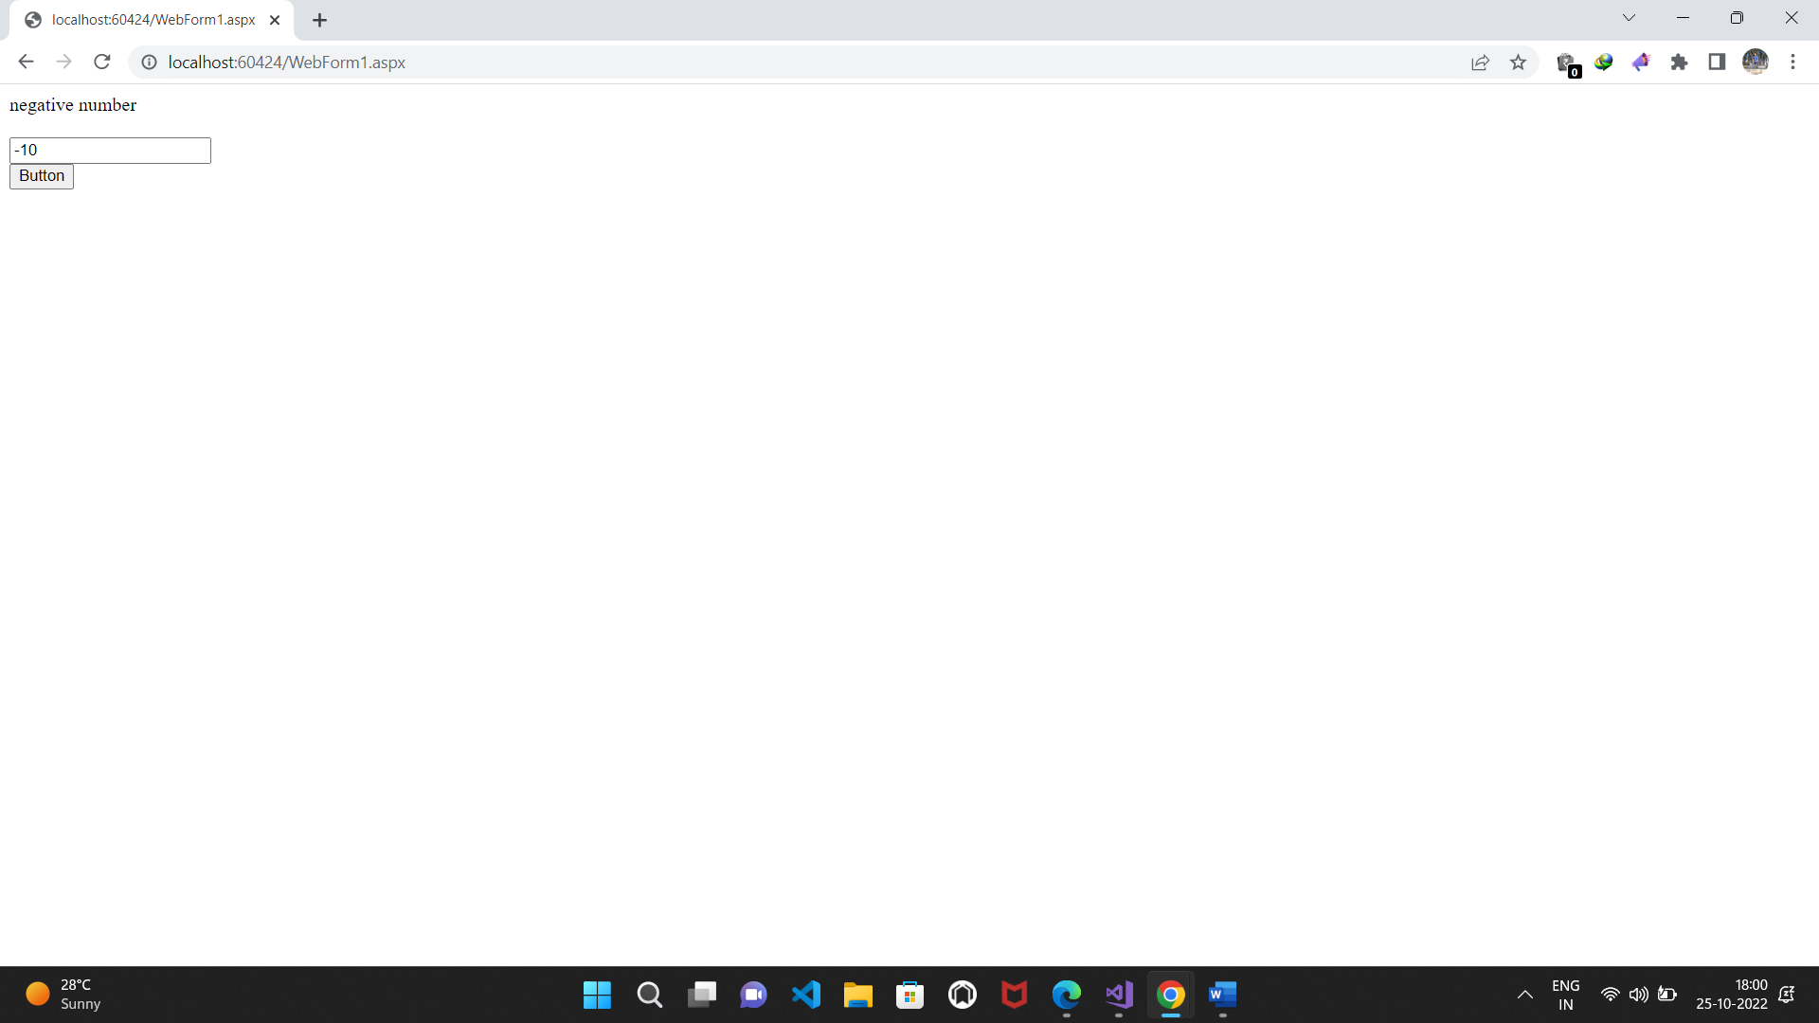

**Practical No.3(a)**

**3. Working with Web Forms and Controls**

1. **Create a simple web page with various server controls to demonstrate setting and use of their properties (Examples : AutoPostBack).**

using System;

using System.Collections.Generic;

using System.Linq;

using System.Web;

using System.Web.UI;

using System.Web.UI.WebControls;

namespace WebApplication3

{

public partial class WebForm1 : System.Web.UI.Page

{

protected void Page_Load(object sender, EventArgs e)

{

}

protected void RadioButton3_CheckedChanged(object sender, EventArgs e)

{

}

protected void Button1_Click(object sender, EventArgs e)

{

string a;

if (RadioButton1.Checked == true)

{

a = RadioButton1.Text;

}

if (RadioButton2.Checked == true)

{

a = RadioButton2.Text;

}

else

{

a = RadioButton3.Text;

}

Label5.Text += " in " + a;

}

protected void DropDownList1_SelectedIndexChanged(object sender, EventArgs e)

{

Label5.Text = "You have been enrolled in " + DropDownList1.SelectedItem;

}

}

}

Design:

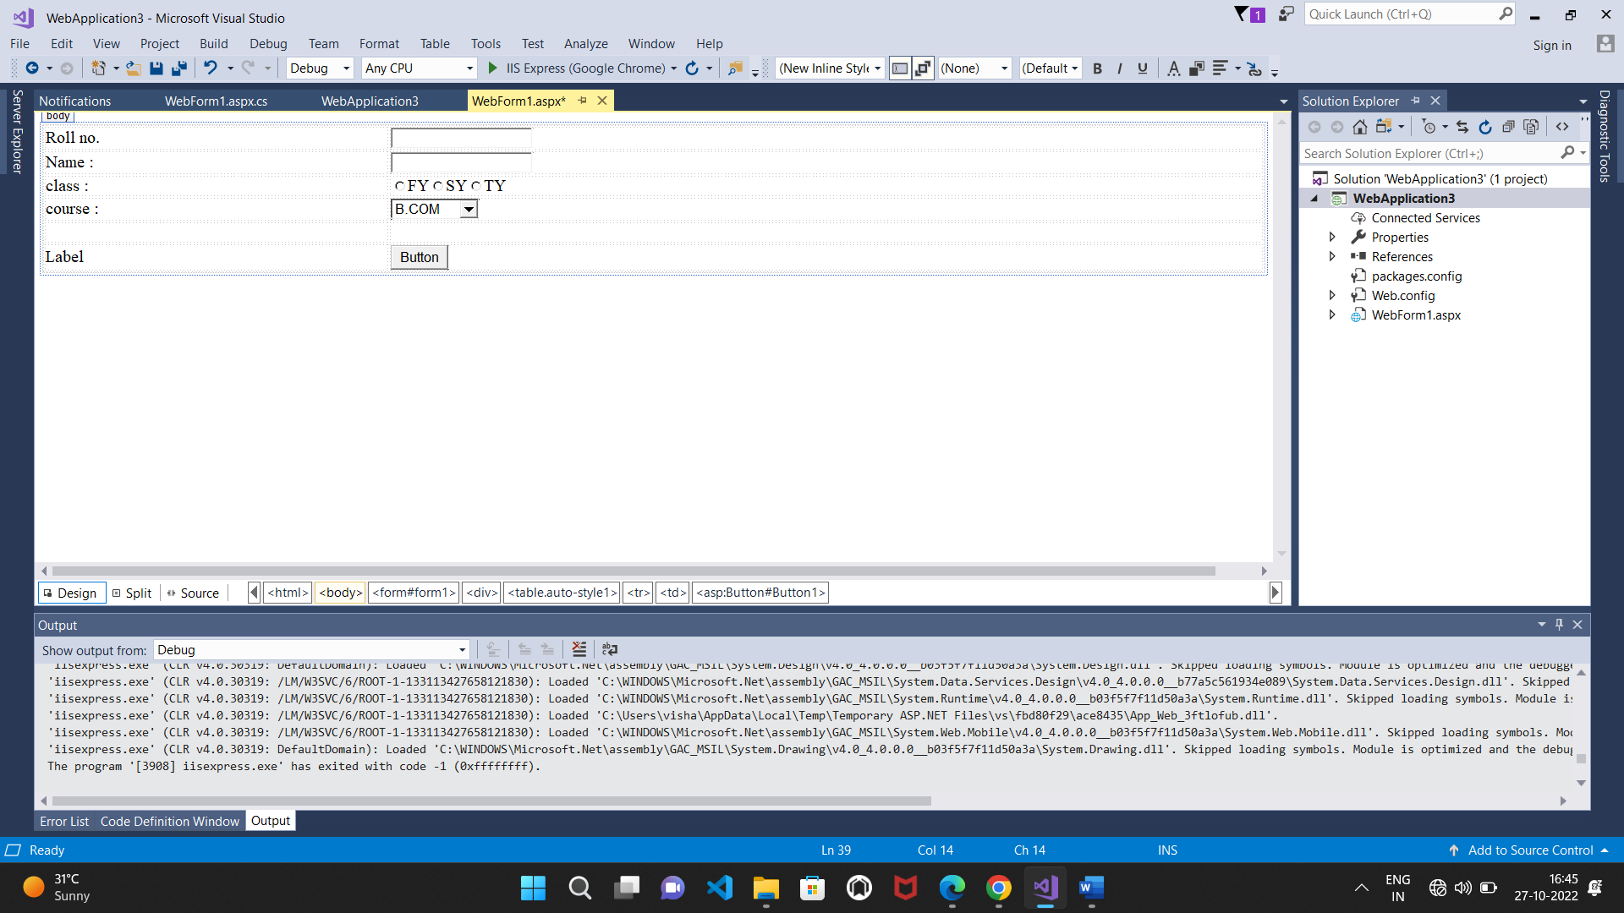

Output:

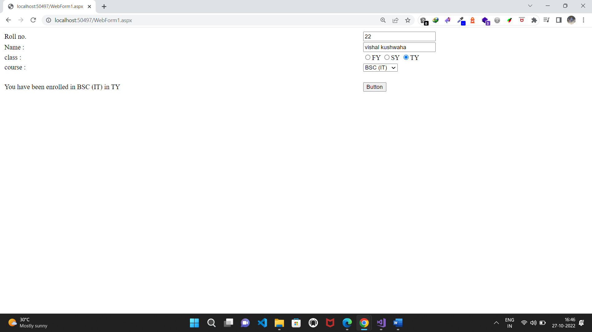

**Practical No.3(b)**

**3. Working with Web Forms and Controls**

**B. Demonstrate the use of Calendar control to perform following operations.**

**a) Display messages in a calendar control b) Display vacation in a calendar control**

**c) Selected day in a calendar control using style d) Difference between two calendar dates**

**a)Display messages in a calendar control**

**Source code:**

**WebForm1.aspx.cs:**

using System;

using System.Collections.Generic;

using System.Linq;

using System.Web;

using System.Web.UI;

using System.Web.UI.WebControls;

namespace WebApplication8

{

public partial class WebForm1 : System.Web.UI.Page

{

protected void Page_Load(object sender, EventArgs e)

{

}

protected void Calendar1_DayRender(object sender, DayRenderEventArgs e)

{

if (e.Day.Date.Day == 7)

e.Cell.Controls.Add(new LiteralControl("</br>Holiday"));

}

}

}

**Design:** 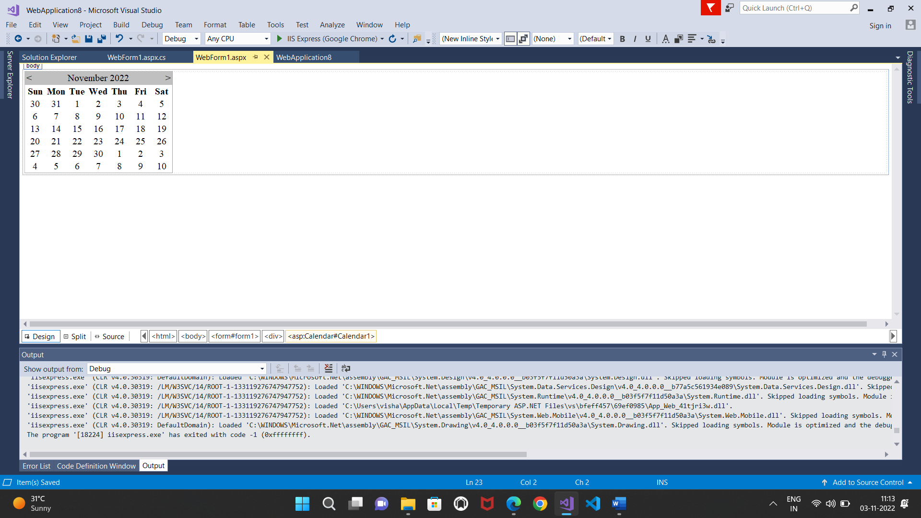

**Output**:

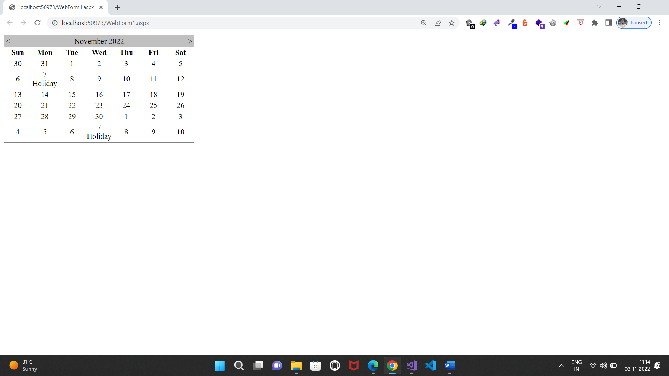

**B)Display vacation in a calendar control**

**Source code:**

**WebForm1.aspx.cs:**

using System;

using System.Collections.Generic;

using System.Linq;

using System.Web;

using System.Web.UI;

using System.Web.UI.WebControls;

namespace WebApplication9

{

public partial class WebForm1 : System.Web.UI.Page

{

protected void Page_Load(object sender, EventArgs e)

{

}

protected void Calendar1_DayRender(object sender, DayRenderEventArgs e)

{

if ((e.Day.Date >= new DateTime(2022, 11, 7)) && (e.Day.Date <= new DateTime(2022, 11, 13)))

{

e.Cell.BackColor = System.Drawing.Color.OrangeRed;

e.Cell.BorderColor = System.Drawing.Color.Black;

e.Cell.BorderWidth = new Unit(2);

}

}

}

}

**Design:** 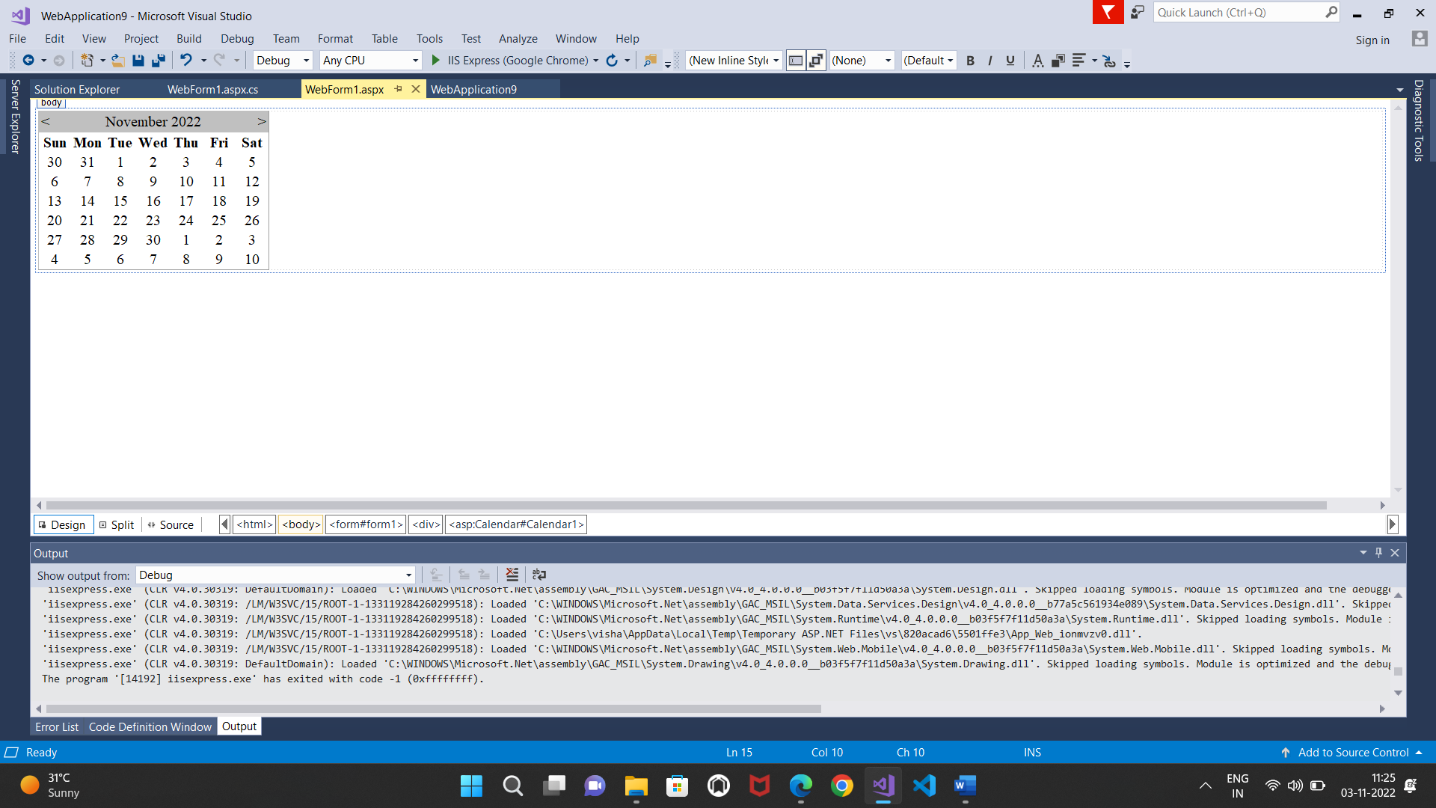

**Output:**

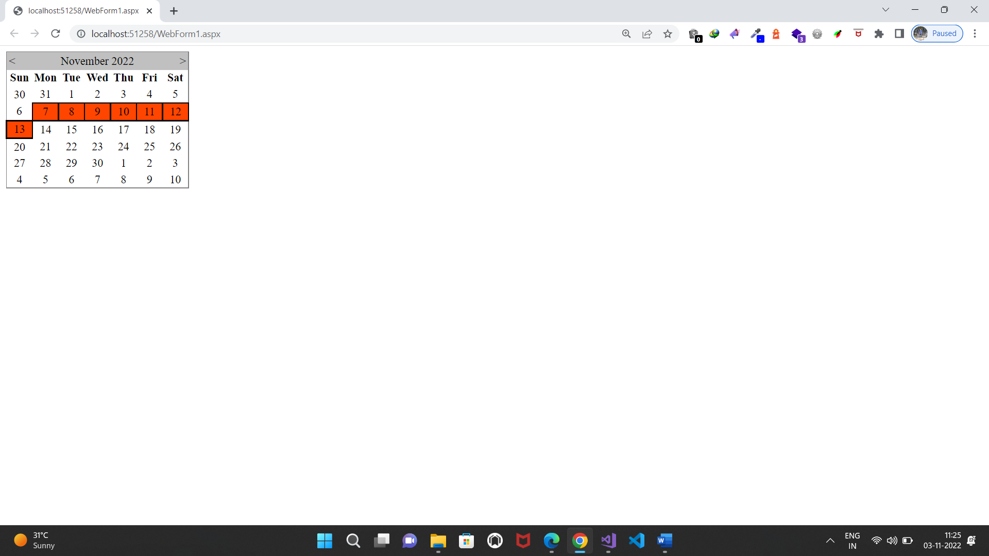

**c)Selected day in a calendar control using style dates**

**Source code:**

**WebForm1.aspx.cs:**

using System;

using System.Collections.Generic;

using System.Linq;

using System.Web;

using System.Web.UI;

using System.Web.UI.WebControls;

namespace WebApplication10

{

public partial class WebForm1 : System.Web.UI.Page

{

protected void Page_Load(object sender, EventArgs e)

{

}

protected void Calendar1_DayRender(object sender, DayRenderEventArgs e)

{

if ((e.Day.Date >= new DateTime(2022, 11, 3)) && (e.Day.Date <= new DateTime(2022, 11, 7)))

{

e.Cell.BackColor = System.Drawing.Color.Blue;

e.Cell.BorderColor = System.Drawing.Color.Black;

e.Cell.BorderWidth = new Unit(3);

if (e.Day.IsOtherMonth)

{

e.Cell.Controls.Clear();

}

}

}

}

}

**Design:**

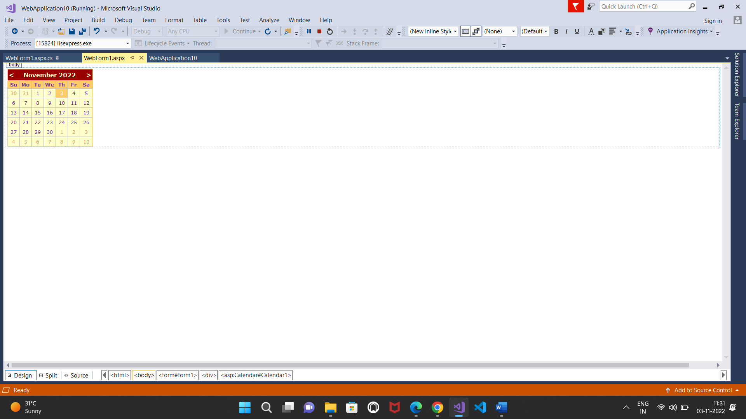

**Output:**

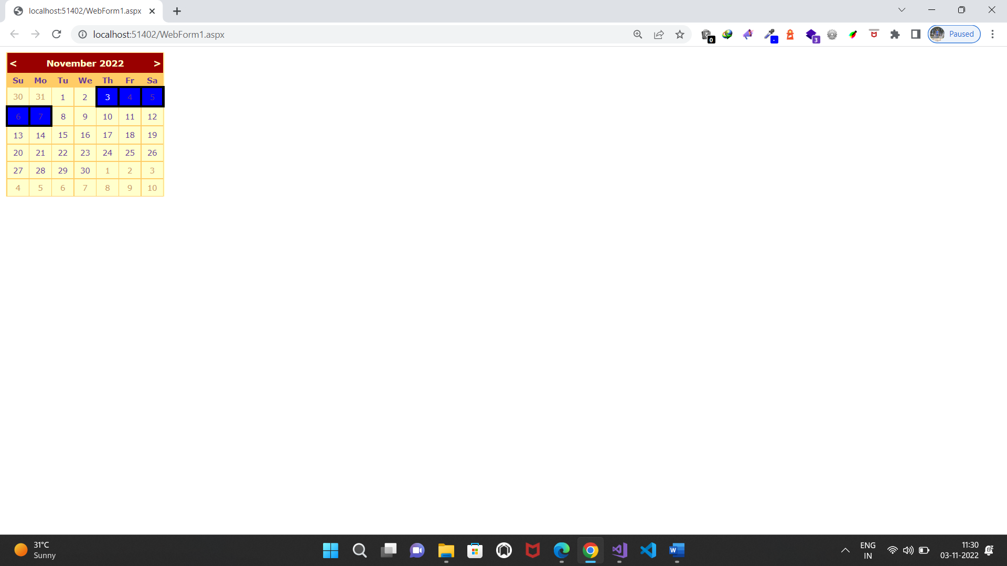

**d) Difference between two calendar dates**

**Source code:**

**WebForm1.aspx.cs:**

using System;

using System.Collections.Generic;

using System.Linq;

using System.Web;

using System.Web.UI;

using System.Web.UI.WebControls;

namespace WebApplication11

{

public partial class WebForm1 : System.Web.UI.Page

{

protected void Page_Load(object sender, EventArgs e)

{

}

protected void Calendar1_SelectionChanged(object sender, EventArgs e)

{

}

protected void Button1_Click(object sender, EventArgs e)

{

TimeSpan t = Calendar1.SelectedDate - Calendar2.SelectedDate;

Label1.Text += t.Days.ToString();

}

}

}

**Design:**

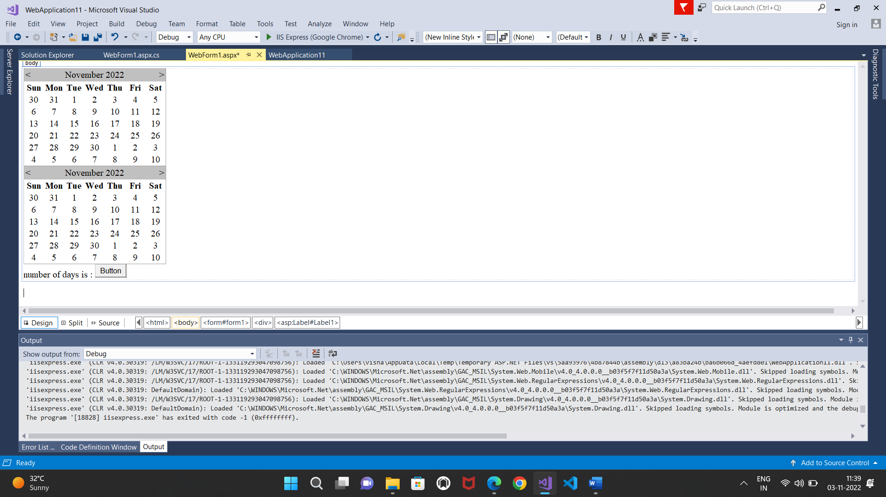

**Output:**

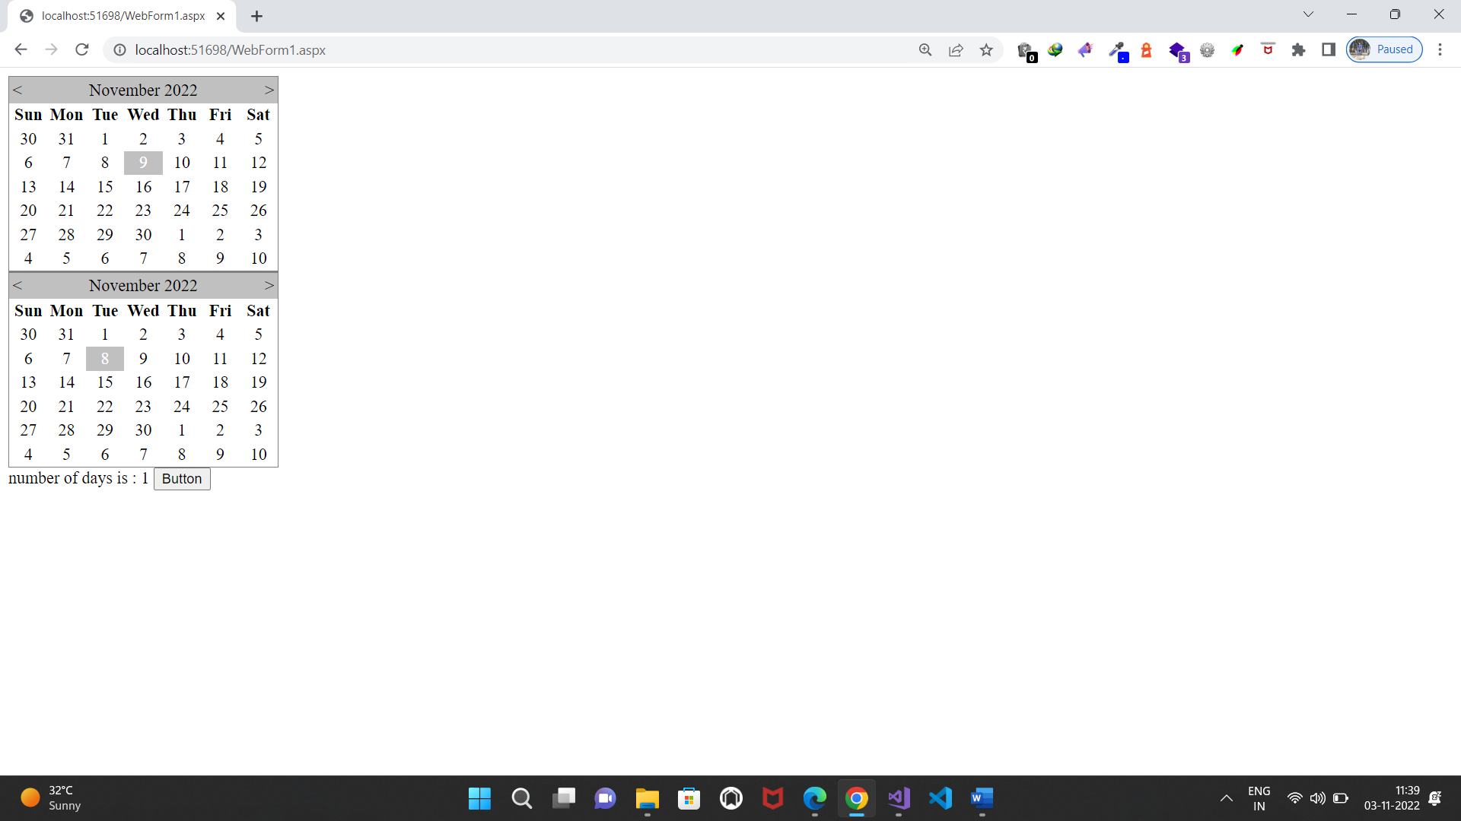

**Practical No.3(c)**

**3. Working with Web Forms and Controls**

**a) Demonstrate the use of Treeview control perform following operations.**

**a) Treeview control and datalist b) Treeview operations**

**Source code:**

**WebForm1.aspx.cs:**

using System;

using System.Collections.Generic;

using System.Linq;

using System.Web;

using System.Web.UI;

using System.Web.UI.WebControls;

namespace WebApplication12

{

public partial class WebForm1 : System.Web.UI.Page

{

protected void Page_Load(object sender, EventArgs e)

{

}

protected void Button1_Click(object sender, EventArgs e)

{

TreeNodeCollection T;

T = TreeView1.CheckedNodes;

DataList1.DataSource = T;

DataList1.DataBind();

DataList1.Visible = true;

}

}

}

**Source code:**

Page Language="C#" AutoEventWireup="true" CodeBehind="WebForm1.aspx.cs" Inherits="WebApplication12.WebForm1" %>

<!DOCTYPE html>

<html xmlns="http://www.w3.org/1999/xhtml">

<head runat="server">

<title></title>

</head>

<body>

<form id="form1" runat="server">

<div>

<asp:TreeView ID="TreeView1" runat="server">

<Nodes>

<asp:TreeNode Text="BCome" Value="BCome" Checked="True" ShowCheckBox="True">

<asp:TreeNode Text="fycome" Value="fycome" Checked="True" ShowCheckBox="True"></asp:TreeNode>

<asp:TreeNode Text="sybcom" Value="sybcom" Checked="True" ShowCheckBox="True"></asp:TreeNode>

<asp:TreeNode Text="tybcom" Value="tybcom" Expanded="True" ShowCheckBox="True"></asp:TreeNode>

</asp:TreeNode>

<asp:TreeNode Text="bscit" Value="bscit" Checked="True" ShowCheckBox="True">

<asp:TreeNode Text="fyit" Value="fyit" Checked="True" ShowCheckBox="True"></asp:TreeNode>

<asp:TreeNode Text="syit" Value="syit" Checked="True" ShowCheckBox="True"></asp:TreeNode>

<asp:TreeNode Text="tyit" Value="tyit" Checked="True" ShowCheckBox="True"></asp:TreeNode>

</asp:TreeNode>

</Nodes>

</asp:TreeView>

<br />

<asp:DataList ID="DataList1" runat="server">

<ItemTemplate>

<%# Eval("text") %>>

</ItemTemplate>

</asp:DataList>

<br />

<asp:Button ID="Button1" runat="server" Text="Button" OnClick="Button1_Click" />

</div>

</form>

</body>

</html>

**Design:** 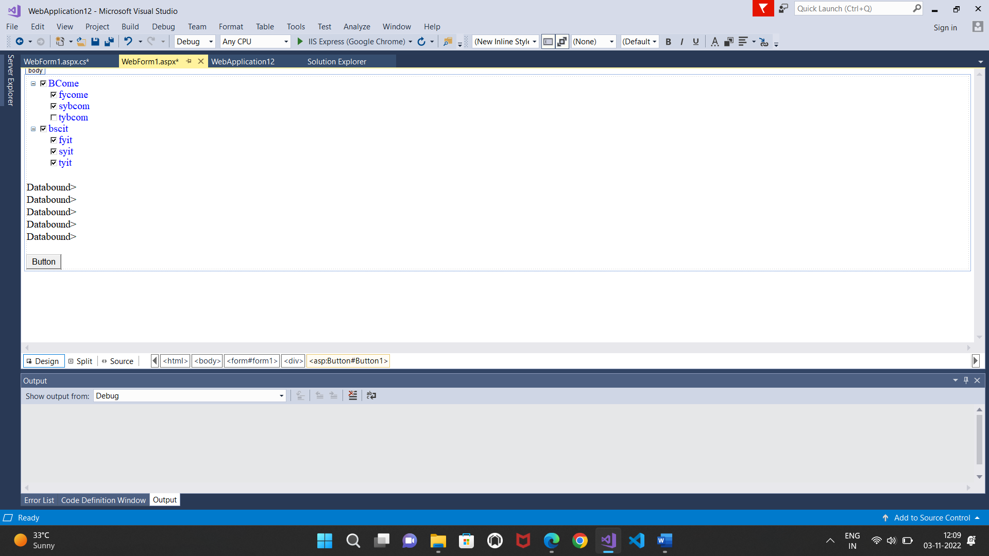

**Output:**

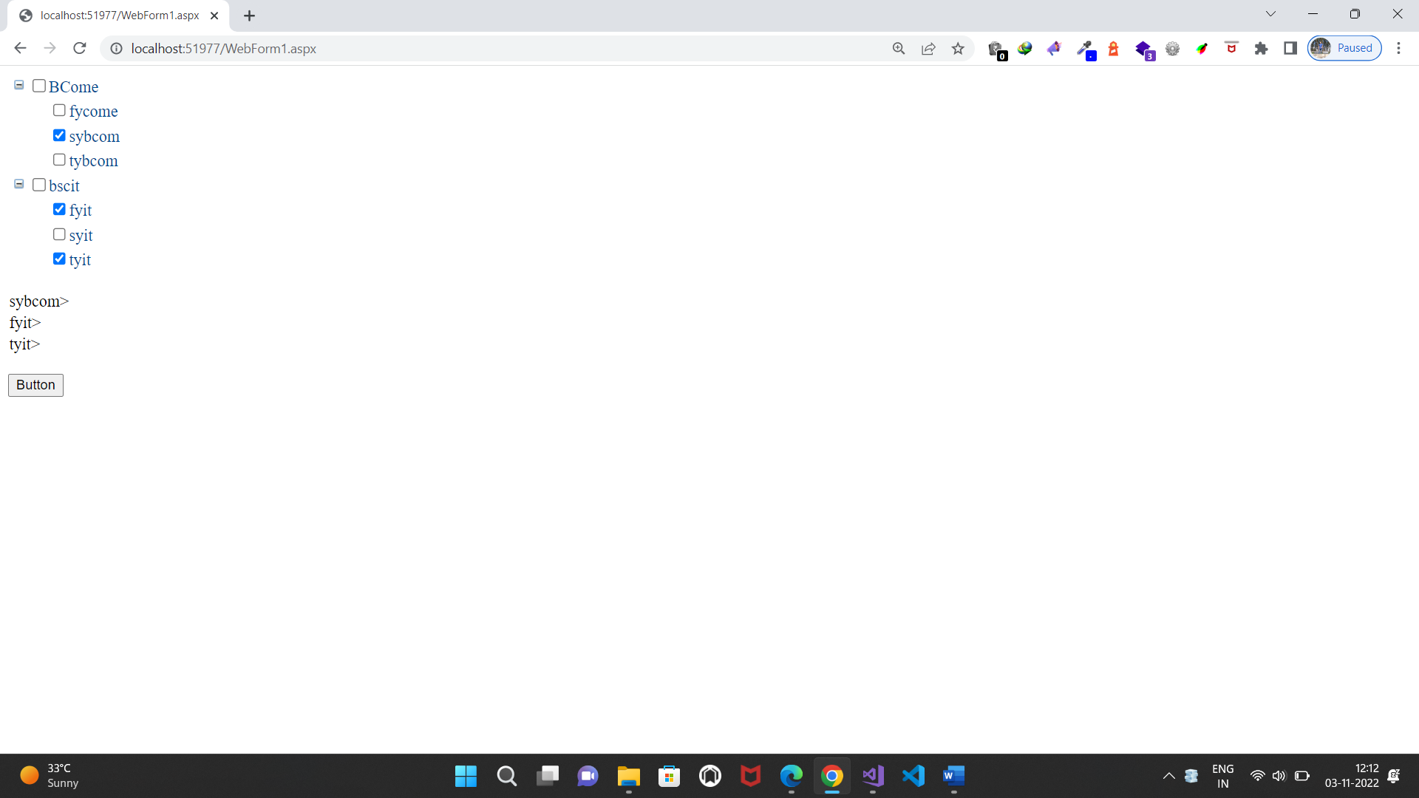

**Practical No.4(a)**

**4. Working with Form Controls**

**a)Create a Registration form to demonstrate use of various Validation controls**

**Source code:**

**WebForm1.aspx.cs:**

using System;

using System.Collections.Generic;

using System.Linq;

using System.Web;

using System.Web.UI;

using System.Web.UI.WebControls;

namespace WebApplication13

{

public partial class WebForm1 : System.Web.UI.Page

{

protected void Page_Load(object sender, EventArgs e)

{

}

protected void Button1_Click(object sender, EventArgs e)

{

Response.Write("submitted");

}

}

}

**Web.config**

<?xml version="1.0" encoding="utf-8"?>

<!--

For more information on how to configure your ASP.NET application, please visit

https://go.microsoft.com/fwlink/?LinkId=169433

-->

<configuration>

<appSettings>

<add key="ValidationSettings:UnobtrusiveValidationMode" value="None" />

</appSettings>

<system.web>

<compilation debug="true" targetFramework="4.6.1"/>

<httpRuntime targetFramework="4.6.1"/>

</system.web>

<system.codedom>

<compilers>

<compiler language="c#;cs;csharp" extension=".cs"

type="Microsoft.CodeDom.Providers.DotNetCompilerPlatform.CSharpCodeProvider, Microsoft.CodeDom.Providers.DotNetCompilerPlatform, Version=2.0.0.0, Culture=neutral, PublicKeyToken=31bf3856ad364e35"

warningLevel="4" compilerOptions="/langversion:default /nowarn:1659;1699;1701"/>

<compiler language="vb;vbs;visualbasic;vbscript" extension=".vb"

type="Microsoft.CodeDom.Providers.DotNetCompilerPlatform.VBCodeProvider, Microsoft.CodeDom.Providers.DotNetCompilerPlatform, Version=2.0.0.0, Culture=neutral, PublicKeyToken=31bf3856ad364e35"

warningLevel="4" compilerOptions="/langversion:default /nowarn:41008 /define:_MYTYPE=\&quot;Web\&quot; /optionInfer+"/>

</compilers>

</system.codedom>

</configuration>

**Design :**

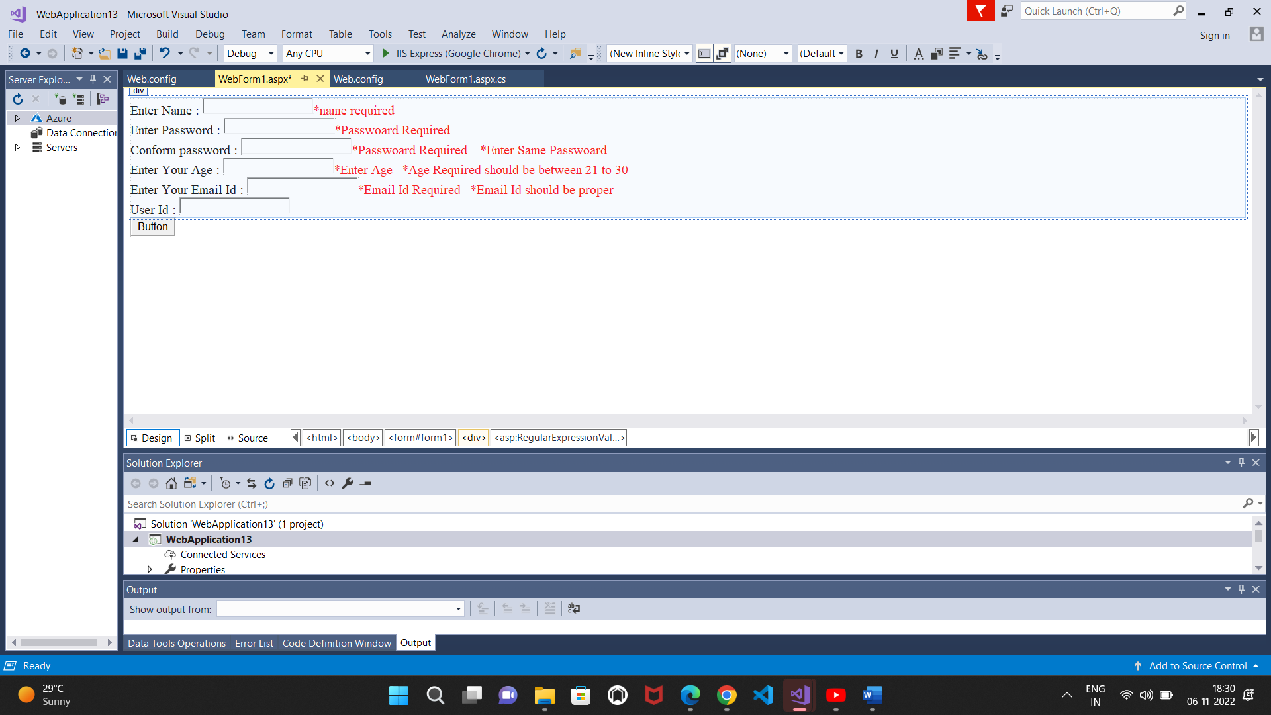

**Output:**

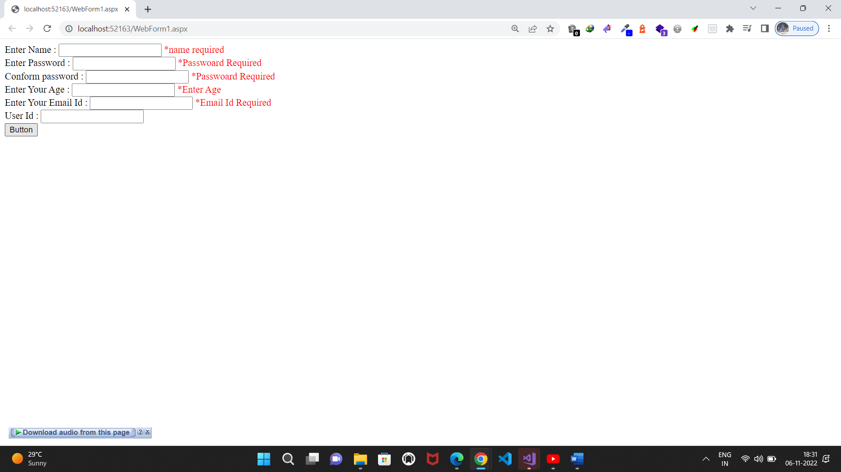

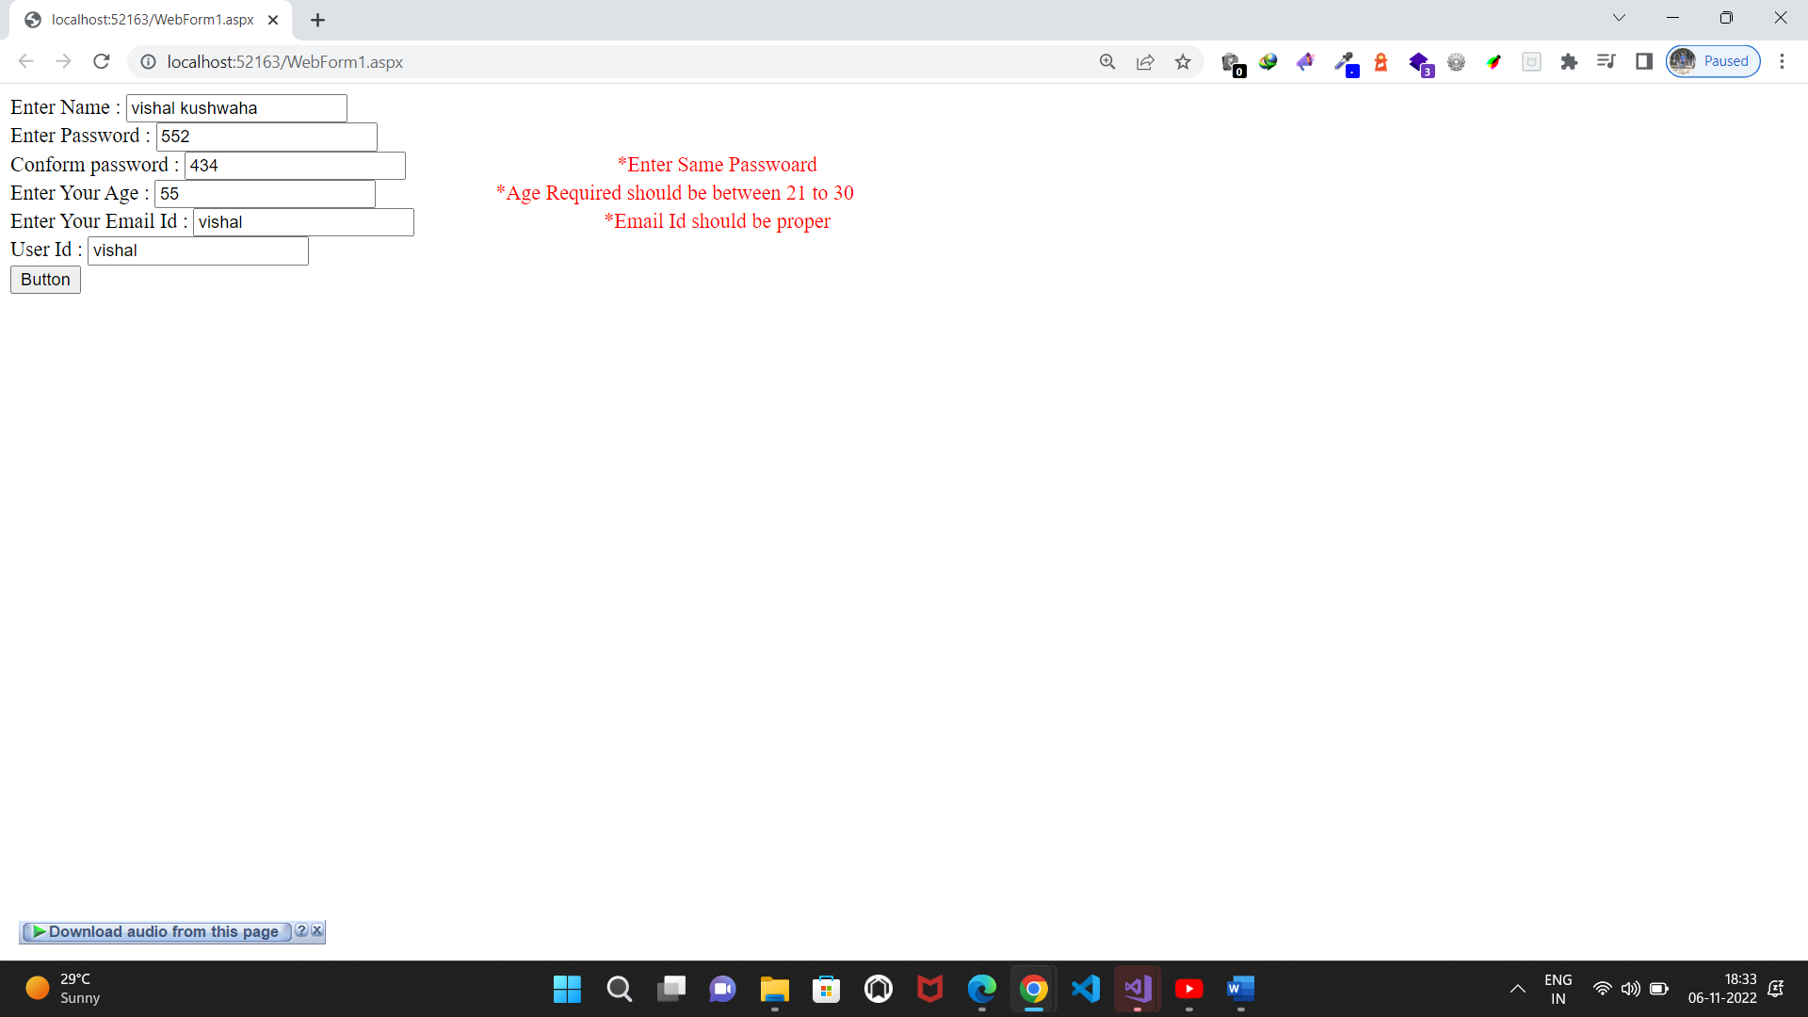

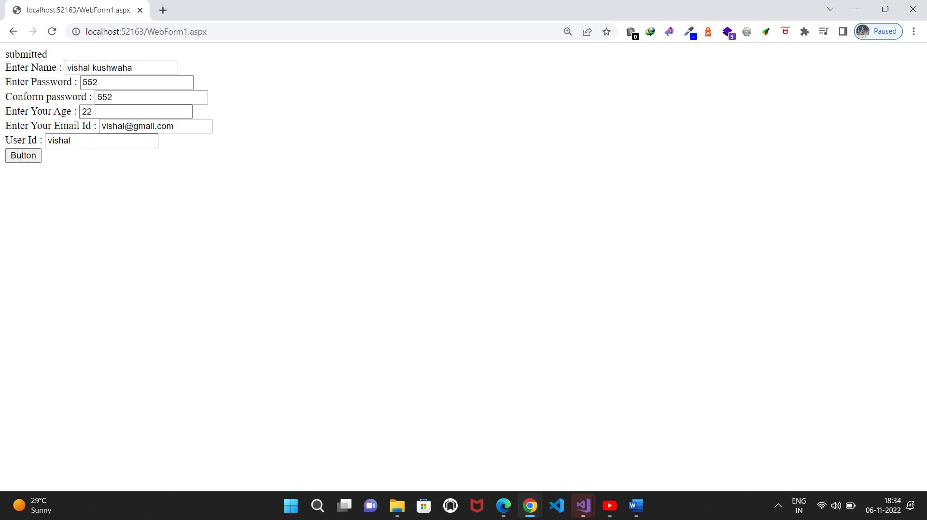

1. **Create Web Form to demonstrate use of Adrotator Control.**

**Source code:**

**WebForm1.aspx.cs:**

using System;

using System.Collections.Generic;

using System.Linq;

using System.Web;

using System.Web.UI;

using System.Web.UI.WebControls;

namespace WebApplication14

{

public partial class WebForm1 : System.Web.UI.Page

{

protected void Page_Load(object sender, EventArgs e)

{

}

}

}

**Xmlfile1.xml**

<?xml version="1.0" encoding="utf-8" ?>

<Advertisements>

<Ad>

<ImageUrl>computer.jpg</ImageUrl>

<Navigateurl></Navigateurl>

<AlternateText>computer</AlternateText>

<Impressions>50</Impressions>

<keyword>computer</keyword>

</Ad>

<Ad>

<ImageUrl>flower.jpg</ImageUrl>

<Navigateurl></Navigateurl>

<AlternateText>flower</AlternateText>

<Impressions>50</Impressions>

<keyword>flower</keyword>

</Ad>

</Advertisements>

**Design:**

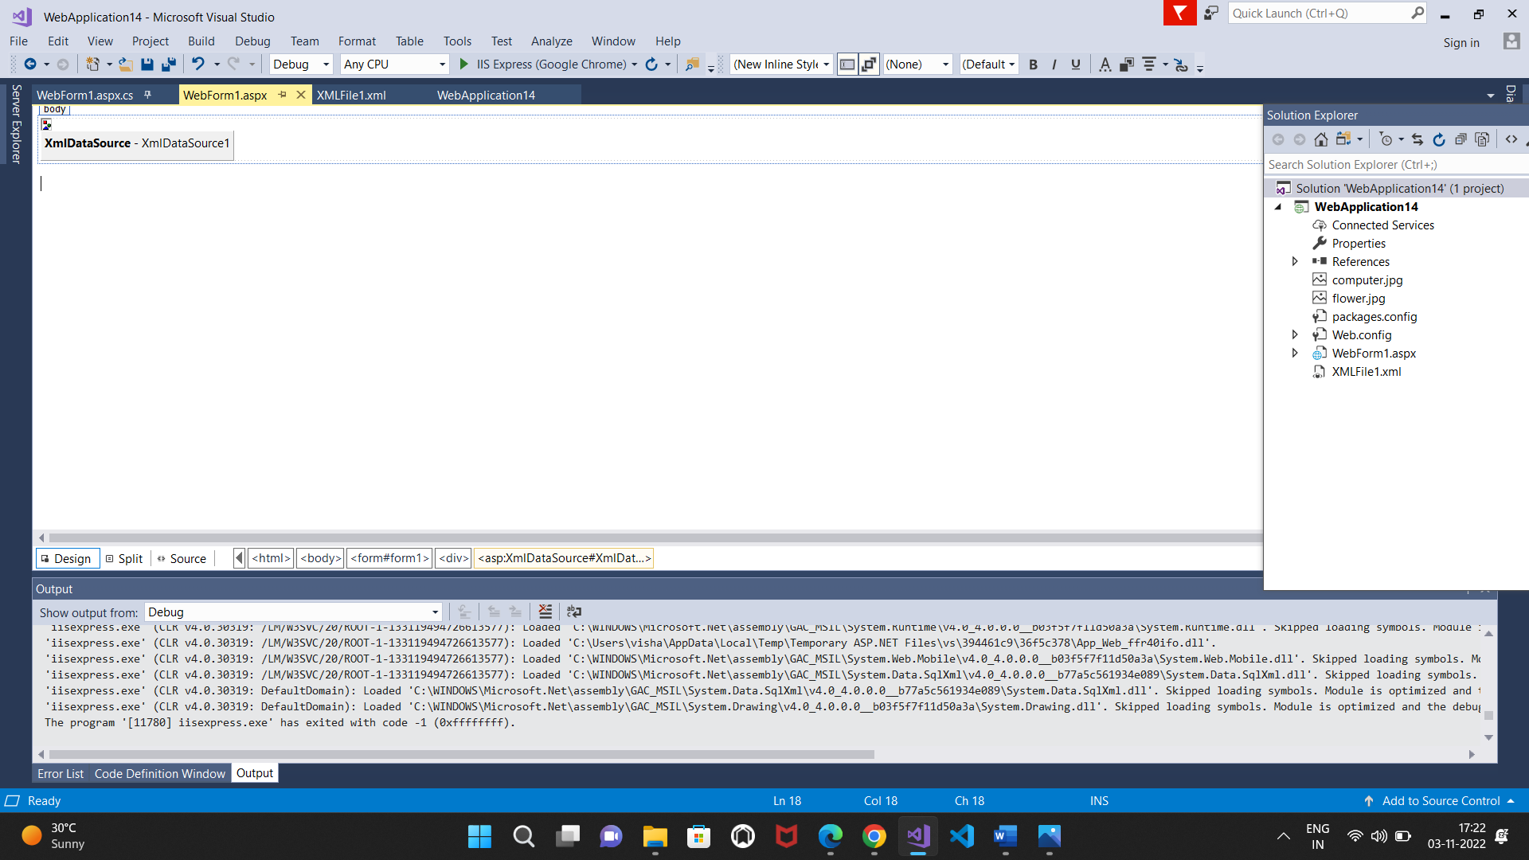

**Output:**

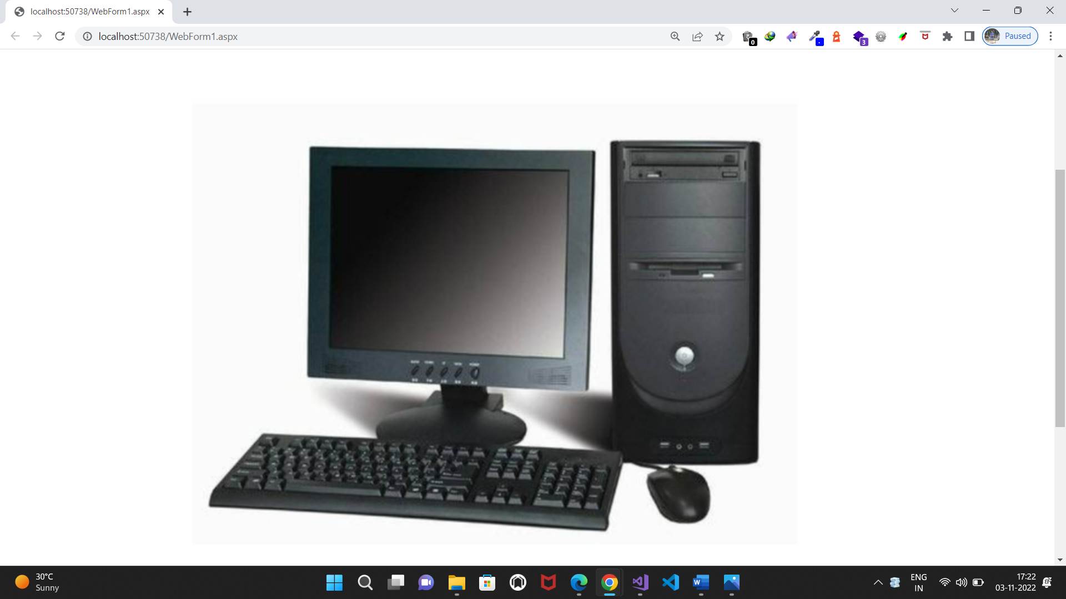

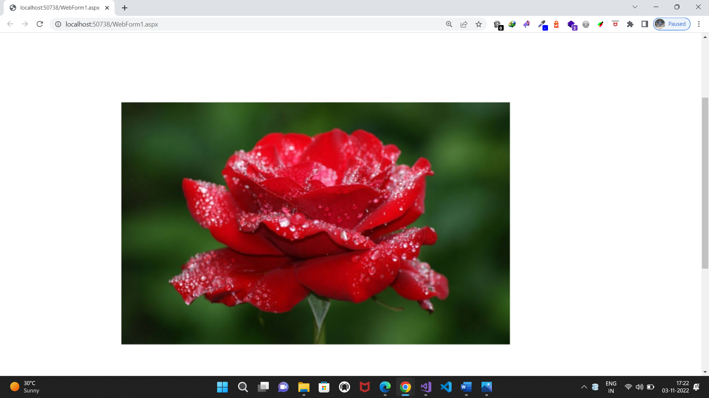

1. **Create Web Form to demonstrate use User Controls**

**Source code:**

**WebForm1.aspx.cs:**

using System;

using System.Collections.Generic;

using System.Linq;

using System.Web;

using System.Web.UI;

using System.Web.UI.WebControls;

namespace WebApplication16

{

public partial class WebForm1 : System.Web.UI.Page

{

protected void Page_Load(object sender, EventArgs e)

{

}

protected void Button1_Click(object sender, EventArgs e)

{

TextBox2.Text = " hello guest " + TextBox1.Text;

}

}

}

**WebUserControl1:ascx.cs**

using System;

using System.Collections.Generic;

using System.Linq;

using System.Web;

using System.Web.UI;

using System.Web.UI.WebControls;

namespace WebApplication16

{

public partial class WebUserControl1 : System.Web.UI.UserControl

{

protected void Page_Load(object sender, EventArgs e)

{

}

protected void Button1_Click(object sender, EventArgs e)

{

TextBox2.Text = " welcome " + TextBox1.Text;

}

}

}

**Webform1:**

<%@ Page Language="C#" AutoEventWireup="true" CodeBehind="WebForm1.aspx.cs" Inherits="WebApplication16.WebForm1" %>

<%@ Register Src="~/WebUserControl1.ascx" TagName="WebUserControl" TagPrefix="uc1" %>

<!DOCTYPE html>

<html xmlns="http://www.w3.org/1999/xhtml">

<head runat="server">

<title></title>

</head>

<body>

<form id="form1" runat="server">

<div>

<asp:TextBox ID="TextBox1" runat="server"></asp:TextBox>

<asp:Button ID="Button1" runat="server" OnClick="Button1_Click" Text="Button" />

<asp:TextBox ID="TextBox2" runat="server"></asp:TextBox>

<br/>

<uc1:WebUserControl runat="server" id="WebUserControl1" />

</div>

</form>

</body>

</html>

**Design:**

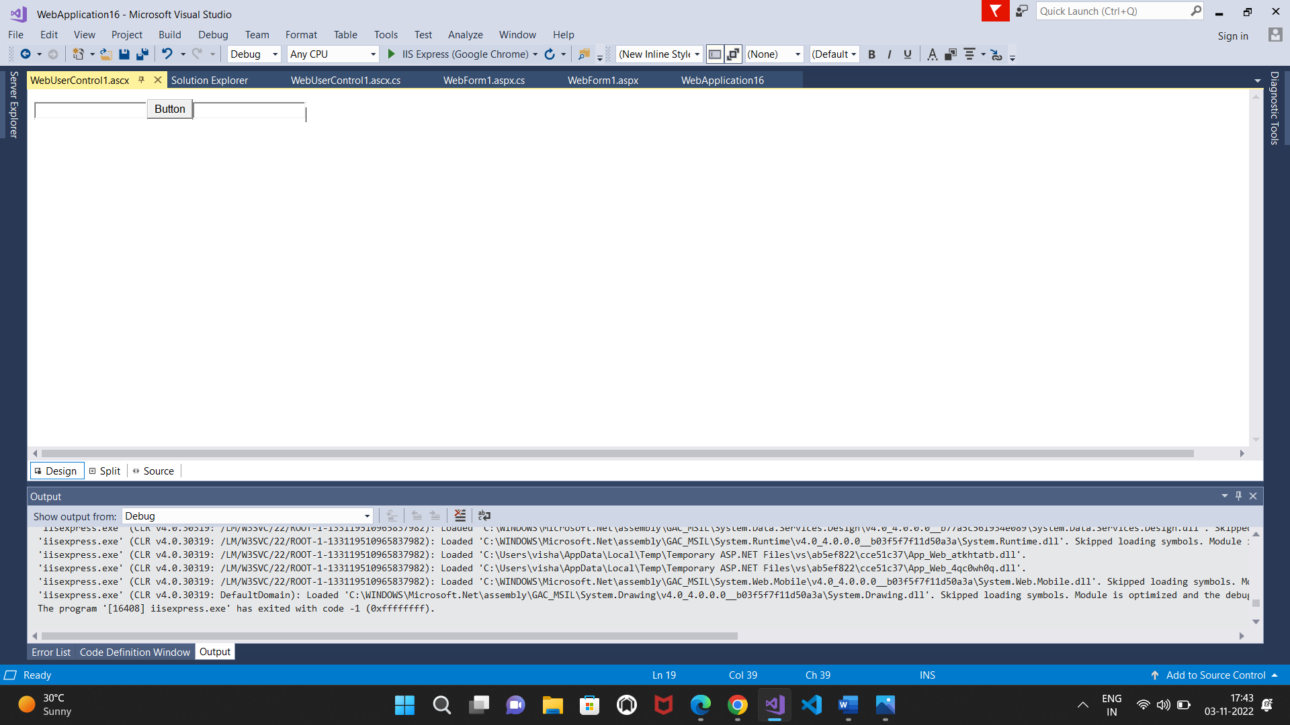

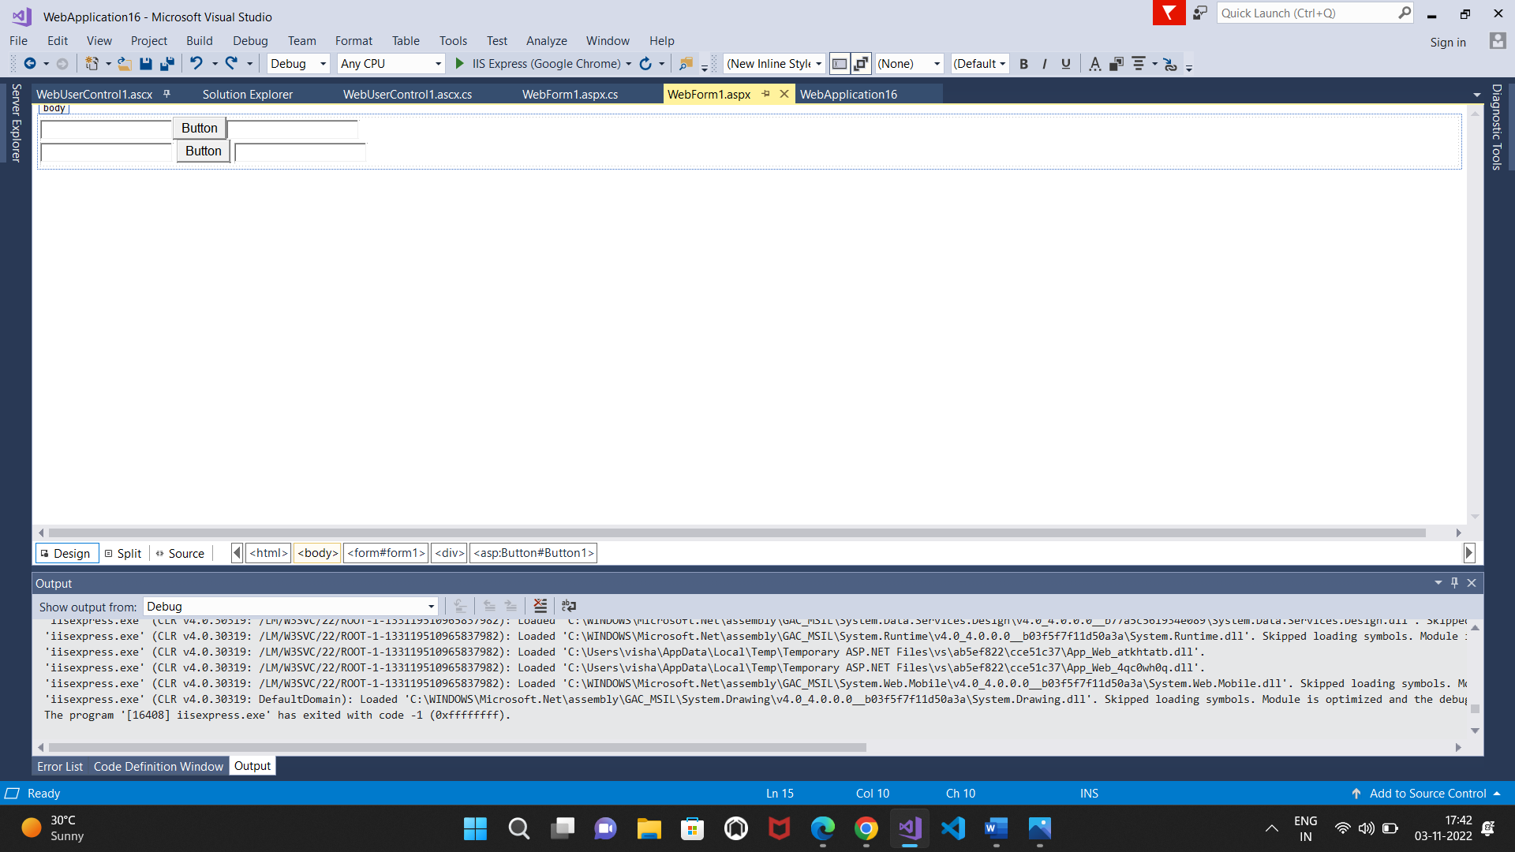

**Output:**

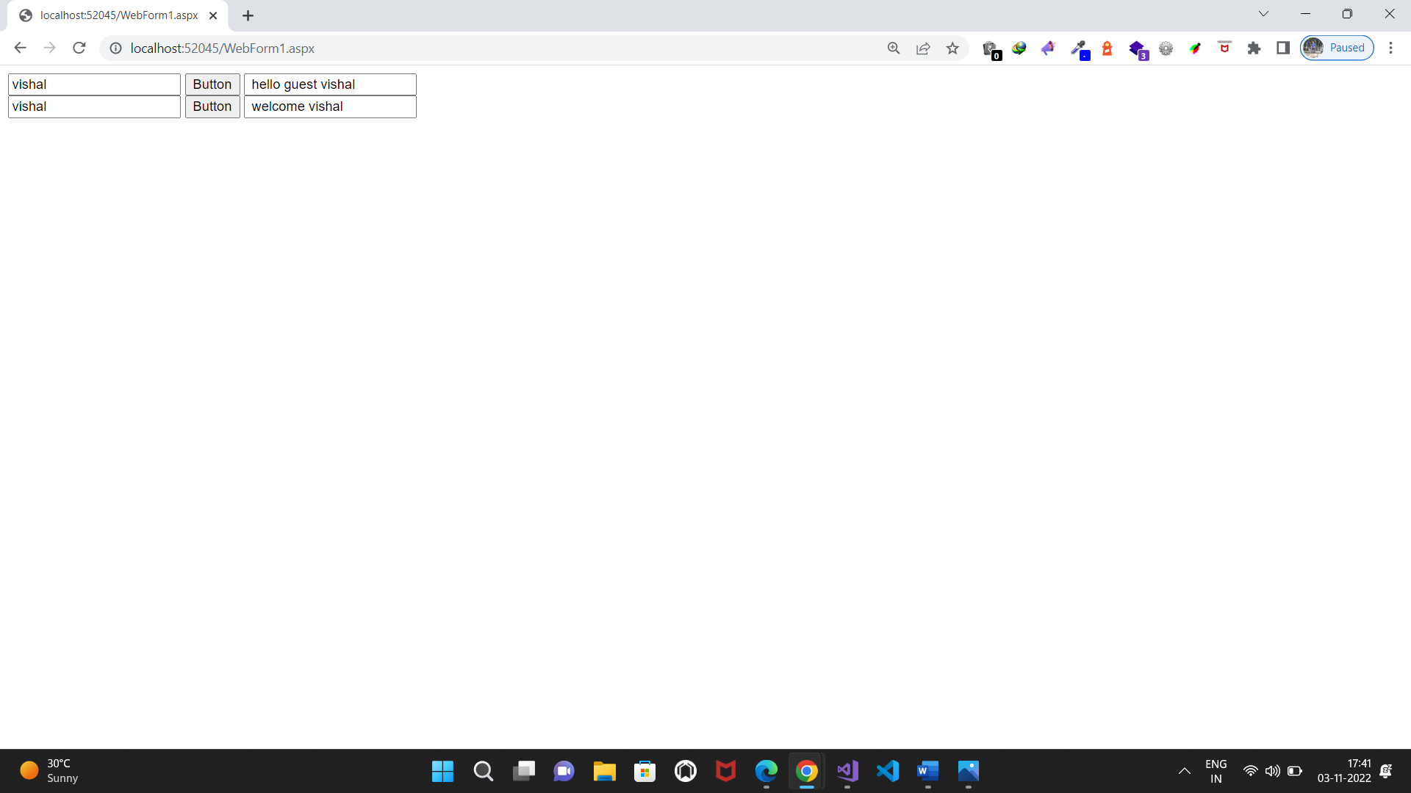

**Practical No.5(a)**

**5. Working with Navigation, Beautification and Master page**

**a. Create Web Form to demonstrate use of Website Navigation controls and Site Map.**

**WebForm2.aspx.cs**

<%@ Page Language="C#" AutoEventWireup="true" CodeBehind="WebForm2.aspx.cs" Inherits="WebApplication15.WebForm2" %>

<!DOCTYPE html>

<html xmlns="http://www.w3.org/1999/xhtml">

<head runat="server">

<title></title>

</head>

<body>

<form id="form1" runat="server">

<div>

<asp:SiteMapPath ID="SiteMapPath1" runat="server">

</asp:SiteMapPath>

<br />welcome to online store

</div>

</form>

</body>

</html>

**WebForm3.aspx.cs**

<%@ Page Language="C#" AutoEventWireup="true" CodeBehind="WebForm3.aspx.cs" Inherits="WebApplication15.WebForm3" %>

<!DOCTYPE html>

<html xmlns="http://www.w3.org/1999/xhtml">

<head runat="server">

<title></title>

</head>

<body>

<form id="form1" runat="server">

<div>

<asp:SiteMapPath ID="SiteMapPath1" runat="server">

</asp:SiteMapPath>

<br />hi welcome to online shopping : mobiles

</div>

</form>

</body>

</html>

**Web.config**

<?xml version="1.0" encoding="utf-8"?>

<!--

For more information on how to configure your ASP.NET application, please visit

https://go.microsoft.com/fwlink/?LinkId=169433

-->

<configuration>

<system.web>

<siteMap>

<providers>

<remove name="MySqlSiteMapProvider"/>

</providers>

</siteMap>

<compilation debug="true" targetFramework="4.6.1"/>

<httpRuntime targetFramework="4.6.1"/>

</system.web>

<system.codedom>

<compilers>

<compiler language="c#;cs;csharp" extension=".cs"

type="Microsoft.CodeDom.Providers.DotNetCompilerPlatform.CSharpCodeProvider, Microsoft.CodeDom.Providers.DotNetCompilerPlatform, Version=2.0.0.0, Culture=neutral, PublicKeyToken=31bf3856ad364e35"

warningLevel="4" compilerOptions="/langversion:default /nowarn:1659;1699;1701"/>

<compiler language="vb;vbs;visualbasic;vbscript" extension=".vb"

type="Microsoft.CodeDom.Providers.DotNetCompilerPlatform.VBCodeProvider, Microsoft.CodeDom.Providers.DotNetCompilerPlatform, Version=2.0.0.0, Culture=neutral, PublicKeyToken=31bf3856ad364e35"

warningLevel="4" compilerOptions="/langversion:default /nowarn:41008 /define:_MYTYPE=\&quot;Web\&quot; /optionInfer+"/>

</compilers>

</system.codedom>

</configuration>

**Web.sitemap**

<?xml version="1.0" encoding="utf-8" ?>

<siteMap xmlns="http://schemas.microsoft.com/AspNet/SiteMap-File-1.0" >

<siteMapNode url="WebForm1.aspx" title="home" description="">

<siteMapNode url="WebForm2.aspx" title="second page" description="" />

<siteMapNode url="WebForm3.aspx" title="third page" description="" />

</siteMapNode>

</siteMap>

**Design:**

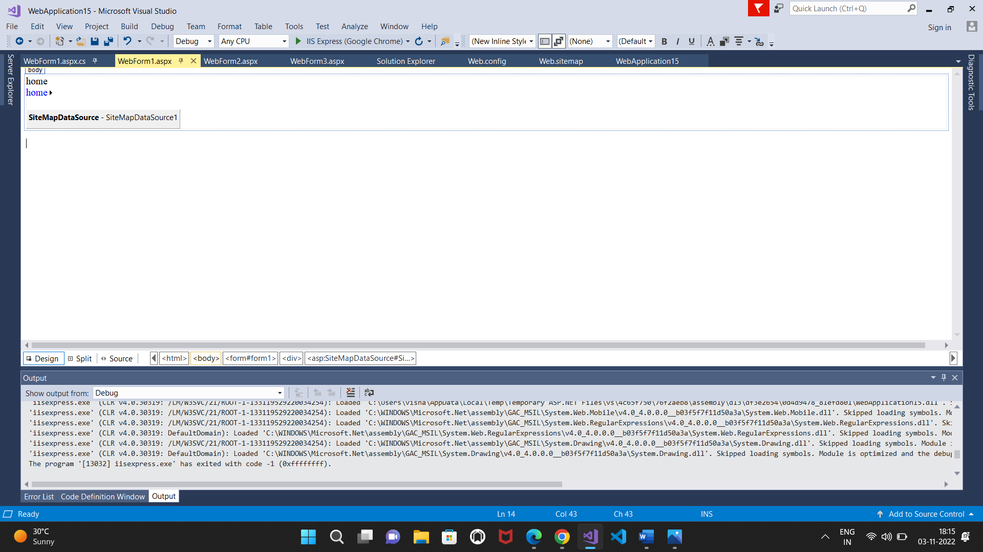

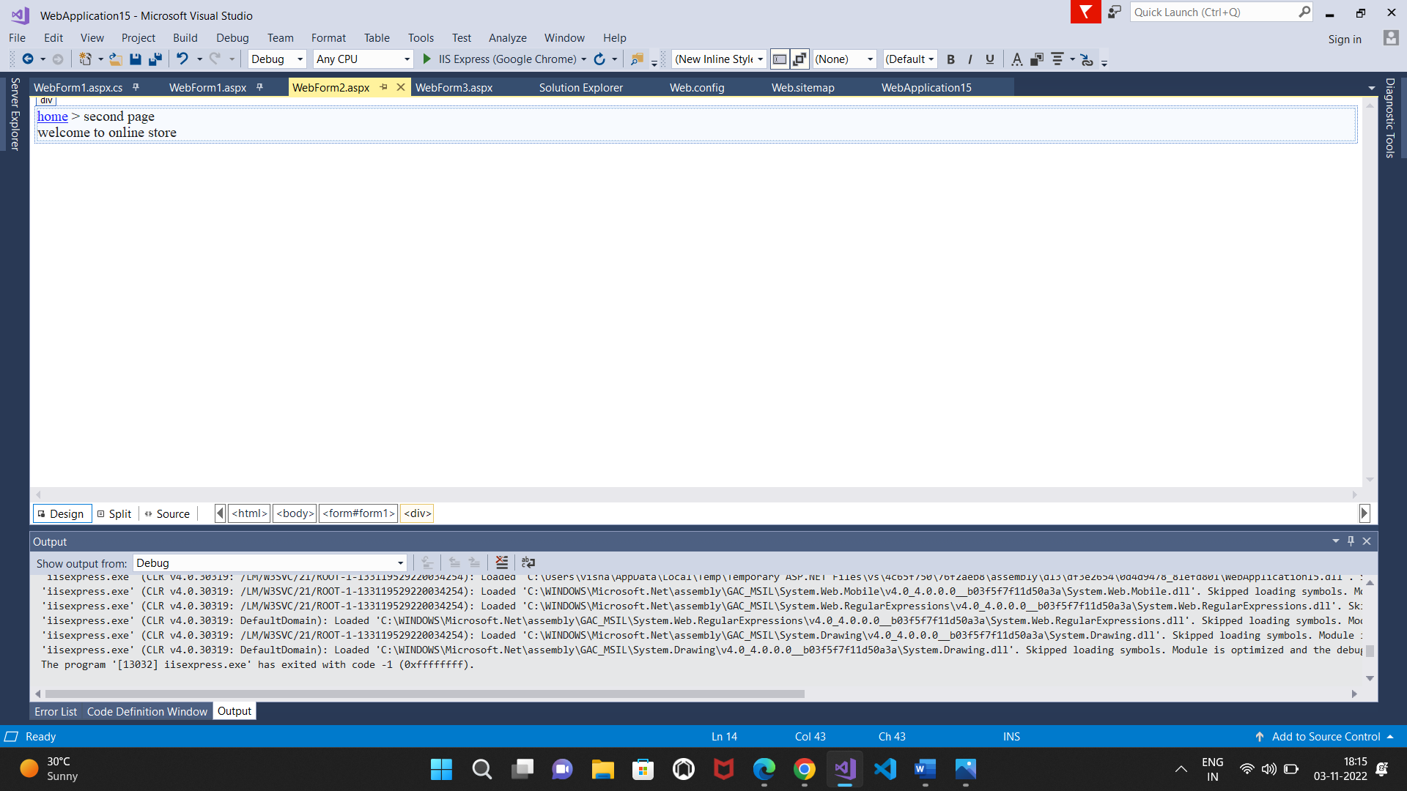

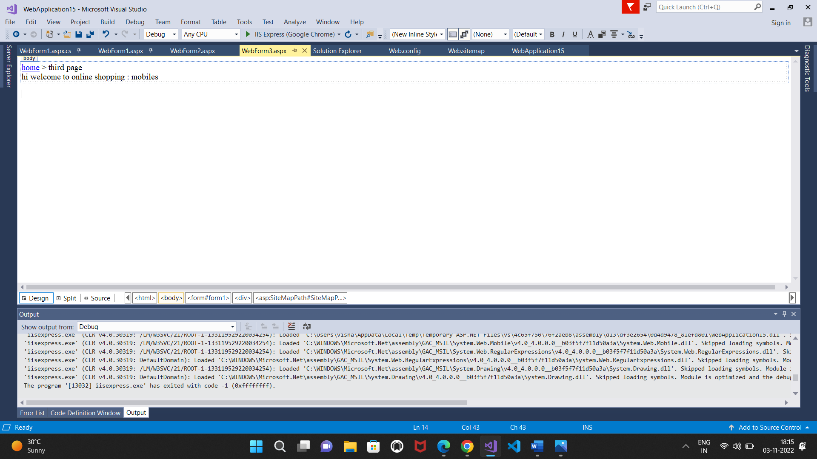

**Output:**

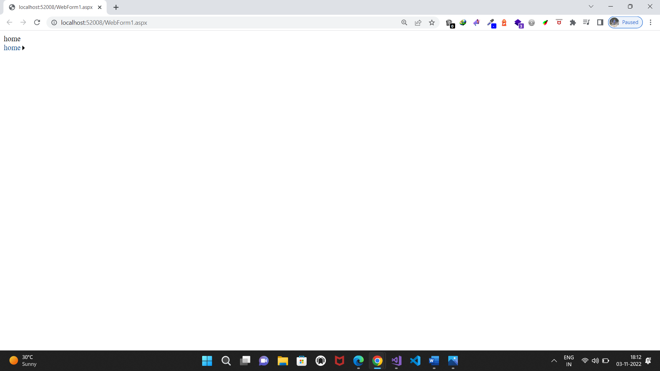

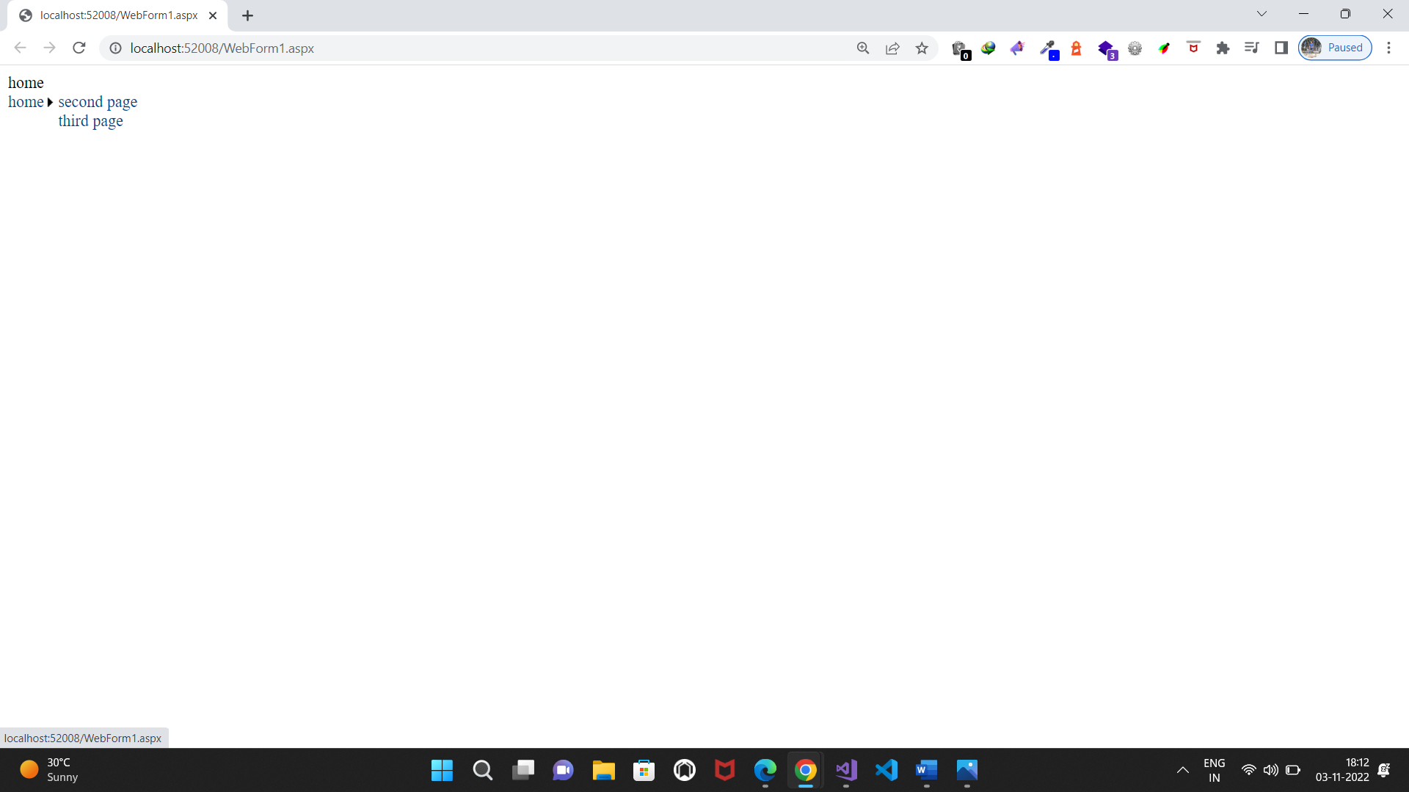 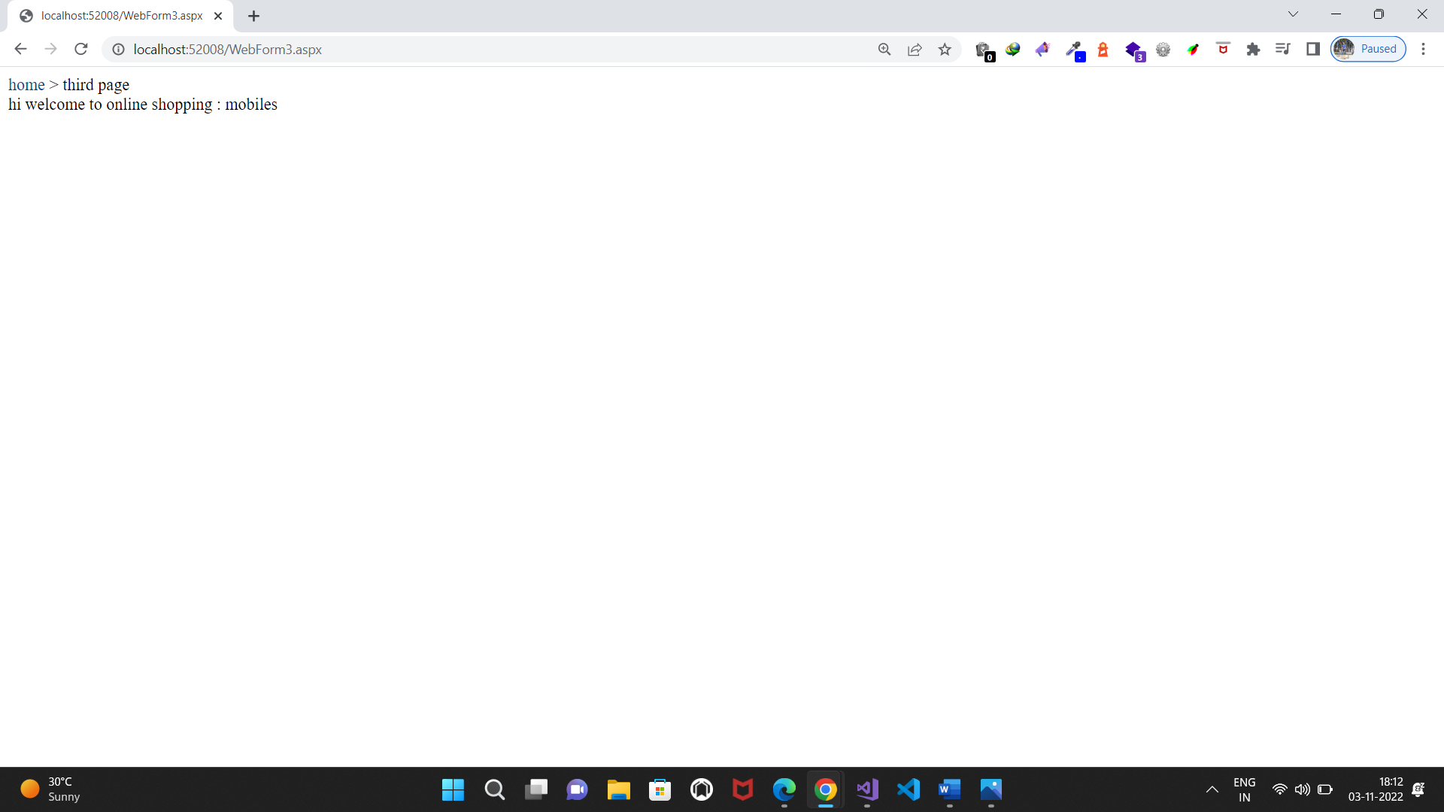

**b. Create a web application to demonstrate use of Master Page with applying Styles and Themes for page beautification.**

**WebForm1.aspx.cs:**

<%@ Page Title="" Language="C#" MasterPageFile="~/Site1.Master" AutoEventWireup="true" CodeBehind="WebForm1.aspx.cs" Inherits="WebApplication17.WebForm1" Theme="Skin1"%>

<asp:Content ID="Content1" ContentPlaceHolderID="head" runat="server">

</asp:Content>

<asp:Content ID="Content2" ContentPlaceHolderID="ContentPlaceHolder1" runat="server">

<p>

</p>

<asp:Label ID="Label1" runat="server" SkinId="Ib1" Text="Select the Date "></asp:Label>

<asp:Calendar ID="Calendar1" runat="server" BackColor="#FFFFCC" BorderColor="#FFCC66" BorderWidth="1px" DayNameFormat="Shortest" Font-Names="Verdana" Font-Size="8pt" ForeColor="#663399" Height="200px" ShowGridLines="True" Width="220px">

<DayHeaderStyle BackColor="#FFCC66" Font-Bold="True" Height="1px" />

<NextPrevStyle Font-Size="9pt" ForeColor="#FFFFCC" />

<OtherMonthDayStyle ForeColor="#CC9966" />

<SelectedDayStyle BackColor="#CCCCFF" Font-Bold="True" />

<SelectorStyle BackColor="#FFCC66" />

<TitleStyle BackColor="#990000" Font-Bold="True" Font-Size="9pt" ForeColor="#FFFFCC" />

<TodayDayStyle BackColor="#FFCC66" ForeColor="White" />

</asp:Calendar>

<asp:HyperLink ID="HyperLink1" runat="server" NavigateUrl="~/WebForm2.aspx">Next</asp:HyperLink>

</asp:Content>

Skin**1.skin:**

<asp:Label runat="server" skinId="Ib1" backcolor=blue/>

**WebForm2.aspx.cs:**

<%@ Page Title="" Language="C#" MasterPageFile="~/Site1.Master" AutoEventWireup="true" CodeBehind="WebForm2.aspx.cs" Inherits="WebApplication17.WebForm2" Theme="Skin1" %>

<asp:Content ID="Content1" ContentPlaceHolderID="head" runat="server">

</asp:Content>

<asp:Content ID="Content2" ContentPlaceHolderID="ContentPlaceHolder1" runat="server">

<asp:Label ID="Label1" runat="server" Text="Label" SkinID="Ib1"></asp:Label>

<asp:TextBox ID="TextBox1" runat="server"></asp:TextBox>

</asp:Content>

**Site1.master.cs:**

<%@ Master Language="C#" AutoEventWireup="true" CodeBehind="Site1.master.cs" Inherits="WebApplication17.Site1" %>

<!DOCTYPE html>

<html>

<head runat="server">

<title></title>

<asp:ContentPlaceHolder ID="head" runat="server">

</asp:ContentPlaceHolder>

</head>

<body>

<link href="StyleSheet1.css" rel="stylesheet" type="text/css"/>

<form id="form1" runat="server">

<div>

<asp:ContentPlaceHolder ID="ContentPlaceHolder1" runat="server">

</asp:ContentPlaceHolder>

</div>

</form>

</body>

</html>

**Stylesheet1.css:**

body {

background-color:whitesmoke;

font:bold;

}

**Design:**

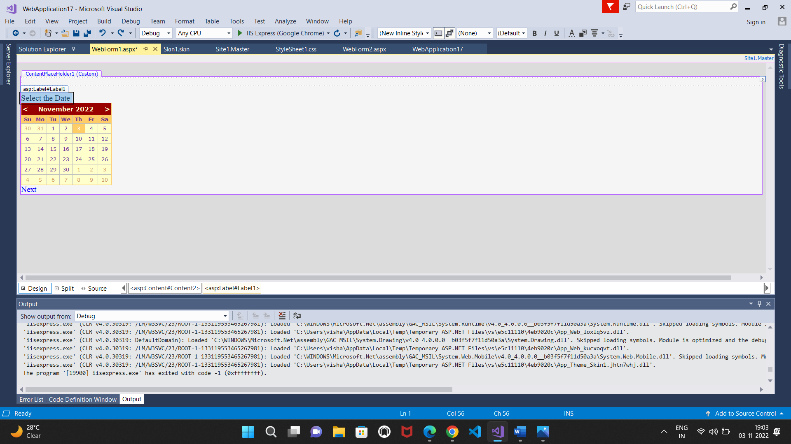

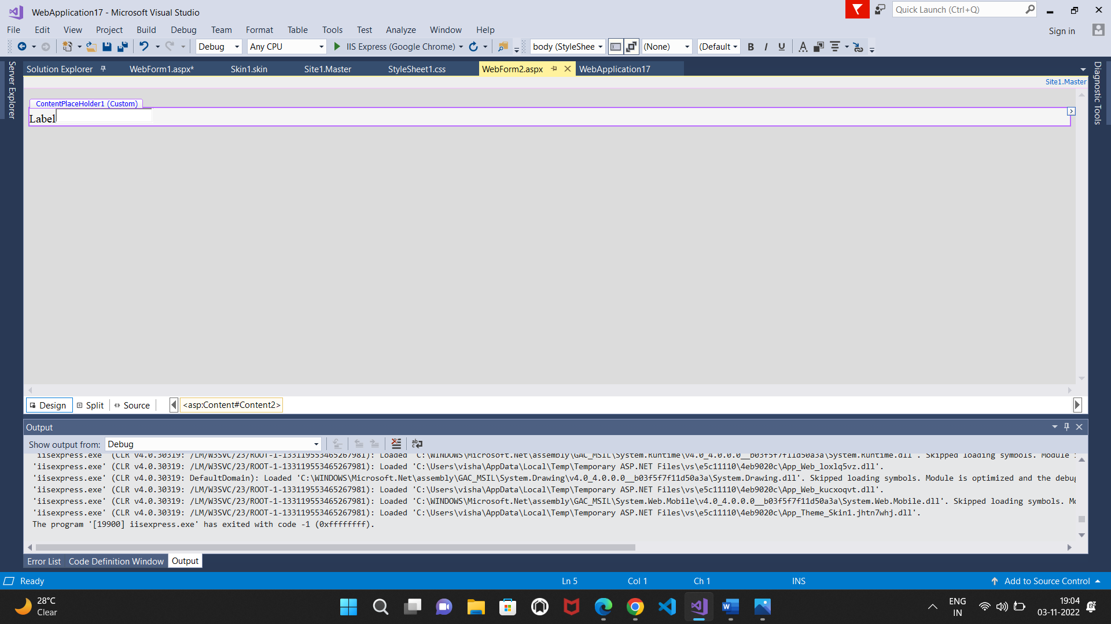

**Output:**

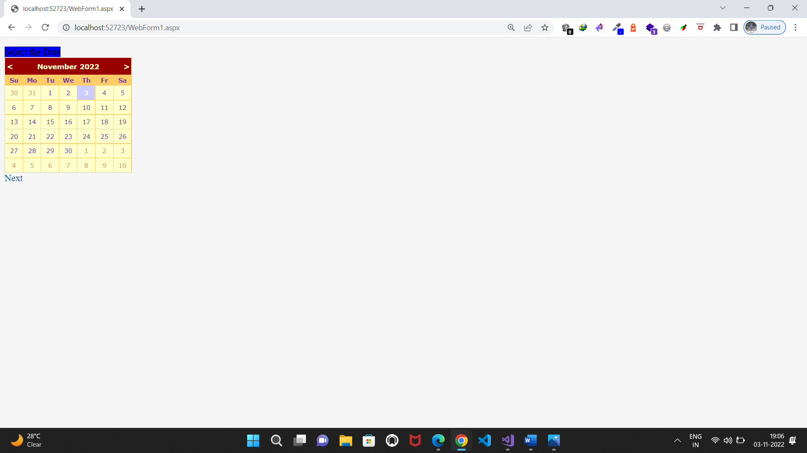

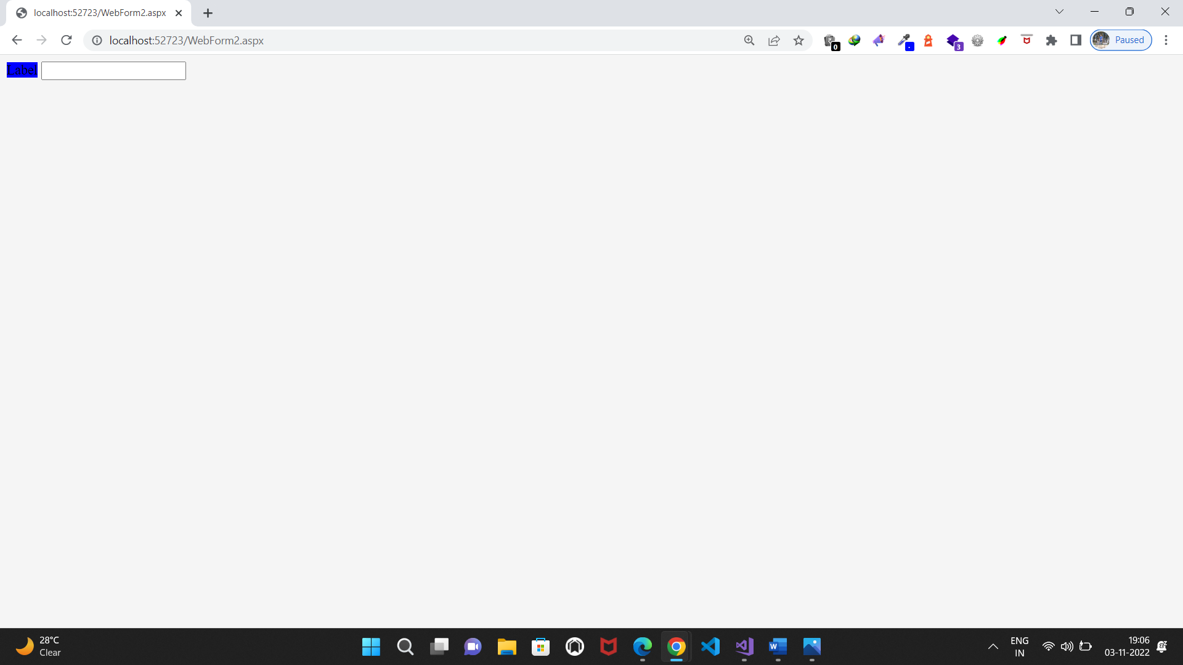

1. **Create a web application to demonstrate various states of ASP.NET Pages**

**Source code:**

**WebForm1.aspx.cs:**

using System;

using System.Collections.Generic;

using System.Linq;

using System.Web;

using System.Web.UI;

using System.Web.UI.WebControls;

namespace WebApplication18

{

public partial class WebForm1 : System.Web.UI.Page

{

protected void Page_Load(object sender, EventArgs e)

{

if (IsPostBack)

{

if (ViewState["count"]!=null)

{

int ViewstateVal1 = Convert.ToInt32(ViewState["count"]) + 1;

Label2.Text = "view state :" + ViewstateVal1.ToString();

ViewState["count"] = ViewstateVal1.ToString();

}

else

{

ViewState["count"] = "1";

}

}

}

protected void Button1_Click(object sender, EventArgs e)

{

Label1.Text = ViewState["count"].ToString();

}

protected void Button2_Click(object sender, EventArgs e)

{

if(HiddenField1.Value !=null)

{

int val = Convert.ToInt32(HiddenField1.Value) + 1;

HiddenField1.Value = val.ToString();

}

}

protected void Button3_Click(object sender, EventArgs e)

{

HttpCookie h = new HttpCookie("name");

h.Value = TextBox1.Text;

Response.Cookies.Add(h);

Response.Redirect("webForm2.aspx");

}

}

}

**WebForm2.aspx.cs**

using System;

using System.Collections.Generic;

using System.Linq;

using System.Web;

using System.Web.UI;

using System.Web.UI.WebControls;

namespace WebApplication18

{

public partial class WebForm2 : System.Web.UI.Page

{

protected void Page_Load(object sender, EventArgs e)

{

if (Request.Cookies["name"] != null)

Response.Write("welcome : " + Request.Cookies["name"].Value);

}

}

}

**Design:**

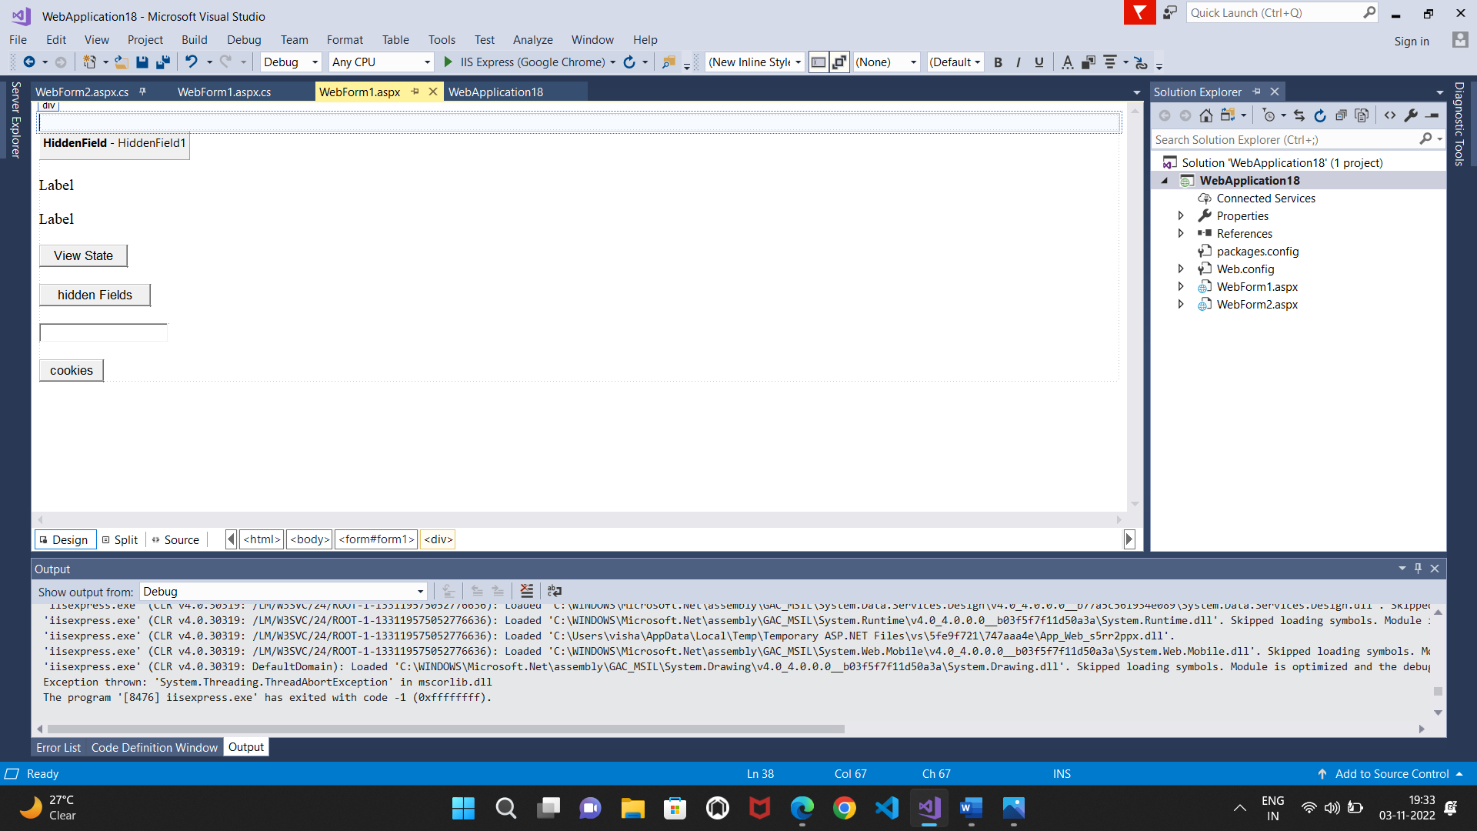

**Output**:

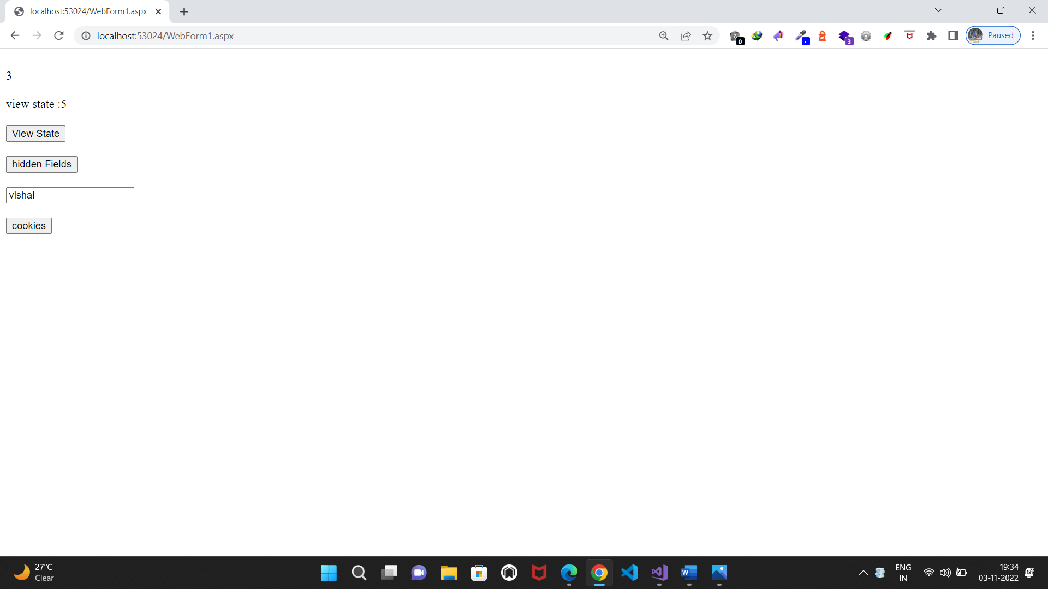

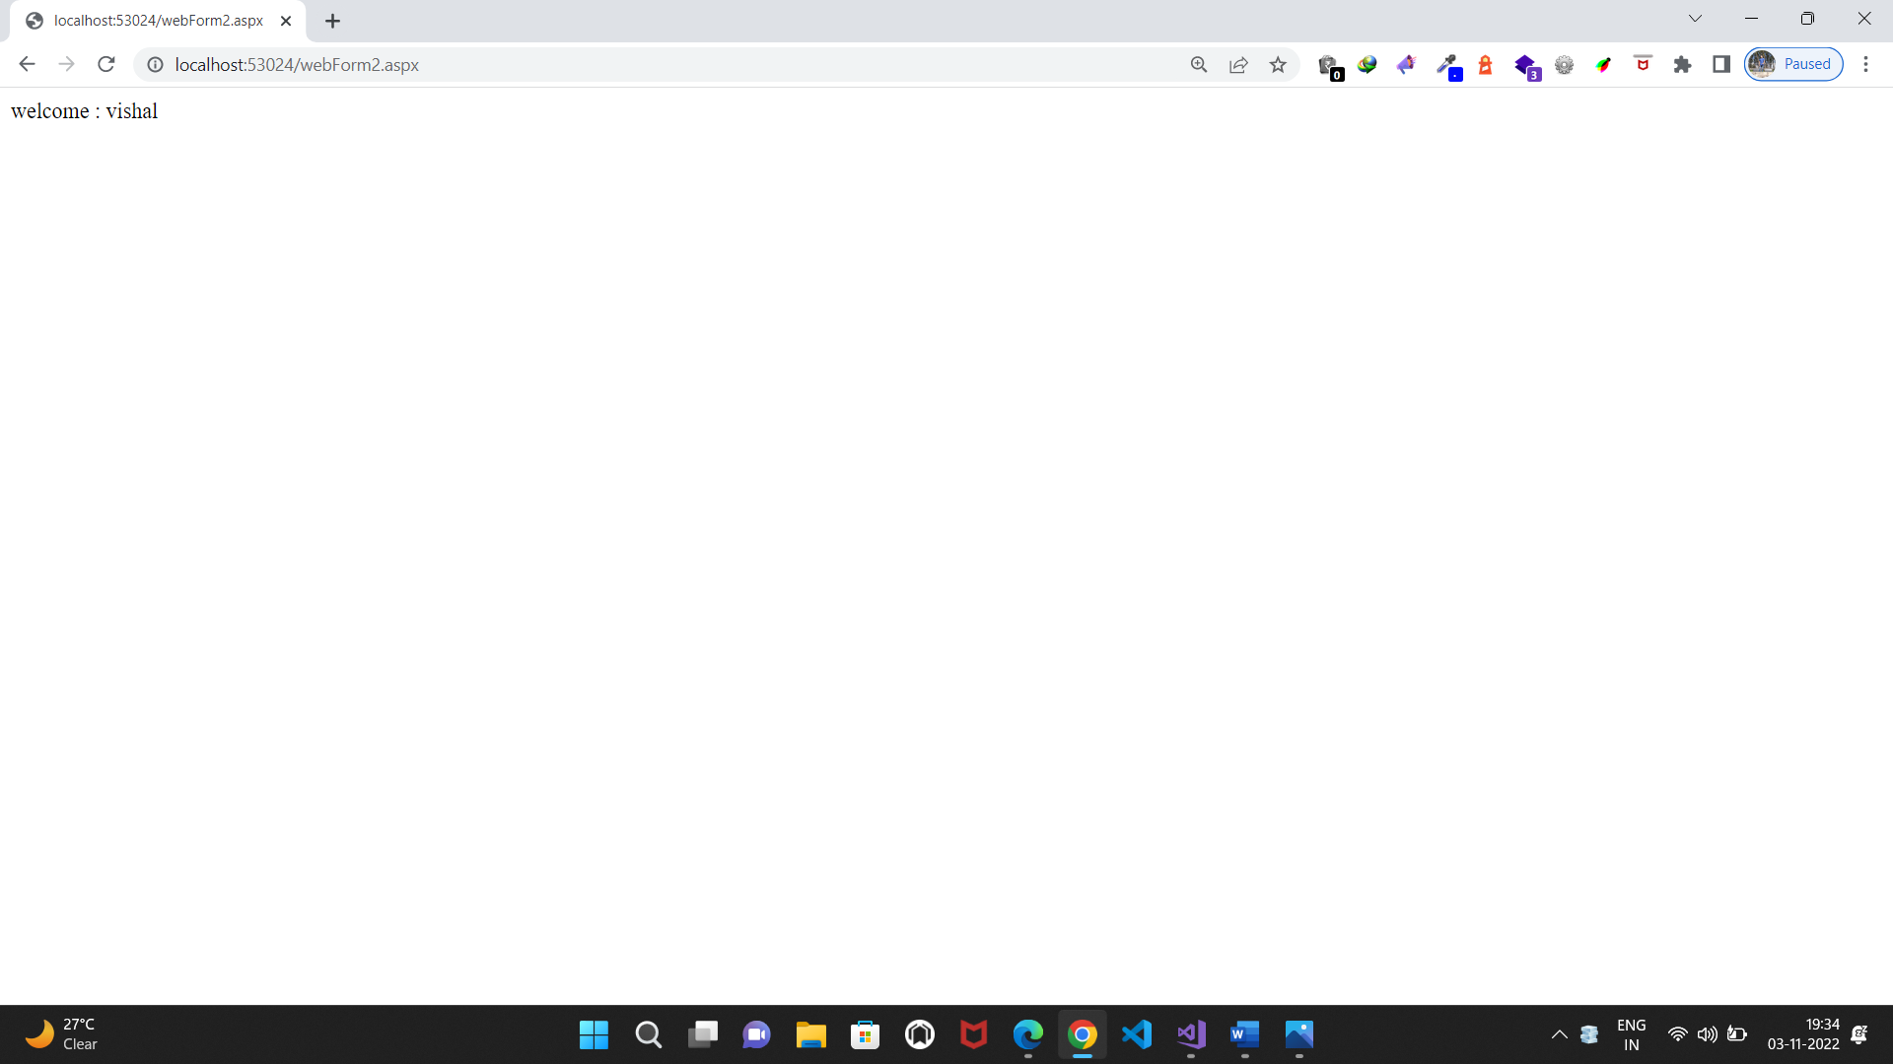

**Practical No.6(a)**

**6. Working with Databas**

**a. Create a web application bind data in a multiline textbox by querying in another textbox.**

**Source code:**

**WebForm1.aspx.cs:**

using System;

using System.Collections.Generic;

using System.Linq;

using System.Web;

using System.Web.UI;

using System.Web.UI.WebControls;

using System.Data.SqlClient;

namespace WebApplication20

{

public partial class WebForm1 : System.Web.UI.Page

{

SqlConnection cn = new SqlConnection("Data Source=VISHA;Initial Catalog=employee;Integrated Security=True;Pooling=False");

SqlCommand co = new SqlCommand ();

SqlDataReader ds;

protected void Page_Load(object sender, EventArgs e)

{

cn.Open();

co.Connection = cn;

}

protected void Button1_Click(object sender, EventArgs e)

{

co.CommandText = "select * from emp where name = '" + TextBox1.Text + "';";

ds = co.ExecuteReader();

while (ds.Read())

{

TextBox2.Text += ds[0].ToString() + "\t" + ds[1].ToString() + "\t" + ds[2].ToString() + "\n";

}

}

}

}

**Design:**

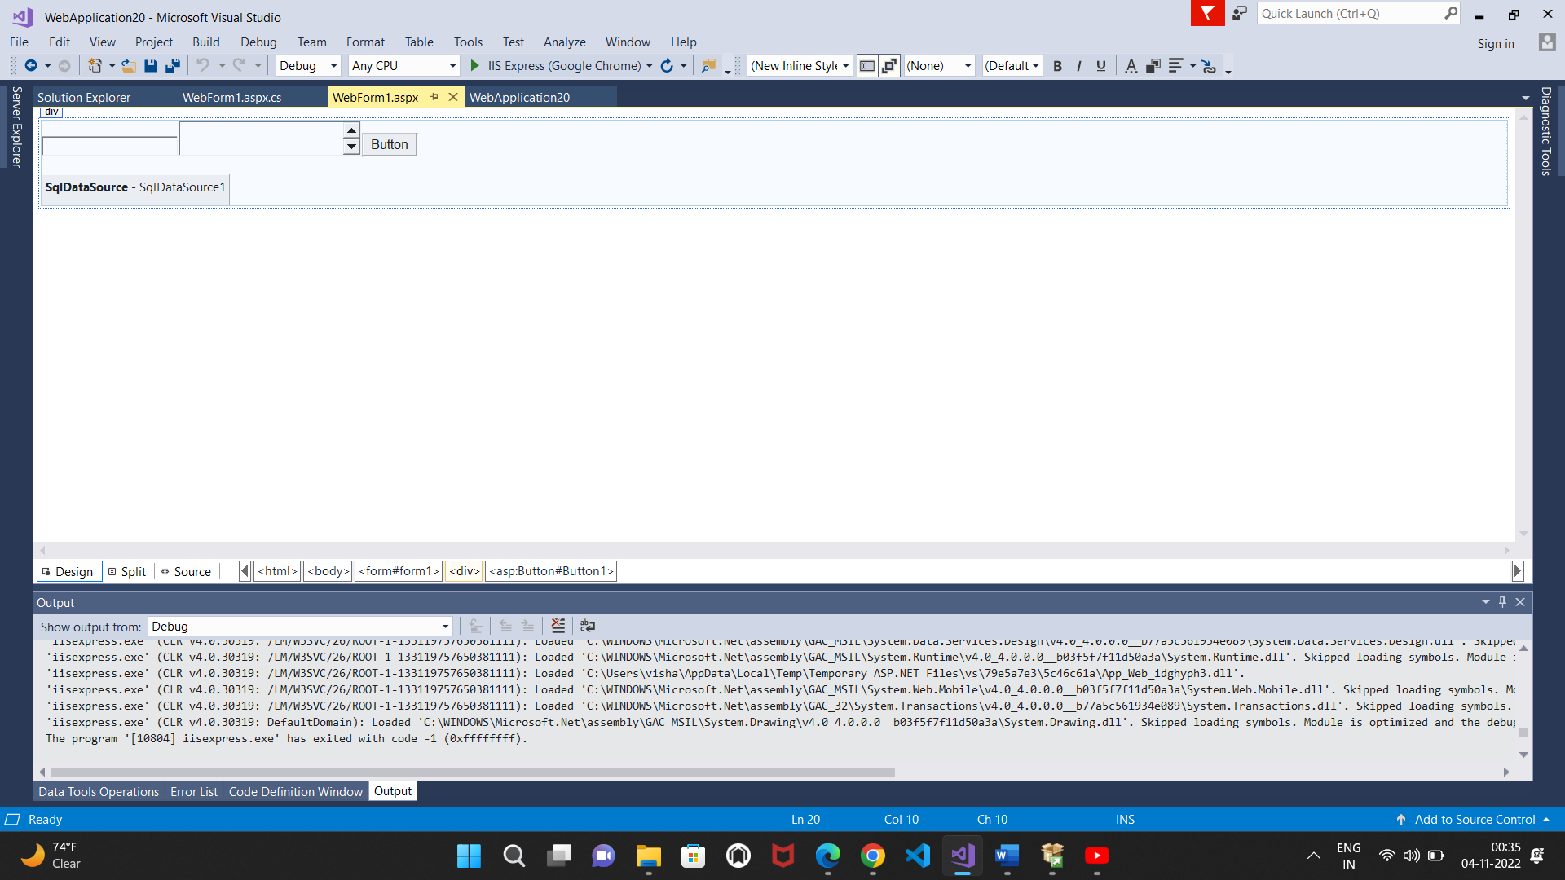

**Output:**

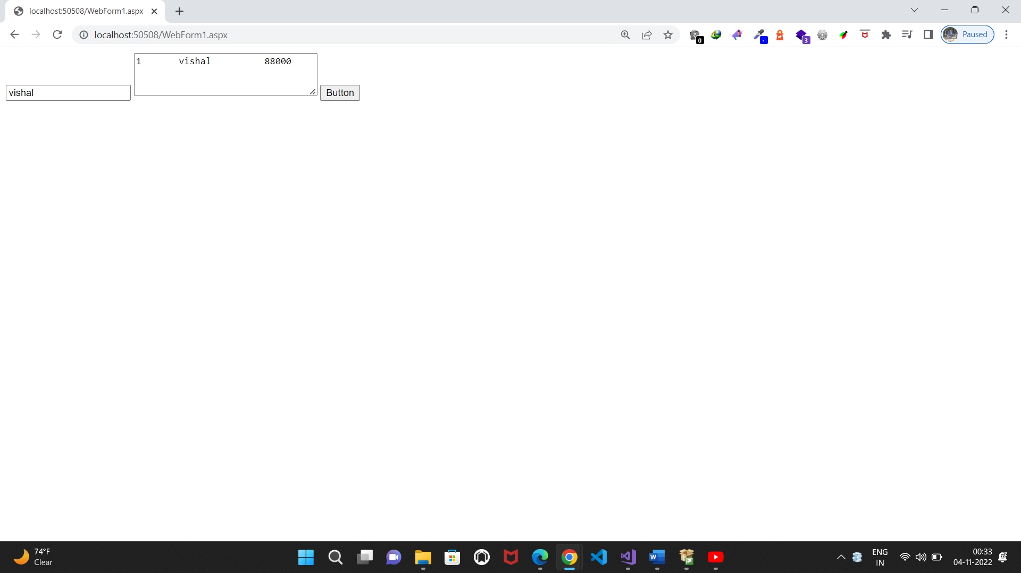

**b. Create a web application to display records by using database.**

**Source code:**

**WebForm1.aspx.cs:**

using System;

using System.Collections.Generic;

using System.Linq;

using System.Web;

using System.Web.UI;

using System.Web.UI.WebControls;

using System.Data.SqlClient;

namespace WebApplication21

{

public partial class WebForm1 : System.Web.UI.Page

{

SqlConnection cn = new SqlConnection("Data Source=visha;Initial Catalog=db1;Integrated Security=True");

SqlCommand co = new SqlCommand();

SqlDataReader ds;

protected void Page_Load(object sender, EventArgs e)

{

cn.Open();

co.Connection = cn;

}

protected void Button1_Click(object sender, EventArgs e)

{

co.CommandText = "select name from stud where rollno = '" + TextBox1.Text + "';";

Label1.Text = co.ExecuteScalar().ToString ();

}

}

}

**Design:**

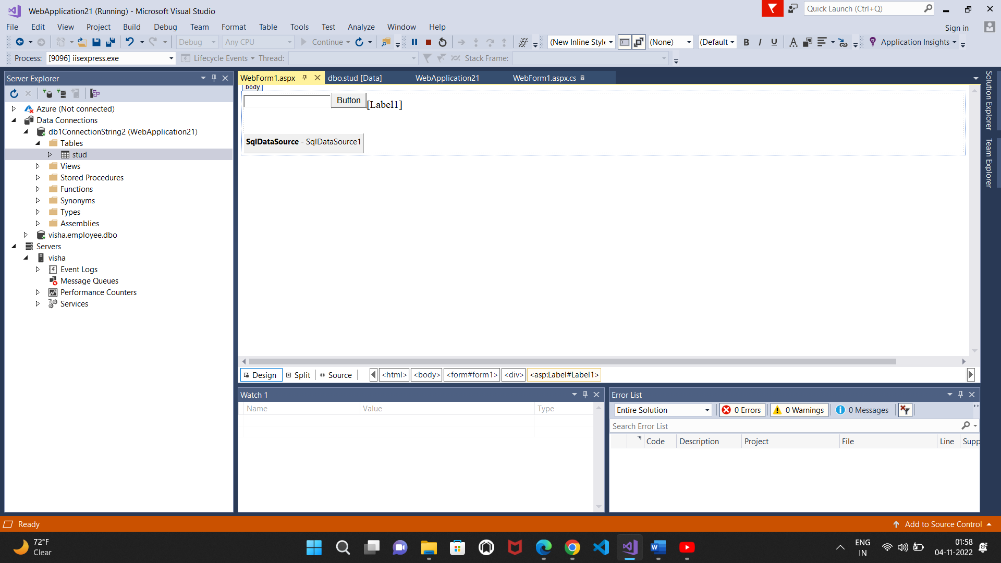

**Output:**

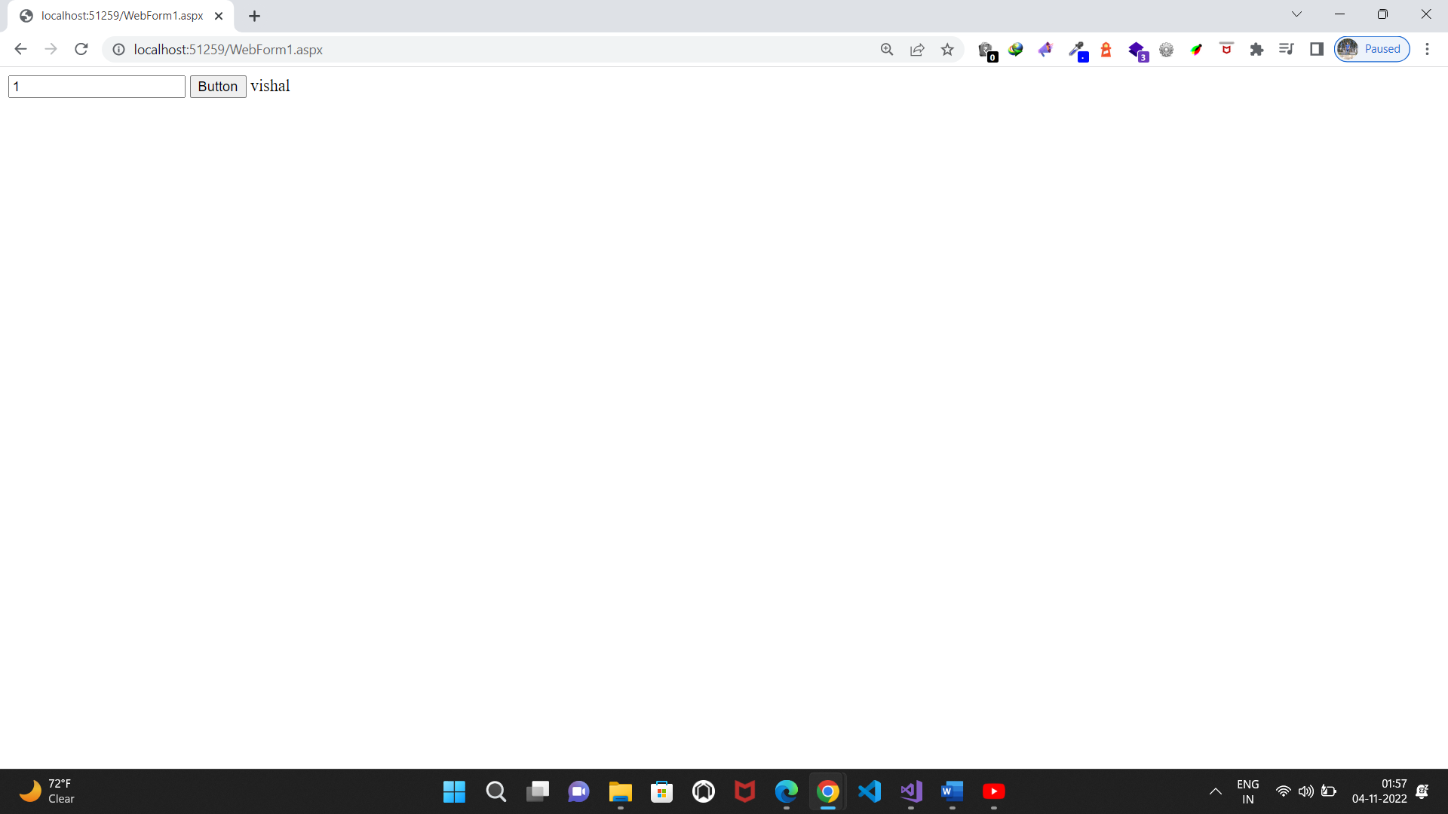

**c. Demonstrate the use of Datalist link control.**

**Design:**

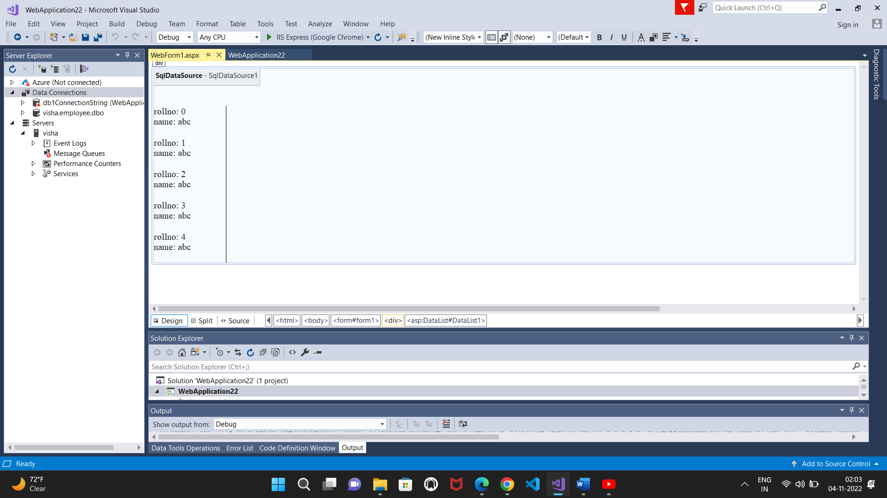

**Output:**

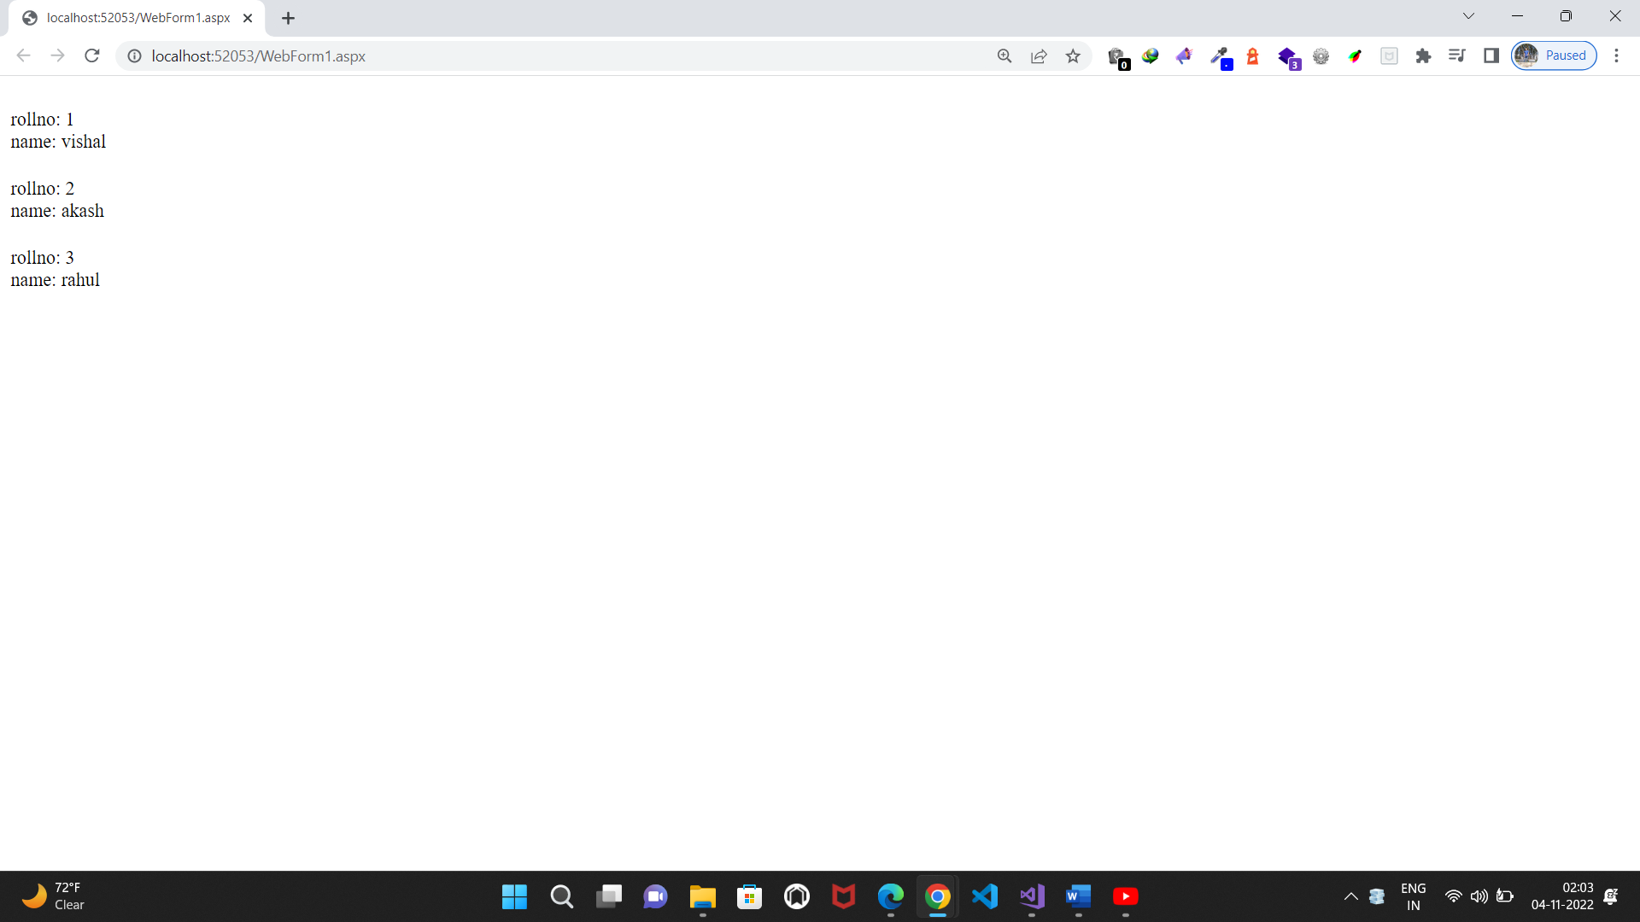

**Practical No.7(a)**

**7. Working with Database**

**a. Create a web application to display Databinding using dropdownlist control.**

**Source code:**

**WebForm1.aspx.cs:**

using System;

using System.Collections.Generic;

using System.Linq;

using System.Web;

using System.Web.UI;

using System.Web.UI.WebControls;

using System.Data.SqlClient;

namespace WebApplication23

{

public partial class WebForm1 : System.Web.UI.Page

{

SqlConnection cn = new SqlConnection("Data Source=visha;Initial Catalog=db1;Integrated Security=True");

SqlCommand co = new SqlCommand();

SqlDataReader ds;

protected void Page_Load(object sender, EventArgs e)

{

cn.Open();

co.Connection = cn;

}

protected void Button1_Click(object sender, EventArgs e)

{

co.CommandText = "select * from stud ;";

ds = co.ExecuteReader();

DropDownList1.DataSource = ds;

DropDownList1.DataTextField = "name";

DropDownList1.DataBind();

}

protected void DropDownList1_SelectedIndexChanged(object sender, EventArgs e)

{

TextBox1.Text = DropDownList1.Text;

}

protected void TextBox1_TextChanged(object sender, EventArgs e)

{

}

}

}

**Design:**

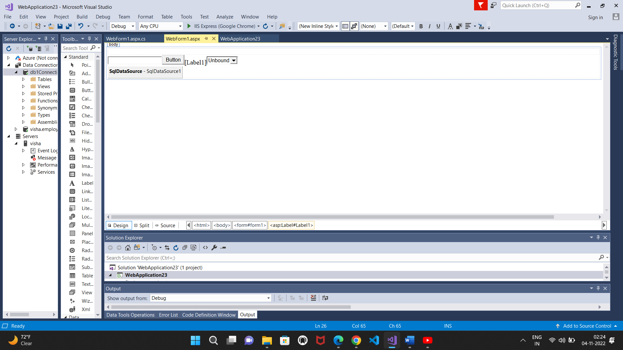

**Output:**

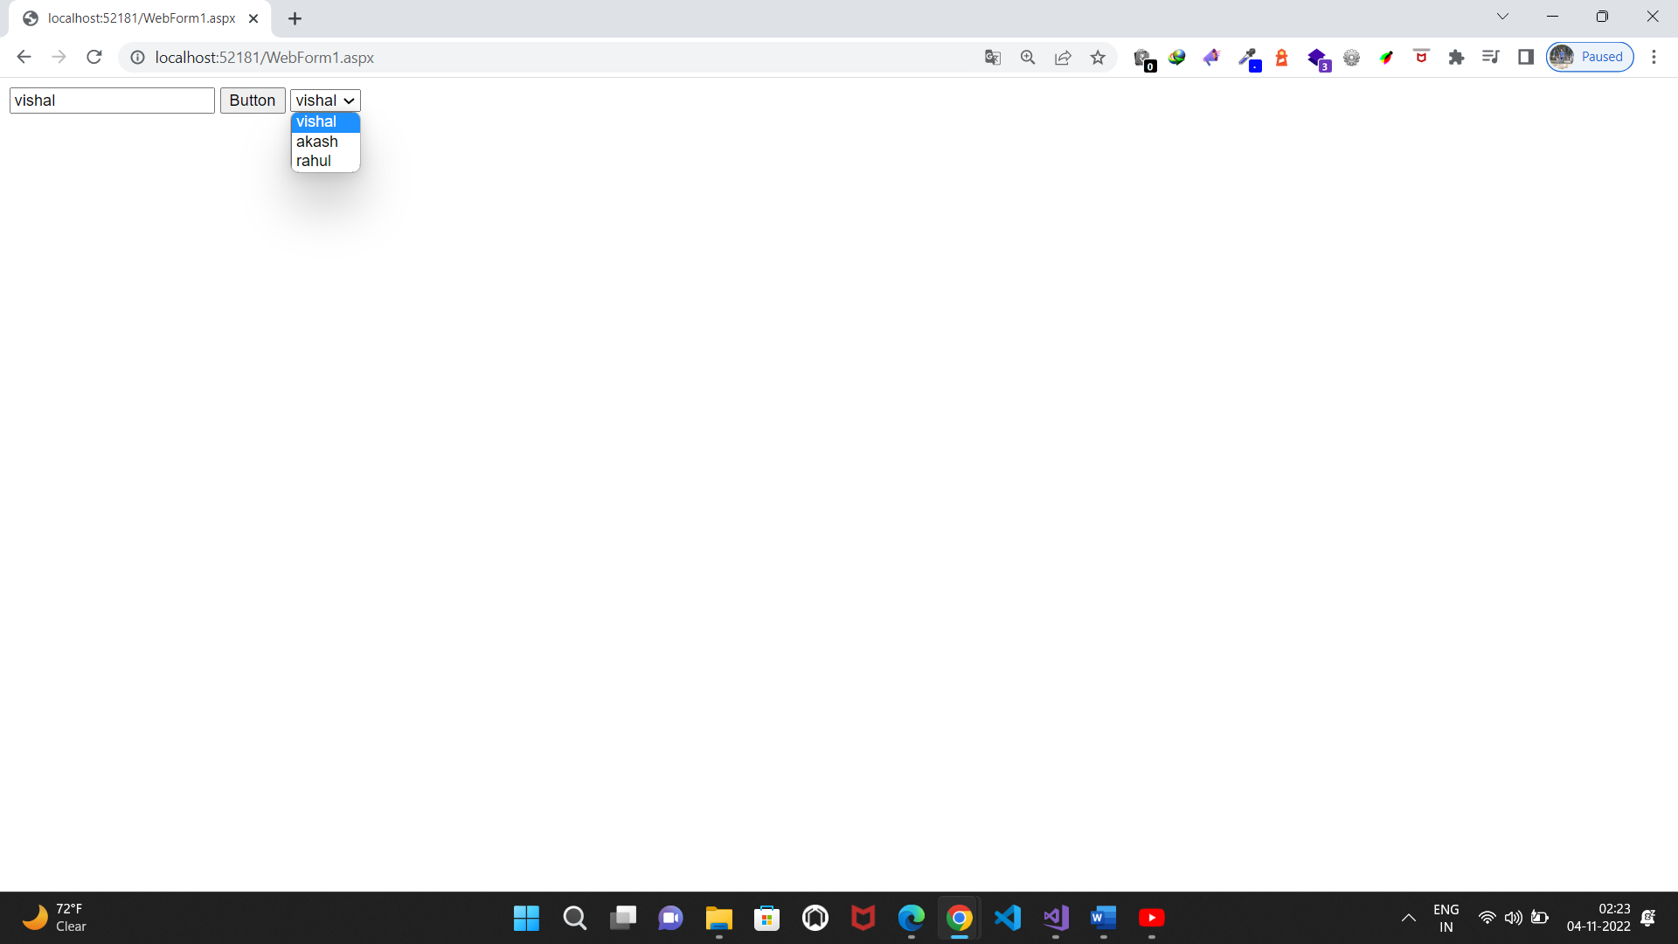

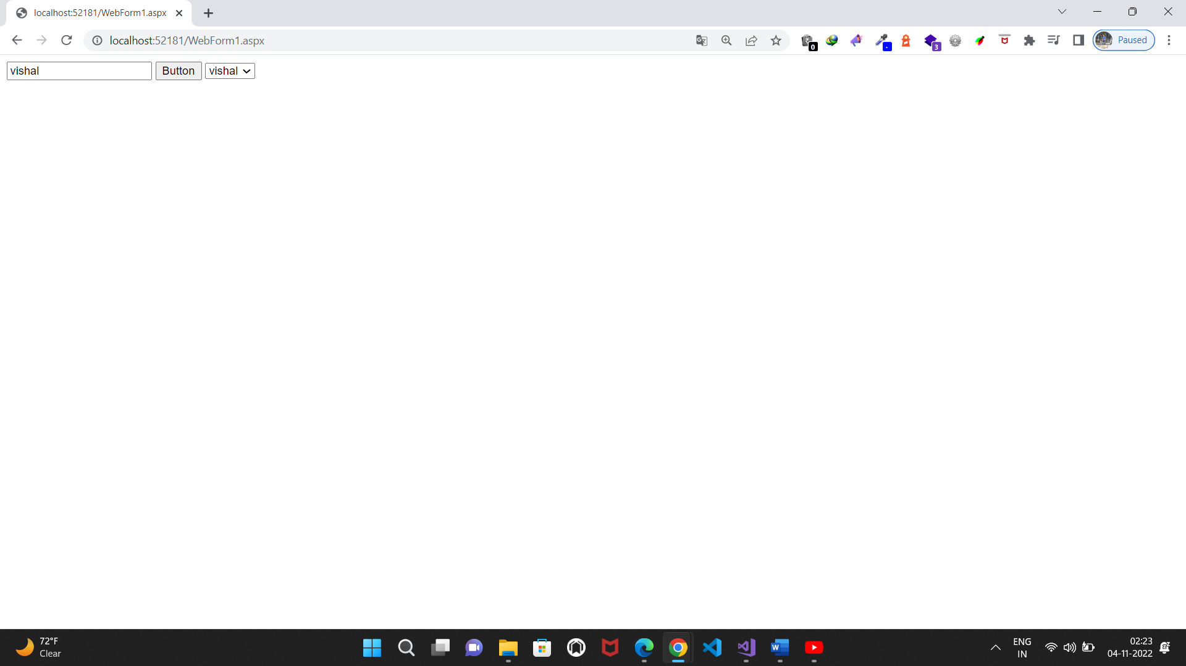

**b. Create a web application for to display the phone no of an author using database.**

**Source code:**

**WebForm1.aspx.cs:**

using System;

using System.Collections.Generic;

using System.Linq;

using System.Web;

using System.Web.UI;

using System.Web.UI.WebControls;

using System.Data.SqlClient;

namespace WebApplication24

{

public partial class WebForm1 : System.Web.UI.Page

{

SqlConnection cn = new SqlConnection("Data Source=visha;Initial Catalog=db2;Integrated Security=True;Pooling=False");

SqlCommand co = new SqlCommand();

SqlDataReader ds;

protected void Page_Load(object sender, EventArgs e)

{

cn.Open();

co.Connection = cn;

}

protected void Button1_Click(object sender, EventArgs e)

{

co.CommandText = "select phonenumber from emp where name='" + TextBox1.Text + "';";

Label1.Text = co.ExecuteScalar().ToString();

}

}

}

**Design:**

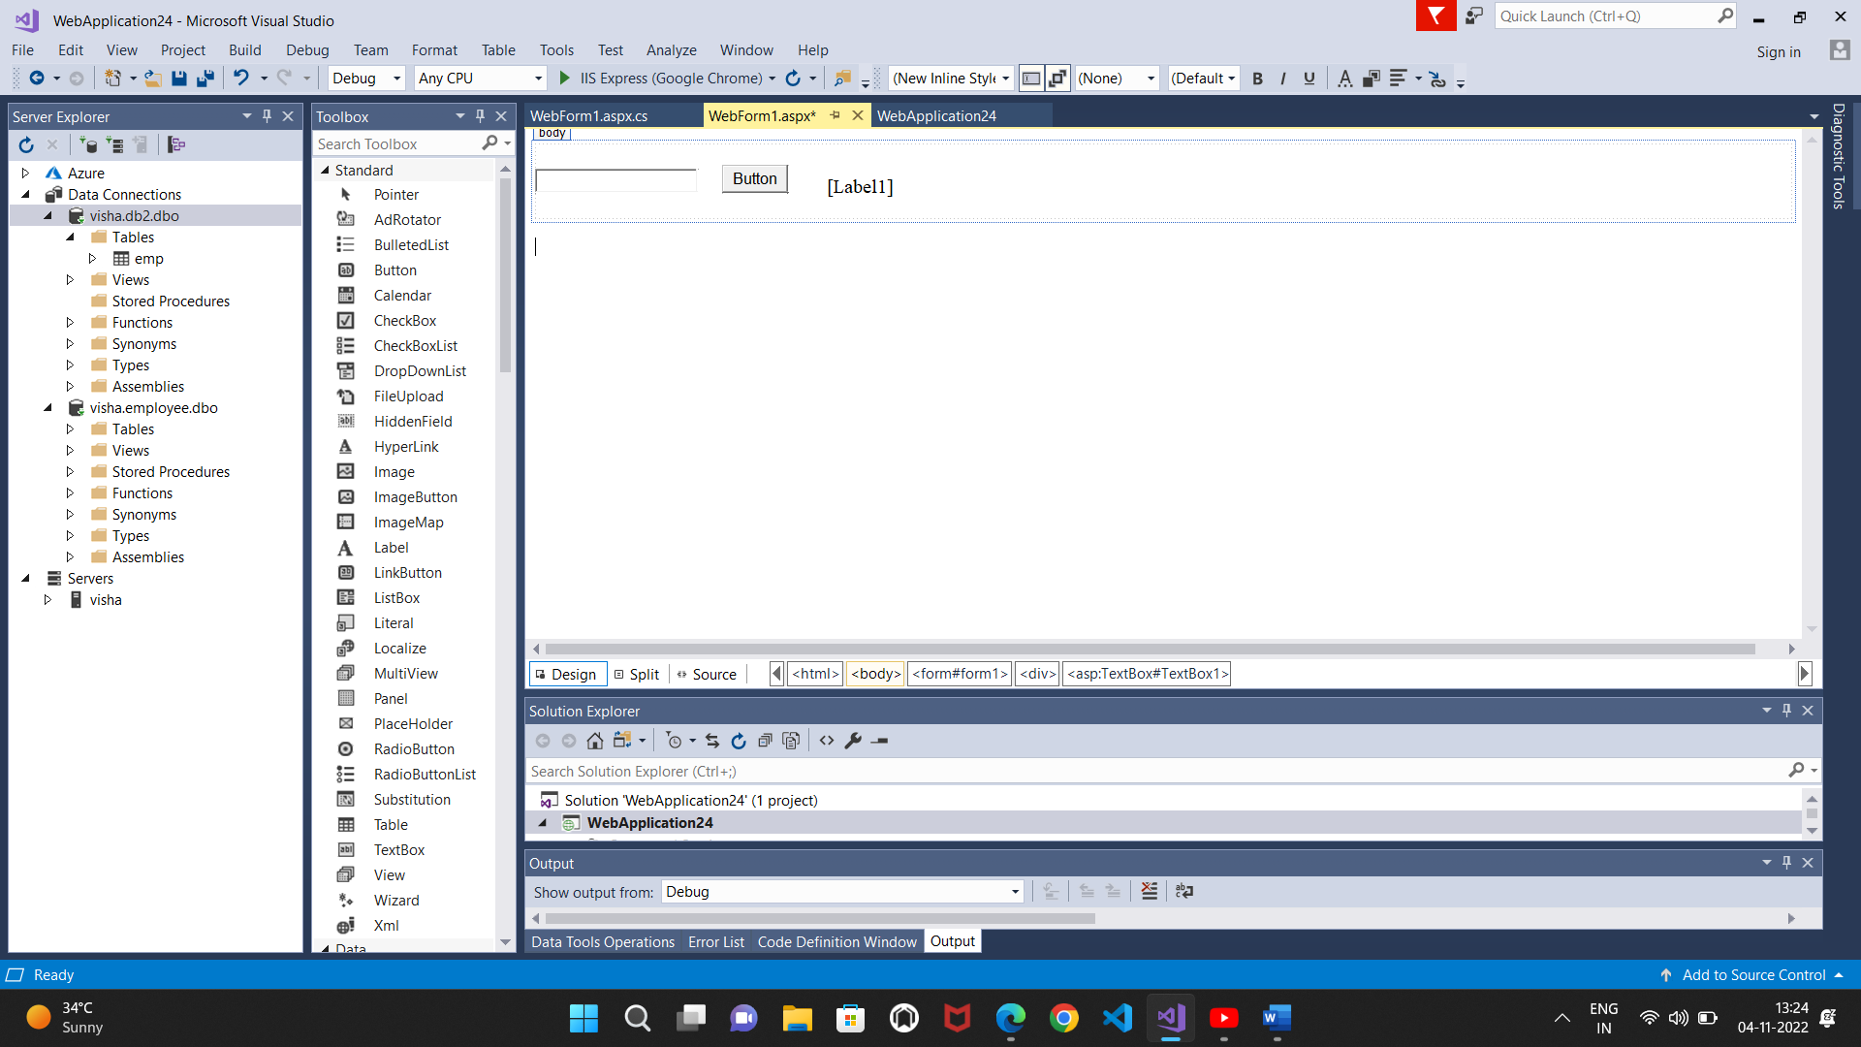

**Output:**

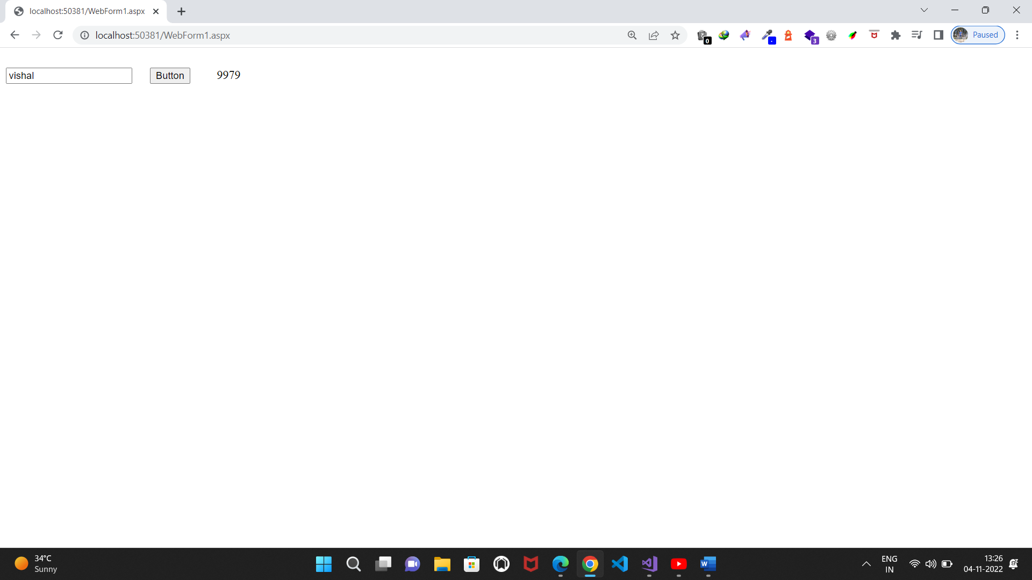

**c. Create a web application for inserting and deleting record from a database. (Using Execute-Non Query).**

**Source code:**

**WebForm1.aspx.cs:**

using System;

using System.Collections.Generic;

using System.Linq;

using System.Web;

using System.Web.UI;

using System.Web.UI.WebControls;

using System.Data.SqlClient;

namespace p7c

{

public partial class WebForm1 : System.Web.UI.Page

{

SqlConnection cn = new SqlConnection("Data Source=DESKTOP-4QULET9;Initial Catalog=atikur;Integrated Security=True");

SqlDataReader ds;

SqlCommand co = new SqlCommand();

SqlParameter @p1,@p2,@p3,@p4;

protected void Button2_Click(object sender, EventArgs e)

{

co.CommandText = ("delete from student where sno='"+TextBox1.Text+"';");

co.ExecuteNonQuery();

}

protected void Button3_Click(object sender, EventArgs e)

{

co.CommandText = "select * from student";

ds = co.ExecuteReader();

GridView1.DataBind();

}

protected void Button1_Click(object sender, EventArgs e)

{

@p1 = new SqlParameter();

@p1.ParameterName = "sno";

@p1.SqlDbType = System.Data.SqlDbType.Int;

@p2 = new SqlParameter();

@p2.ParameterName = "name";

@p2.SqlDbType = System.Data.SqlDbType.VarChar;

@p3 = new SqlParameter();

@p3.ParameterName = "city";

@p3.SqlDbType = System.Data.SqlDbType.Int;

@p4 = new SqlParameter();

@p4.ParameterName = "class";

@p4.SqlDbType = System.Data.SqlDbType.VarChar;

co.Parameters.AddWithValue("@p1", TextBox1.Text);

co.Parameters.AddWithValue("@p2", TextBox2.Text);

co.Parameters.AddWithValue("@p3", TextBox3.Text);

co.Parameters.AddWithValue("@p4", TextBox4.Text);

co.CommandText = "insert into student(sno,name,city,class) values(@p1,@p2,@p3,@p4);";

co.ExecuteNonQuery();

}

protected void Page_Load(object sender, EventArgs e)

{

cn.Open();

co.Connection = cn;

}

}

}

**Design:**

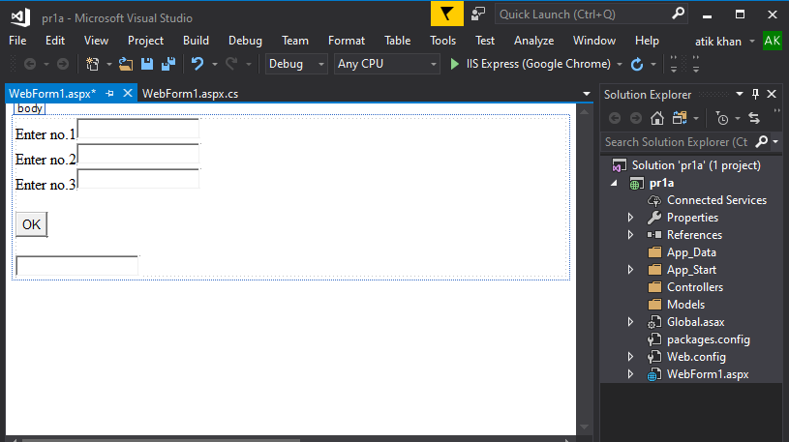

**Output:**

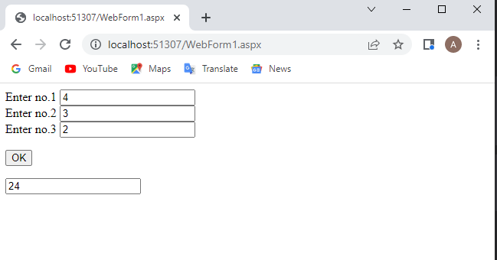

**Practical No.8(a)**

**8. Working with data controls**

**a)Create a web application to demonstrate various uses and properties of SqlDataSource.**

**Source code:**

**WebForm1.aspx.cs:**

using System;

using System.Collections.Generic;

using System.Linq;

using System.Web;

using System.Web.UI;

using System.Web.UI.WebControls;

using System.Data.SqlClient;

namespace WebApplication26

{

public partial class WebForm1 : System.Web.UI.Page

{

SqlCommand co = new SqlCommand();

SqlDataReader ds;

SqlDataSource s = new SqlDataSource();

protected void Page_Load(object sender, EventArgs e)

{

s.ConnectionString = "Data Source=visha;Initial Catalog=db1;Integrated Security=True";

}

protected void Button1_Click(object sender, EventArgs e)

{

s.SelectCommand = "select * from student ;";

GridView1.DataBind();

}

protected void Button2_Click(object sender, EventArgs e)

{

SqlParameter p1 = new SqlParameter(), p2 = new SqlParameter(), p3 = new SqlParameter(), p4 = new SqlParameter();

s.InsertParameters.Add("p1", System.Data.DbType.Int32, TextBox1.Text);

s.InsertParameters.Add("p2", System.Data.DbType.String, TextBox2.Text);

s.InsertParameters.Add("p3", System.Data.DbType.String, TextBox3.Text);

s.InsertParameters.Add("p4", System.Data.DbType.String, TextBox4.Text);

s.InsertCommand = "insert into student values (@p1,@p2,@p3,@p4);";

s.Insert();

}

protected void Button3_Click(object sender, EventArgs e)

{

SqlParameter p1 = new SqlParameter(), p2 = new SqlParameter();

s.UpdateParameters.Add("p2", System.Data.DbType.String, TextBox2.Text);

s.UpdateParameters.Add("p1", System.Data.DbType.Int32, TextBox1.Text);

s.UpdateCommand = "update student SET name=@p2 where sno=@p1;";

s.Update();

}

protected void Button4_Click(object sender, EventArgs e)

{

SqlParameter p1 = new SqlParameter();

s.DeleteParameters.Add("p1", System.Data.DbType.Int32, TextBox1.Text);

s.DeleteCommand = "delete student where sno=@p1";

s.Delete();

}

}

}

**Design:**

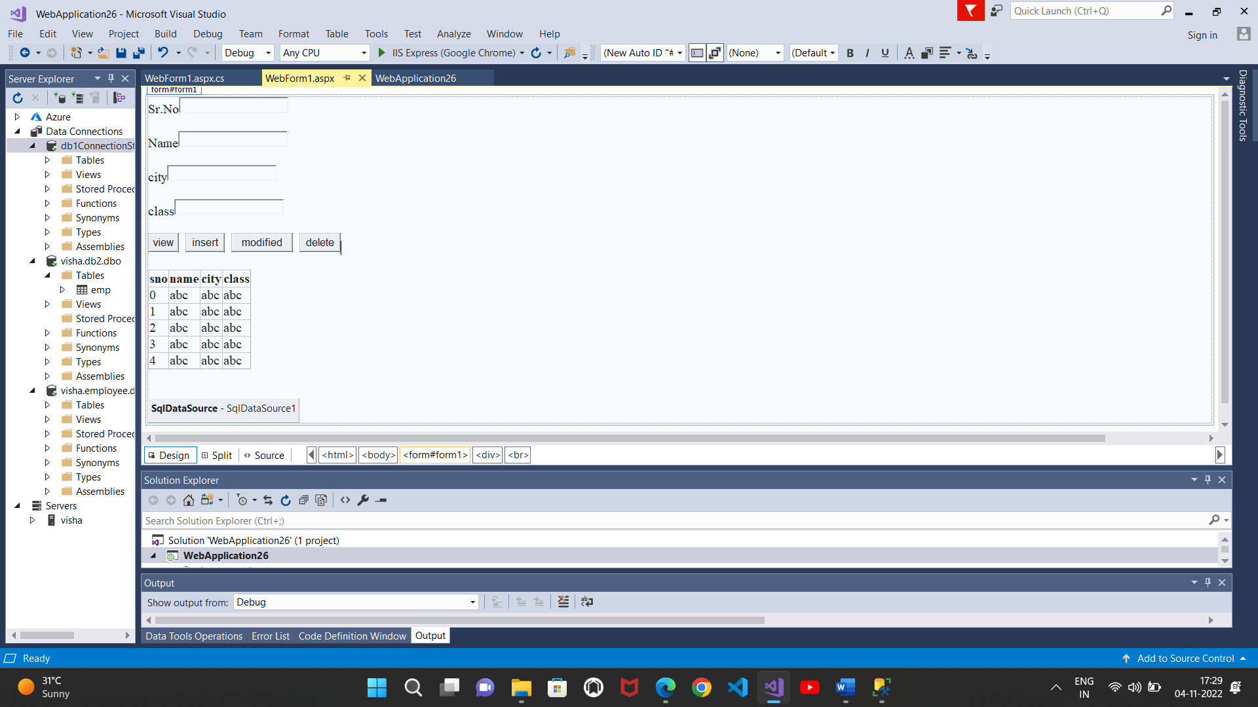

**Output:**

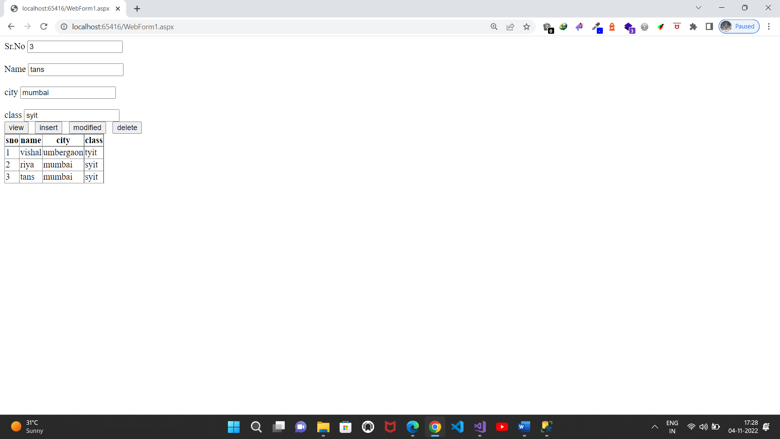

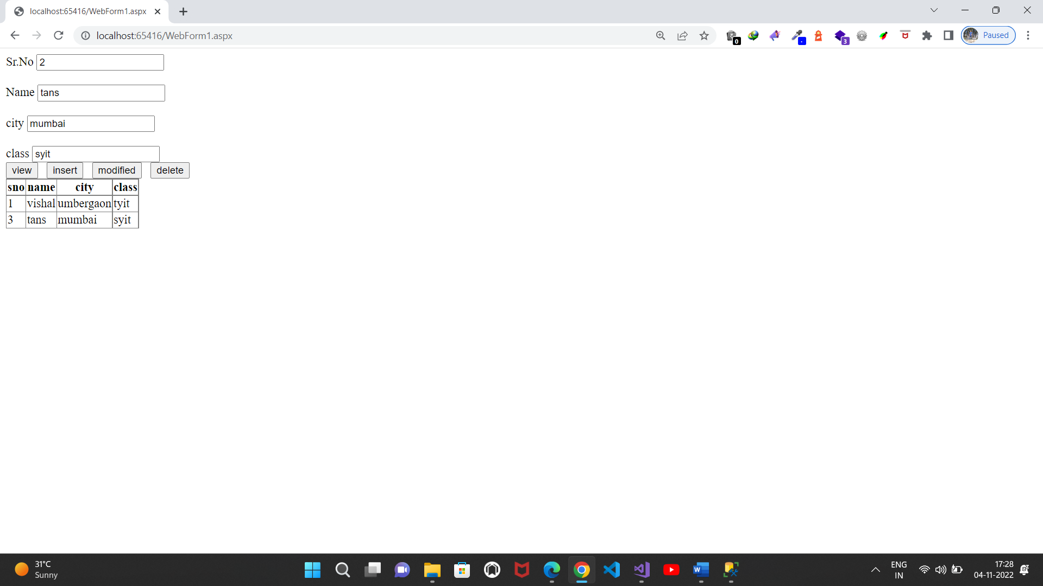

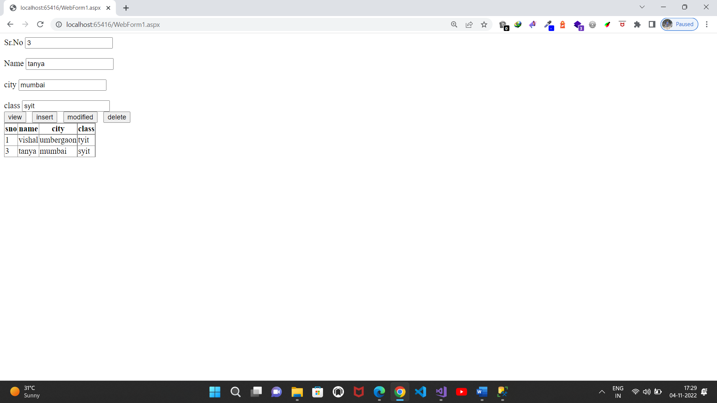

**b.Create a web application to demonstrate data binding using DetailsView and FormView Control.**

**Design:**

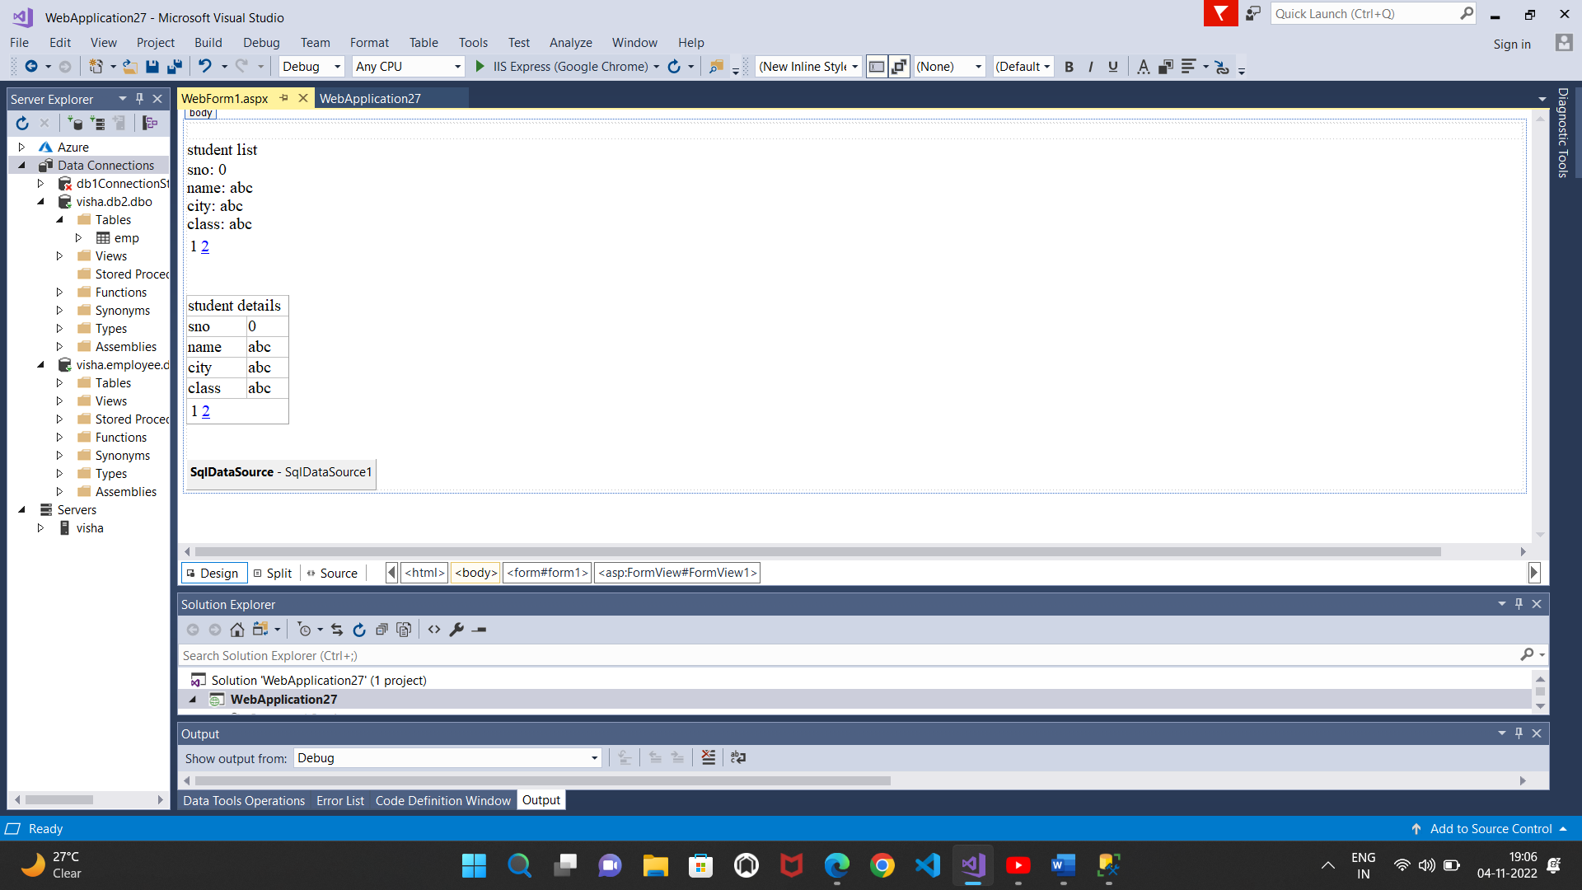

**Output:**

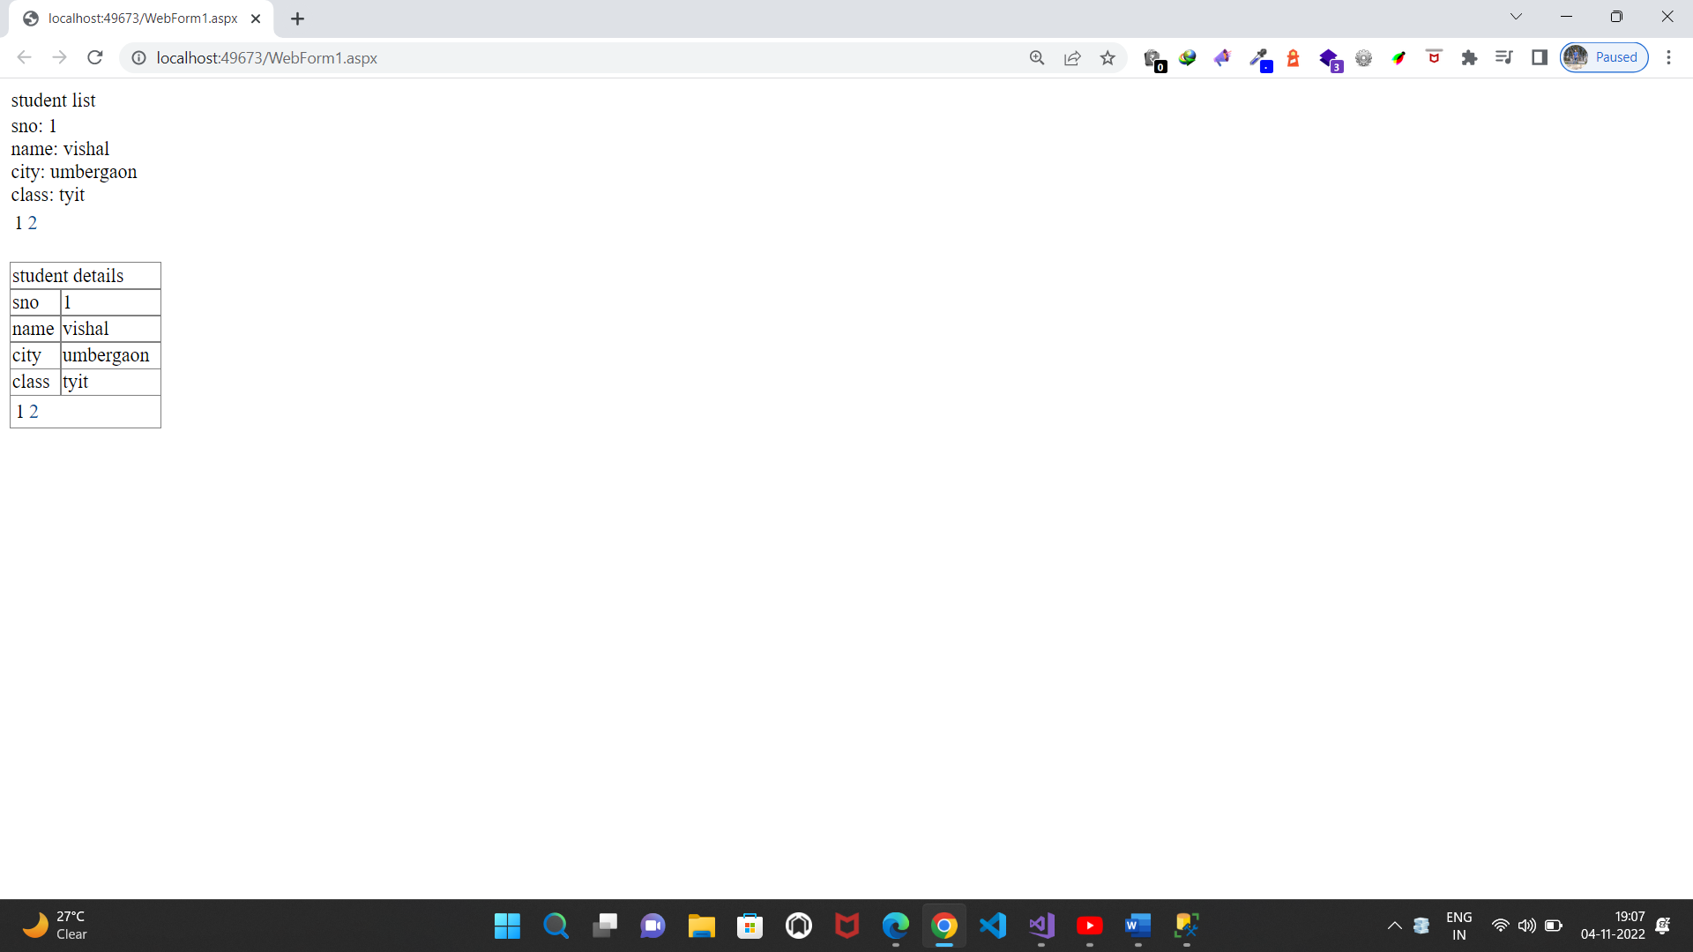

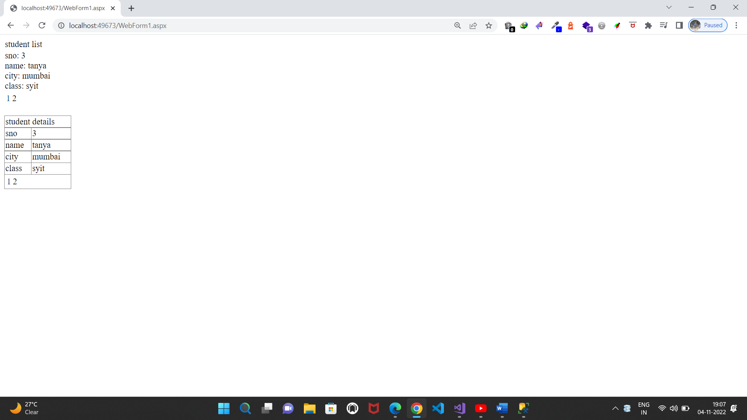

**c)Create a web application to display Using Disconnected Data Access and Databinding using GridView**.

**Source code:**

**WebForm1.aspx.cs:**

using System;

using System.Collections.Generic;

using System.Linq;

using System.Web;

using System.Web.UI;

using System.Web.UI.WebControls;

using System.Data.SqlClient;

using System.Data;

namespace WebApplication28

{

public partial class WebForm1 : System.Web.UI.Page

{

SqlConnection con = new SqlConnection("Data Source=visha;Initial Catalog=db1;Integrated Security=True");

SqlDataAdapter da;

DataSet ds = new DataSet();

protected void Page_Load(object sender, EventArgs e)

{

}

protected void Button1_Click(object sender, EventArgs e)

{

da = new SqlDataAdapter("select * from student", con);

da.Fill(ds, "stud");

GridView1.DataSource = ds;

GridView1.DataBind();

}

}

}

**Design:**

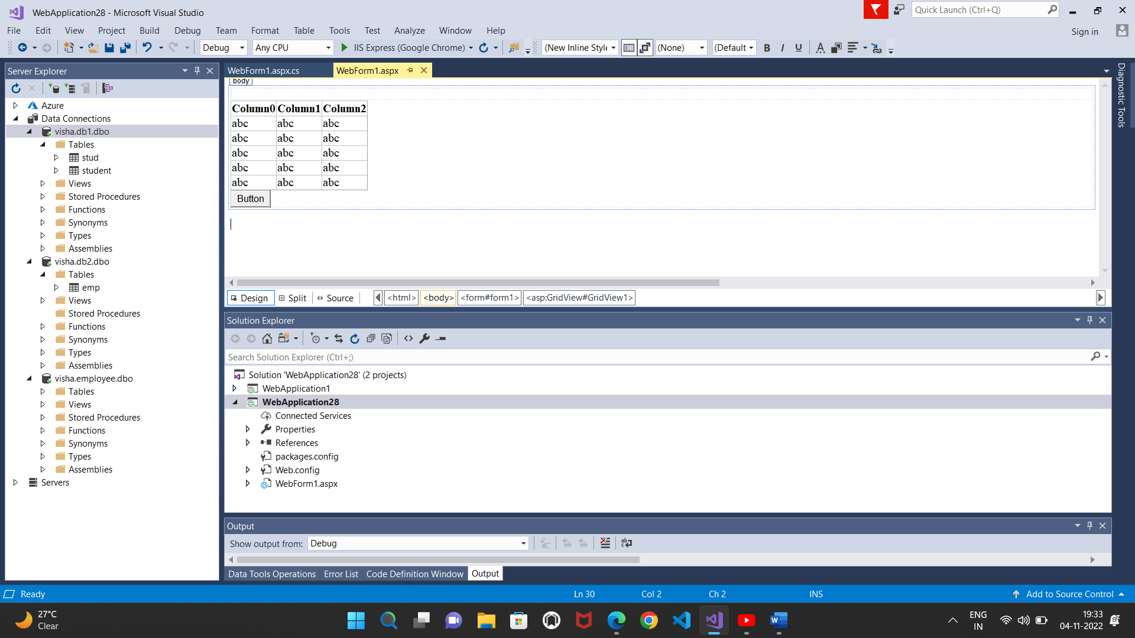

**Output:**

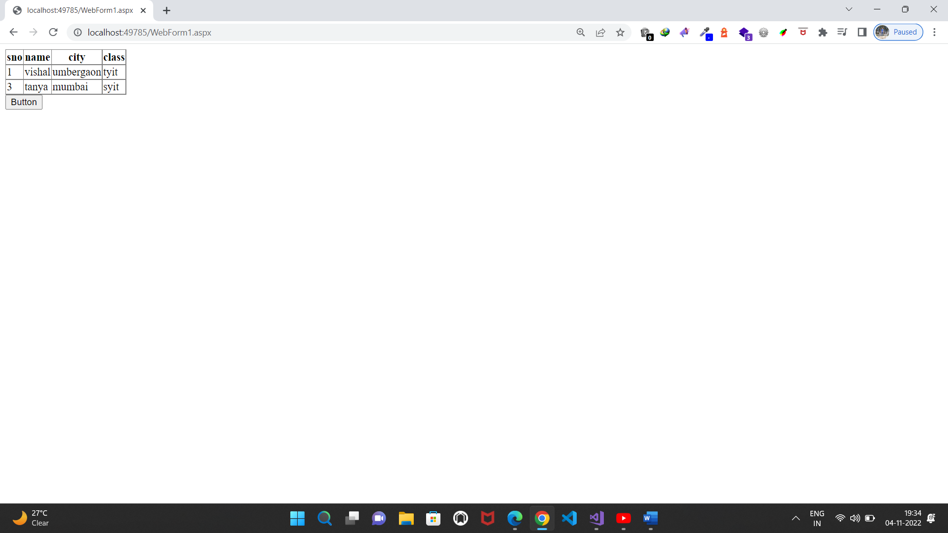

**Practical No.9(a)**

**9. Working with GridView control**

**a. Create a web application to demonstrate use of GridView control template and GridView hyperlink.**

**Design:**

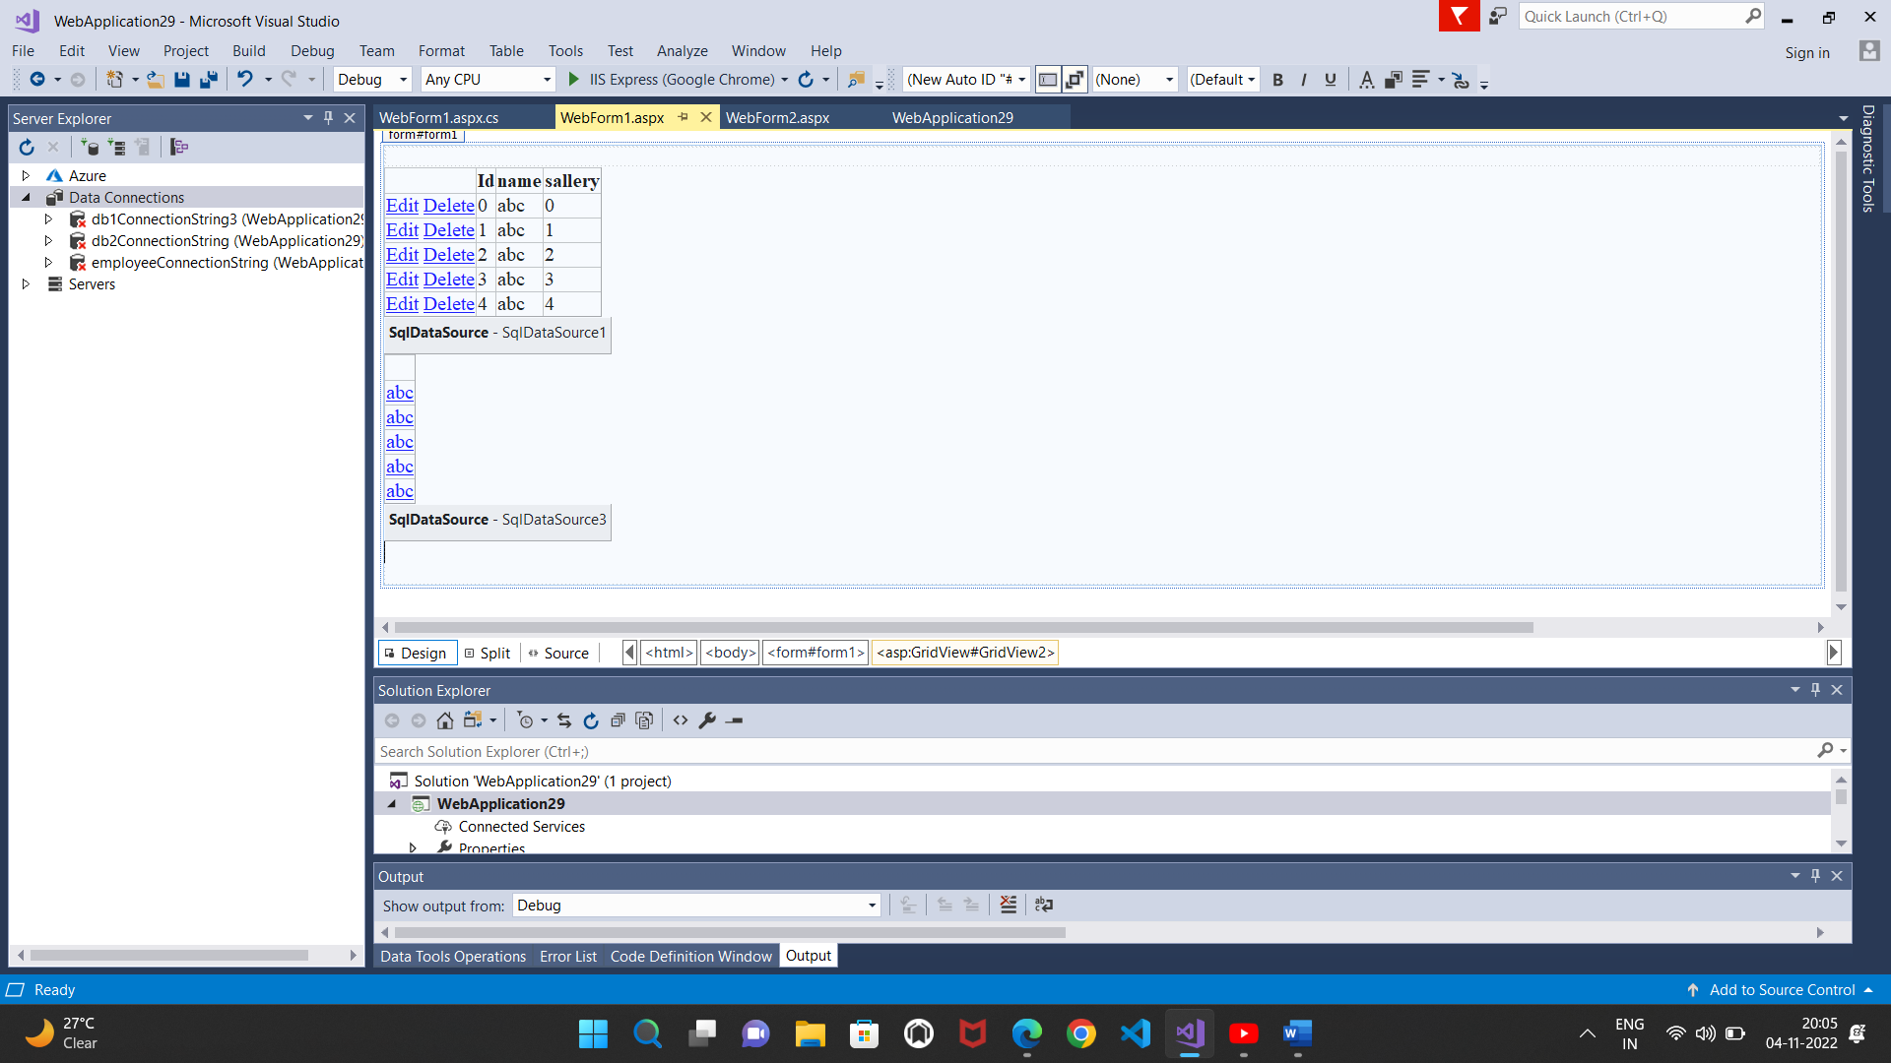

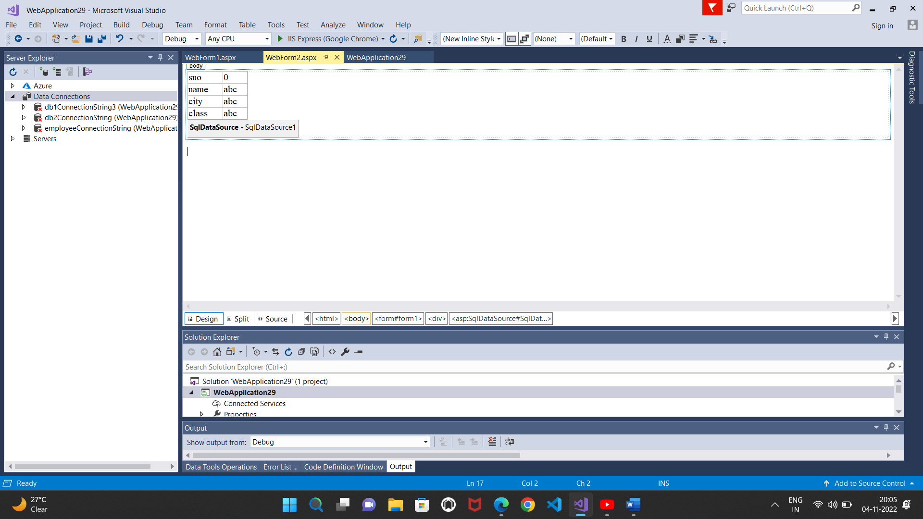

**Output:**

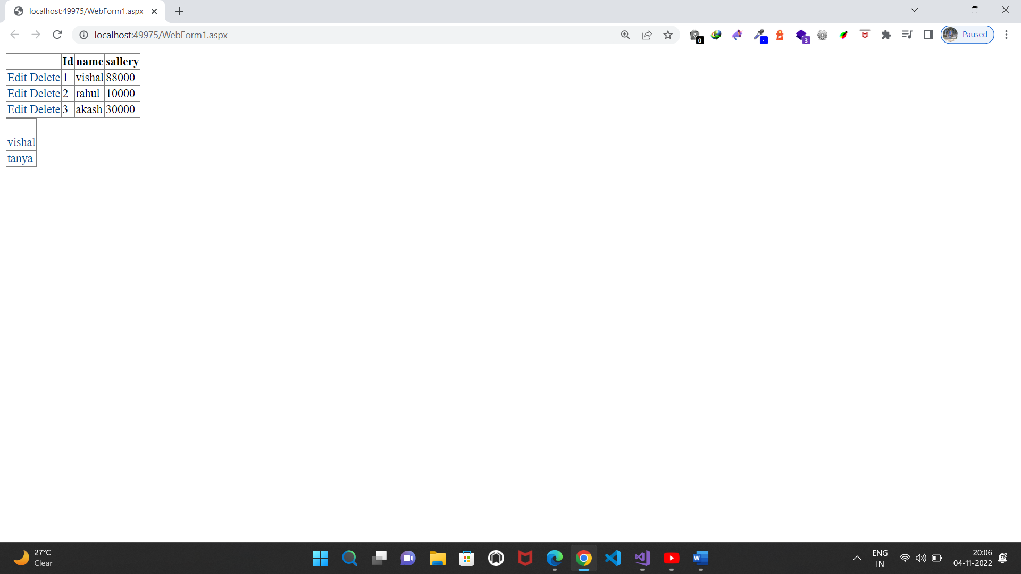

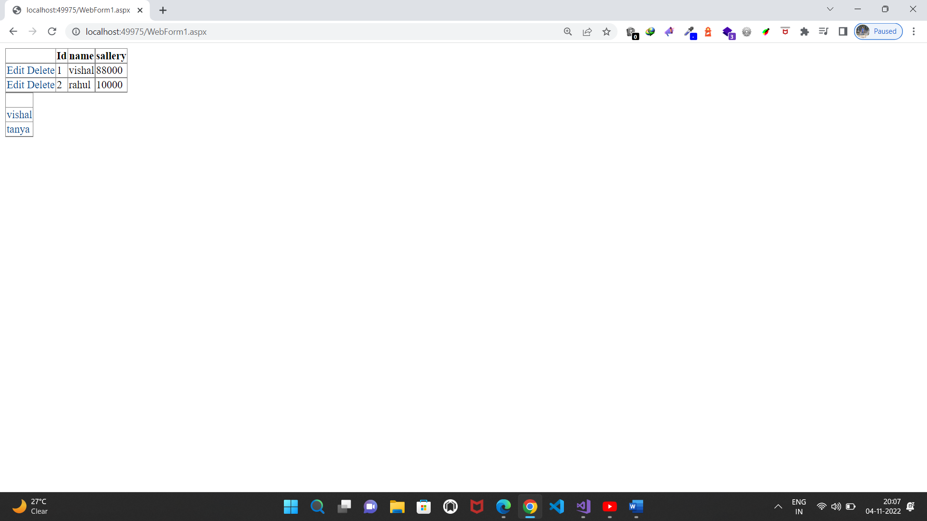

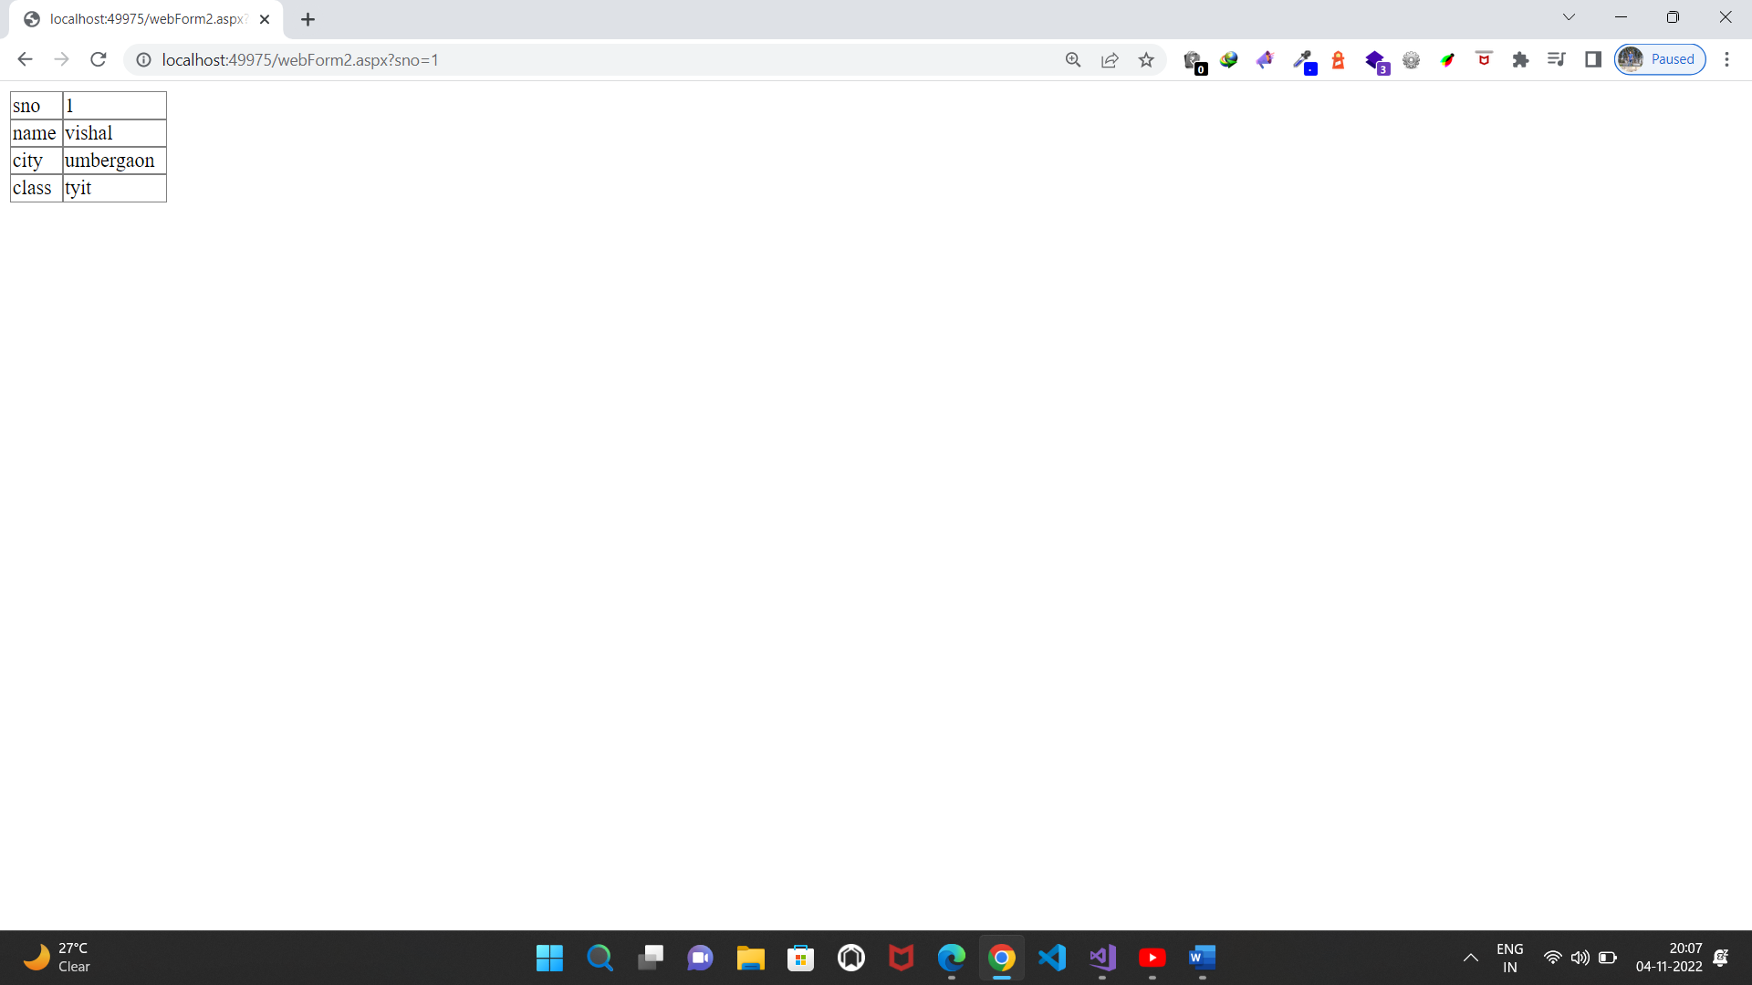

**b. Create a web application to demonstrate use of GridView button column and GridView events.**

**Source code:**

**WebForm1.aspx.cs:**

using System;

using System.Collections.Generic;

using System.Linq;

using System.Web;

using System.Web.UI;

using System.Web.UI.WebControls;

namespace WebApplication30

{

public partial class WebForm1 : System.Web.UI.Page

{

protected void Page_Load(object sender, EventArgs e)

{

}

protected void GridView1_RowCommand(object sender, GridViewCommandEventArgs e)

{

if(e.CommandName == "b1")

{

GridView1.Rows[Convert.ToInt16(e.CommandArgument)].BackColor = System.Drawing.Color.Blue;

}

}

}

}

**Design:**

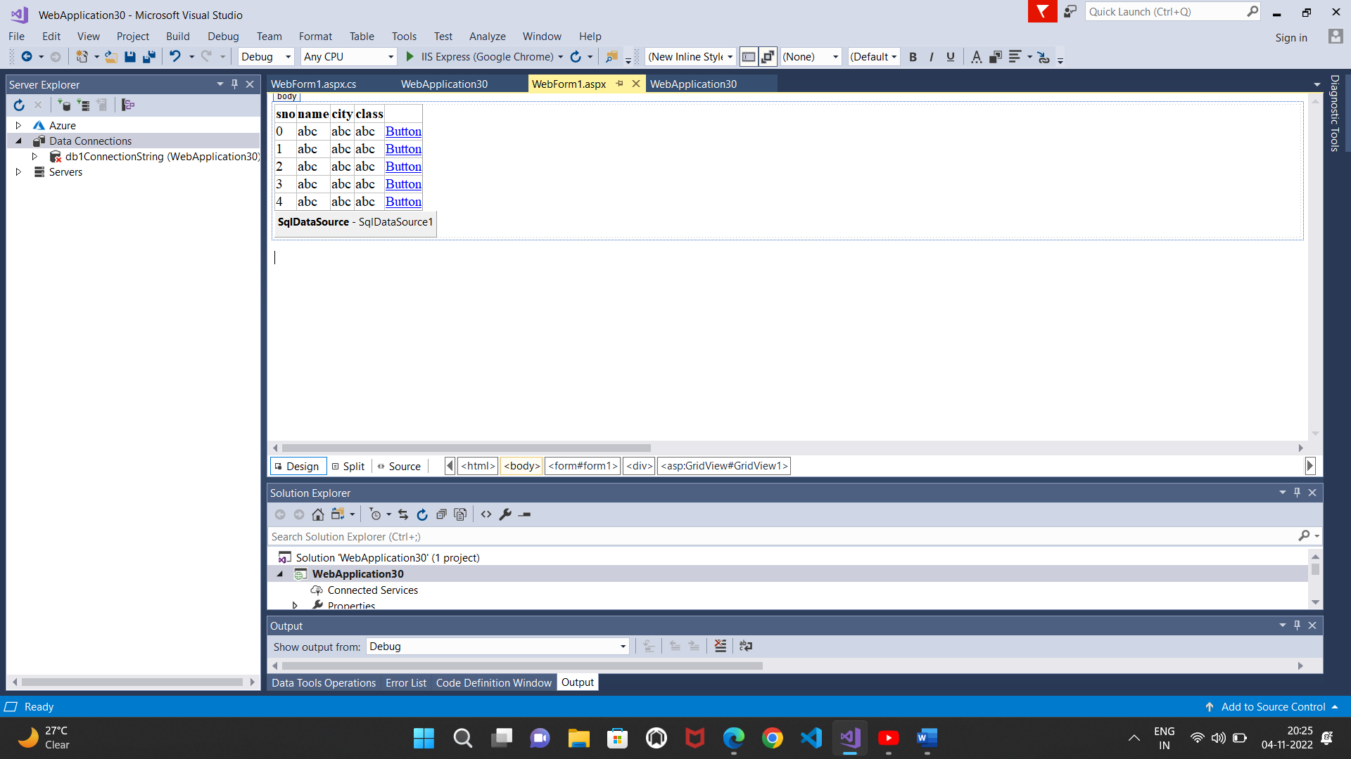

**Output:**

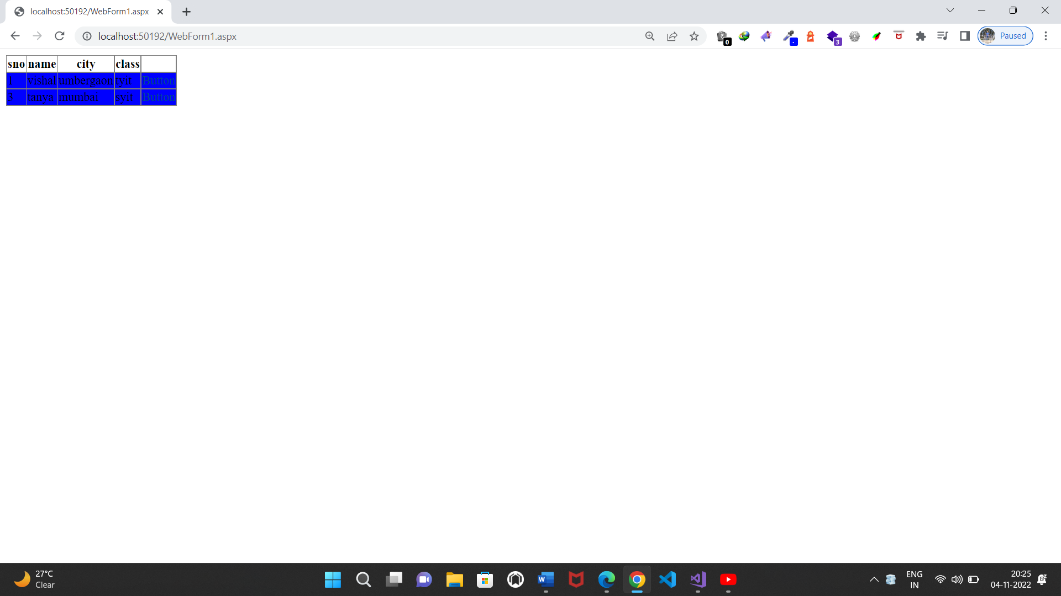

**c)Create a web application to demonstrate GridView paging and Creating own table format using GridView**.

**Source code:**

**WebForm1.aspx.cs:**

using System;

using System.Collections.Generic;

using System.Linq;

using System.Web;

using System.Web.UI;

using System.Web.UI.WebControls;

namespace WebApplication31

{

public partial class WebForm1 : System.Web.UI.Page

{

protected void Page_Load(object sender, EventArgs e)

{

}

protected void GridView1_PageIndexChanging(object sender, GridViewPageEventArgs e)

{

GridView1.PageIndex = e.NewPageIndex;

}

protected void DropDownList1_SelectedIndexChanged(object sender, EventArgs e)

{

GridView1.PageIndex = DropDownList1.SelectedIndex;

}

}

}

**Design:**

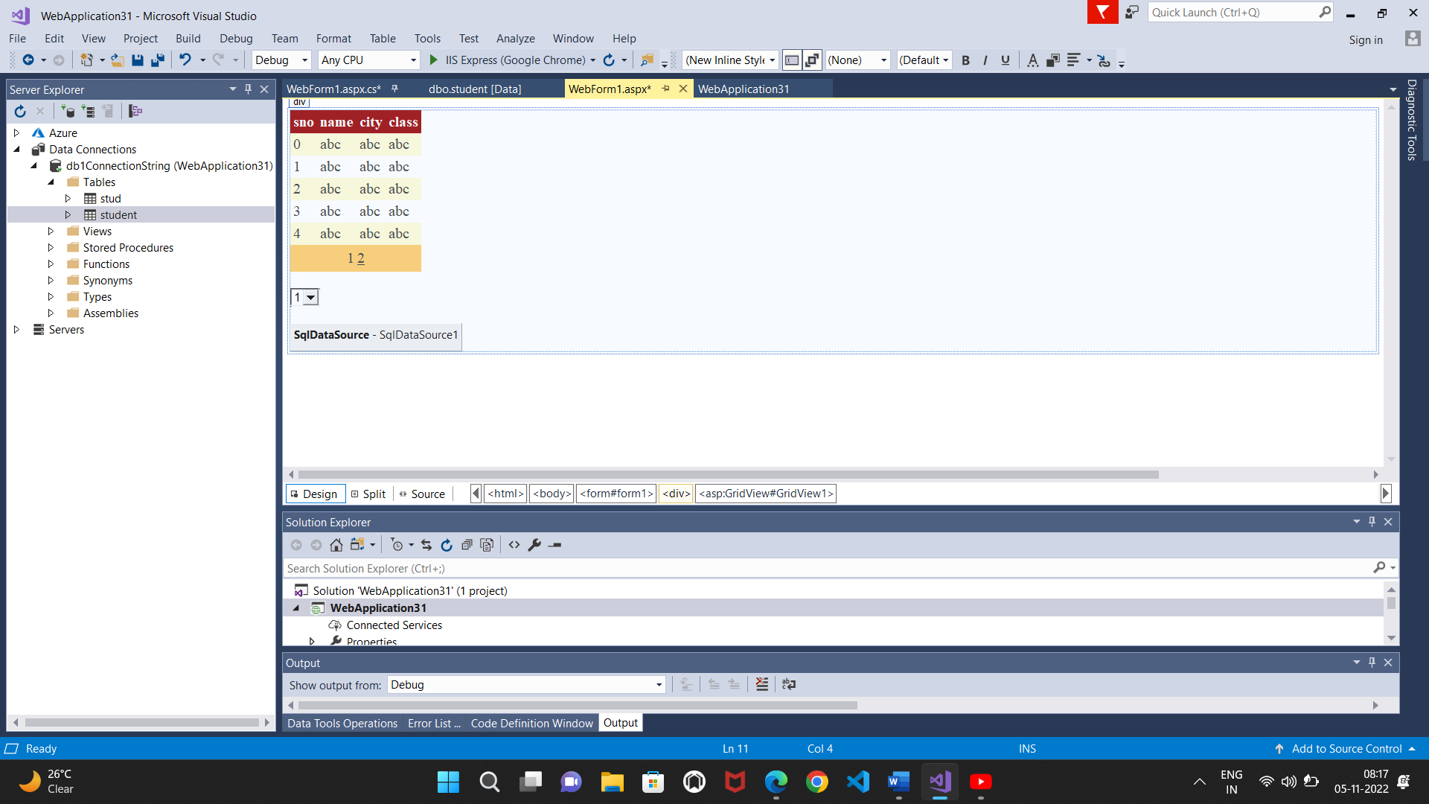

**Output:**

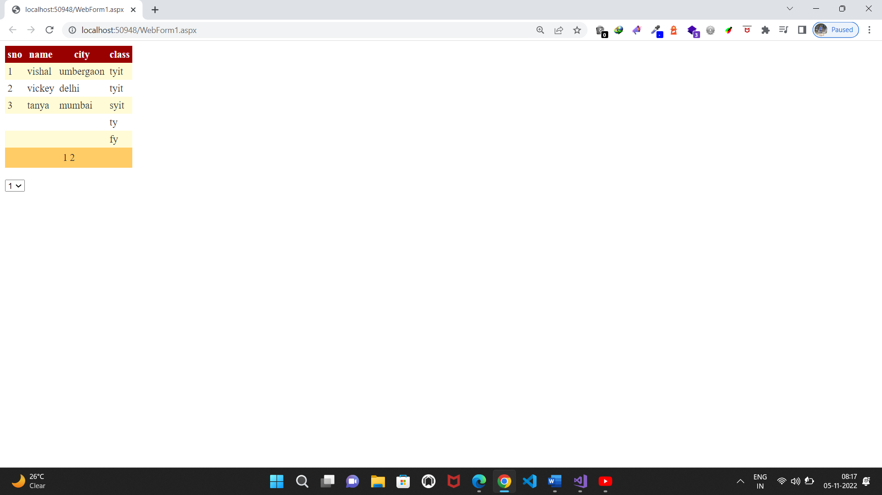

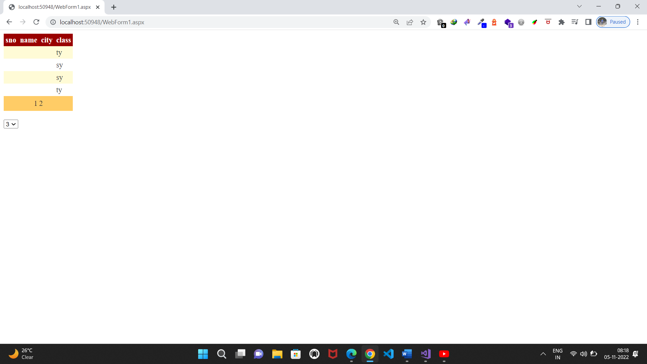

**Practical No.10(a)**

**Working with AJAX and XML**

**a. Create a web application to demonstrate reading and writing operation with XML**

**Source code:**

**WebForm1.aspx.cs:**

using System;

using System.Collections.Generic;

using System.Linq;

using System.Web;

using System.Web.UI;

using System.Web.UI.WebControls;

using System.Data;

using System.Xml;

namespace WebApplication37

{

public partial class WebForm1 : System.Web.UI.Page

{

protected void Page_Load(object sender, EventArgs e)

{

}

protected void Button1_Click(object sender, EventArgs e)

{

DataSet ds = new DataSet();

ds.ReadXml(Server.MapPath("XMLFile1.xml"));

GridView1.DataSource = ds.Tables[0].DefaultView;

GridView1.DataBind();

}

protected void Button2_Click(object sender, EventArgs e)

{

using (XmlWriter s = XmlWriter.Create(@"C:\Users\visha\source\repos\WebApplication37\XMLFile1.xml"))

{

s.WriteStartElement("Student");

s.WriteElementString("name", "vishal ");

s.WriteElementString("class", "TYIT");

s.WriteElementString("name", "Bob");

s.WriteElementString("class", "abc");

s.WriteElementString("name", "Tina");

s.WriteElementString("class", "xyz");

s.WriteEndElement();

}

Response.Write("Ok");

}

}

}

**XMLFile1.xml**

<?xml version="1.0" encoding="utf-8" ?>

<student>

<name> vishal</name>

<roll>22</roll>

</student>

**Design:**

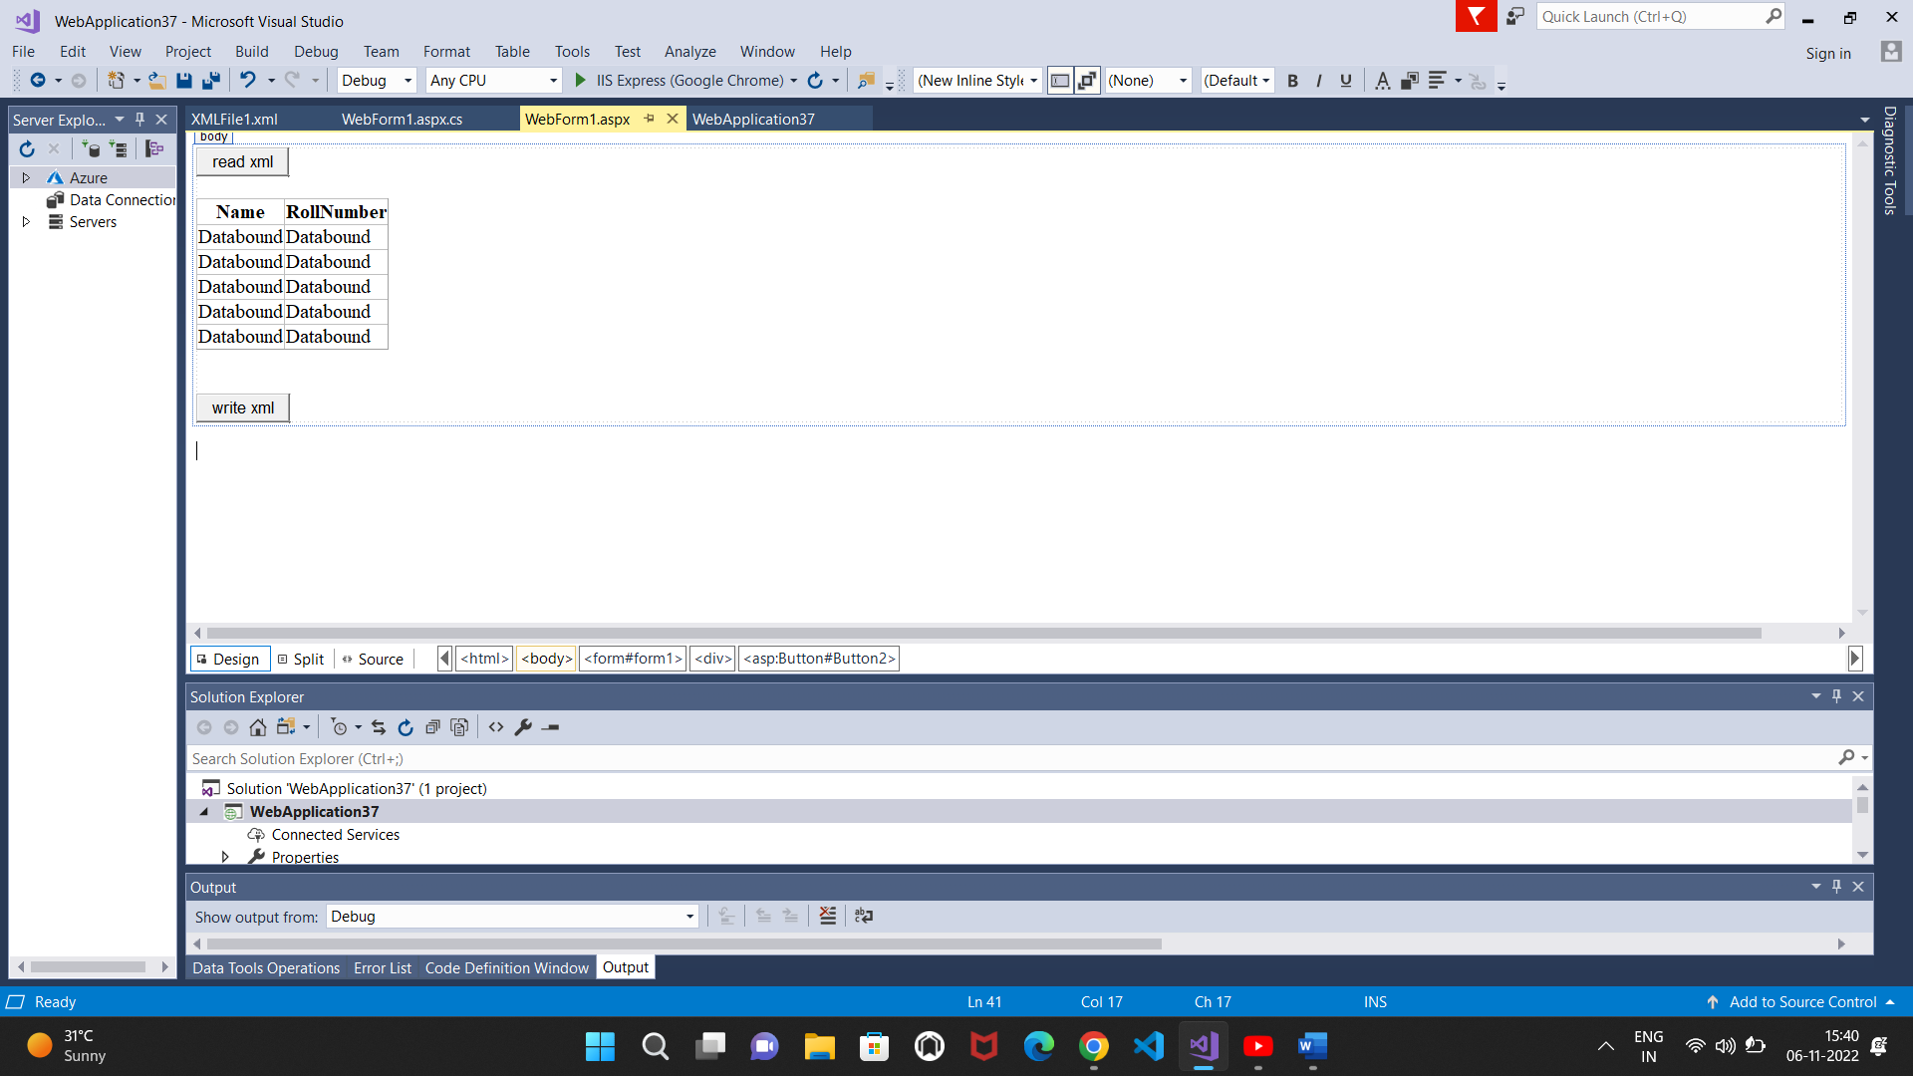

**Output:**

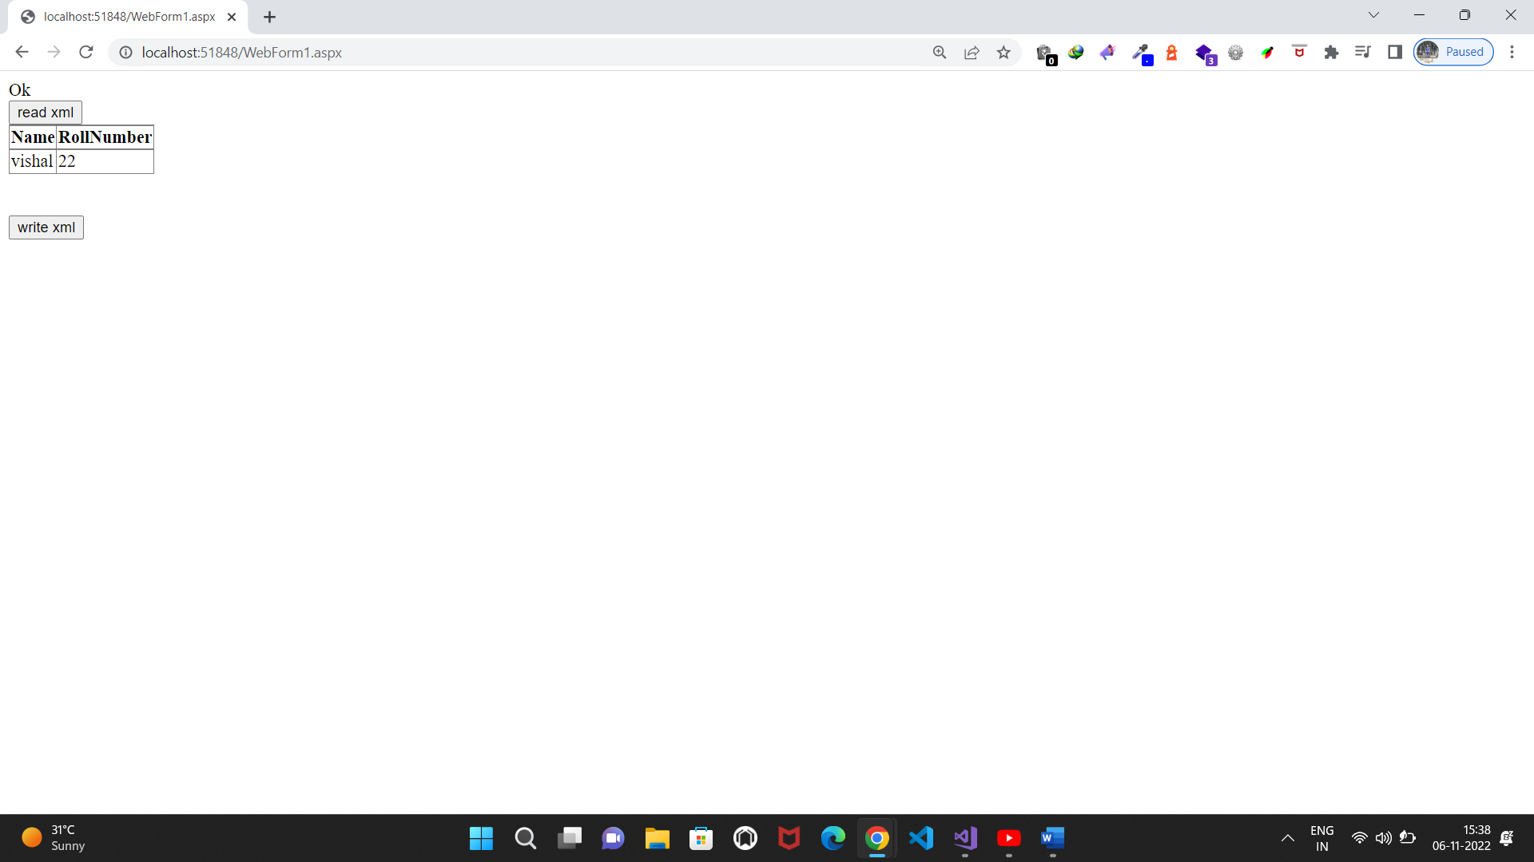

**c)Create a web application to demonstrate use of various Ajax controls**

**Source code:**

**WebForm1.aspx.cs:**

using System;

using System.Collections.Generic;

using System.Linq;

using System.Web;

using System.Web.UI;

using System.Web.UI.WebControls;

using System.Data;

using System.Xml;

namespace WebApplication35

{

public partial class WebForm1 : System.Web.UI.Page

{

protected void Page_Load(object sender, EventArgs e)

{

System.Threading.Thread.Sleep(2000);

}

protected void Button1_Click(object sender, EventArgs e)

{

TextBox1.Text = DateTime.Now.ToLongTimeString();

}

}

}

**Design:**

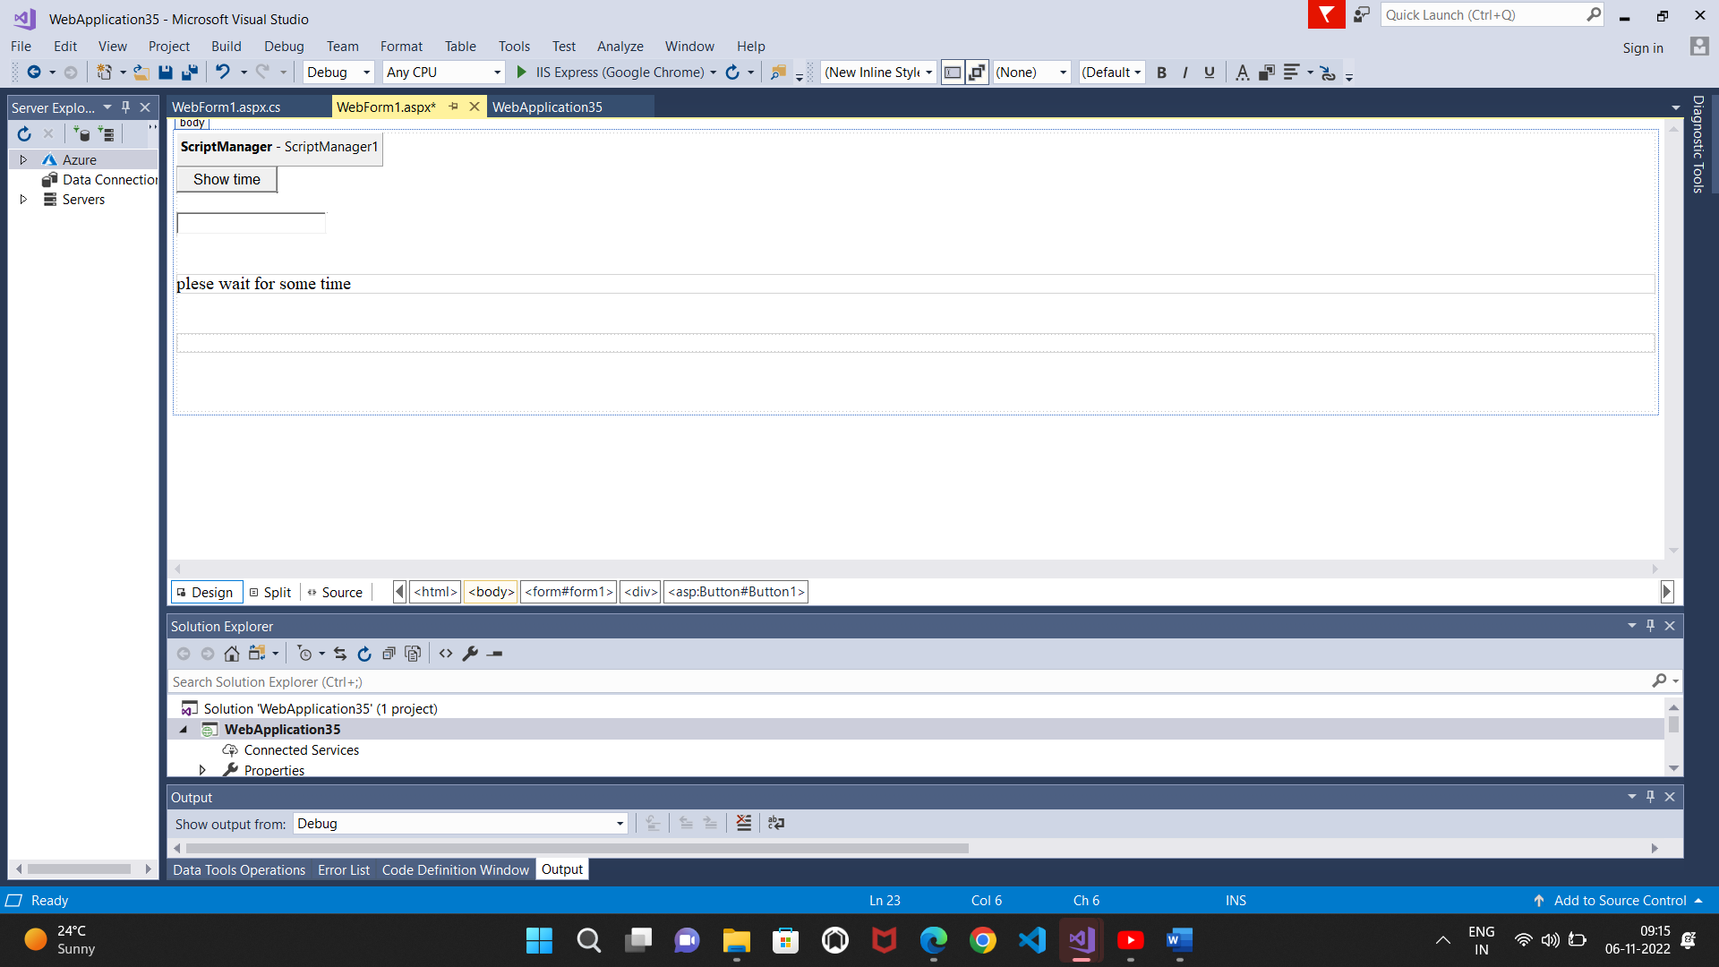**Output:**

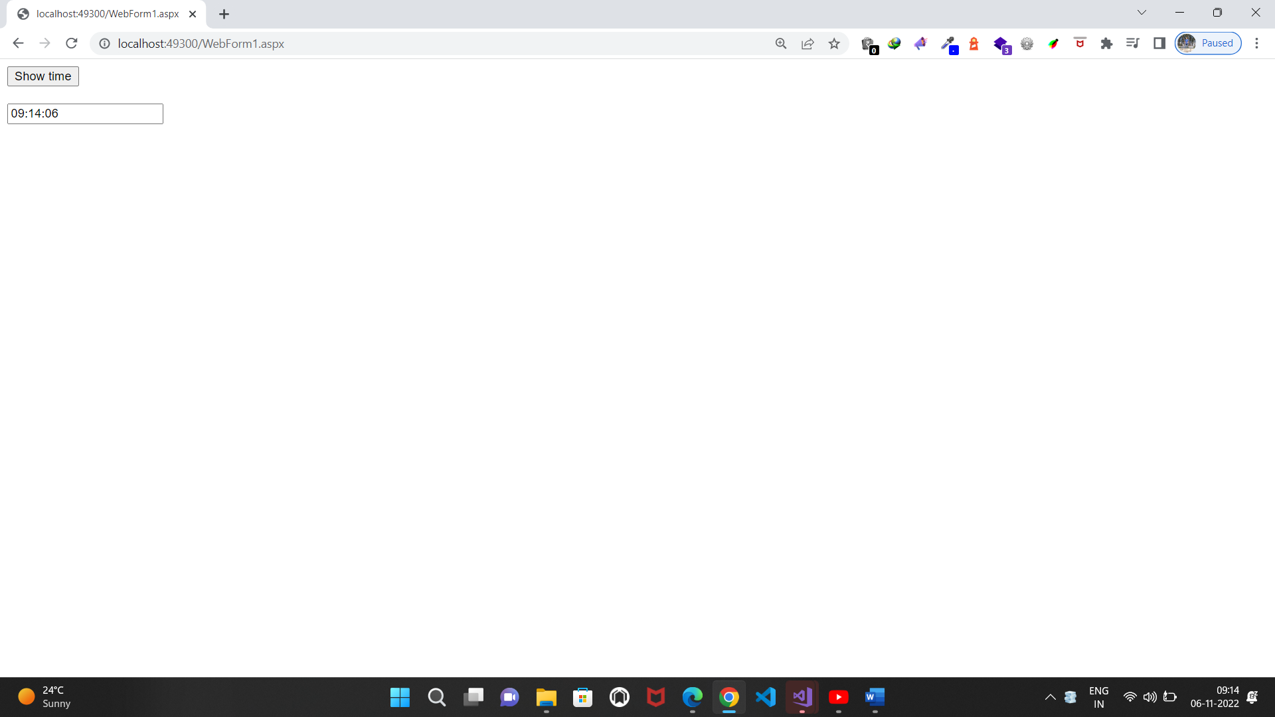

**Practical No.11(a)**

**11. Programs to create and use DLL**

**Class1.cs**

using System;

using System.Collections.Generic;

using System.Linq;

using System.Text;

using System.Threading.Tasks;

namespace ClassLibrary2

{

public class Class1

{

public int add(int a, int b)

{

int c = a + b;

return c;

}

}

}

**Program.cs**

using System;

using System.Collections.Generic;

using System.Linq;

using System.Text;

using System.Threading.Tasks;

namespace ConsoleApp1

{

class Program

{

static void Main(string[] args)

{

ClassLibrary2.Class1 c = new ClassLibrary2.Class1();

int t = c.add(1, 2);

Console.WriteLine("addition={0}", t);

Console.ReadKey();

}

}

}

**Output:**

